Senior project 1

Prepared by :

Mohamad Al Nasser

Under the supervision of :
Eng. Rania Rajab
Eng.Mohamad Al Balky

Dedication

To those who cleared the thorns from my path to pave the way for my journey of knowledge.. To my dear and generous parents..
To my esteemed teachers who never withheld knowledge or guidance from us..
To my colleagues and friends, and to everyone who contributed with a footstep or an idea in accomplishing this programming work..
We dedicate this humble effort to you.

مستخلص المشروع:
يعاني قطاع النقل العام البري بين المحافظات من عشوائية إدارية واعتماد كلي على المعاملات الورقية التقليدية، مما يؤدي إلى مشاكل في تنظيم المواعيد، تلاعب بأسعار التذاكر، وضياع شكاوى المواطنين. يقدم هذا المشروع حلاً برمجياً متكاملاً لأتمتة وحوكمة "مراكز انطلاق الحافلات" (الكراجات الموحدة).
تم بناء النظام باستخدام هندسة برمجية متطورة تعتمد على معمارية الخدمات المصغرة (Microservices Architecture) عبر بيئة عمل .NET 8 للخدمات الخلفية، وإطار عمل React لبناء واجهات المستخدم، مع عزل قواعد البيانات لكل خدمة باستخدام SQL Server وحزمها داخل حاويات Docker. يوفر النظام واجهات متزامنة تخدم ثلاثة أطراف: إدارة الكراج لضبط طوابير الانطلاق والخطوط، السائقين لمتابعة الرحلات، والمواطنين لحجز المقاعد وتقديم الشكاوى الفورية المربوطة بالرحلة. تم إخضاع النظام لاختبارات أداء وضغط مكثفة لضمان استقرار البوابة البرمجية وسرعة الاستجابة تحت ظروف الضغط العالي.

Abstract
Inter-provincial public transportation centers face significant operational challenges due to manual paper-based management, resulting in scheduling inefficiencies, ticket price manipulation, and unhandled passenger complaints. This project proposes a comprehensive software solution to automate and govern "Public Transport Launch Centers" (Unified Terminals).
The system is engineered using a modern Microservices Architecture via .NET 8 for the backend services and React for building responsive user interfaces. Each service manages an independent SQL Server database, fully containerized using Docker. The platform integrates three synchronized interfaces to serve key stakeholders: Garage Administrators (to control dynamic line queuing), Bus Drivers (to track assigned shifts), and Citizens (for digital ticket booking and real-time complaint submission tied directly to trip data). To ensure system reliability and high availability, the architecture was subjected to rigorous performance and load testing, verifying optimal response times under heavy concurrent user traffic

Content
Dedication 2
مستخلص المشروع: 3
Abstract 4
Content 5
Diagram 12
Chapter One Introduction and Project Definition 17
Introduction to the Project Topic 18
1-Overview: 18
2-Project Justifications 18
3-Project Objective 19
4-Project Scope Assumptions and Restrictions 19
4.1. Project Scope 19
5-The project's contribution to Knowledge and the field F(What is New 21
5- Research Methodology 22
6- Organizational Document Structure – 22
7-Basic Definitions and Concepts 25
Chapter Two: Project Development and Management Methodology 27
1-Project Definition 28
2-Project objective 28
3-Scope 28
4-Development Method Used (Iterative Incremental) 30
5-Work plan 31
6-Project charter 32
7-Roles and Responsibilities 33
8- Risk management 34
9- Project Quality Management 35
Chapter3 Reference study 36
1- Similar applications 37
2-Comparison table between systems 40
3.Modern technologies and frameworks in the field 41
4-Theoretical Framework and Reference Studies (Theoretical Framework) 42
5. Modern and Future Directions in the Field (Future Trends in the Field) 43
Chapter 4 44
Analytical study 44
1-Feasibility study 45
2-Requirements Elicitation 45
3-stakeholders 45
4-functctional requirements 46
5-Nonfunctional requirement 47
7-system description of features(High level use case diagram) 49
7-1-Main Use Case Diagrams 50
7-2- use case Descriptions 52
7-3-Activity Diagrams 76
7-4-Sequence Diagrams 92
7-5-Requirements Traceability Matrix 110
7-6-Test Case Descriptions 113
Part Three: Design and Architecture 116
Chapter 5 117
Architectural Design 117
5.1 High-Level System Design 118
5.1.1 System Block Diagram 118
5.1.2 Architectural Pattern 120
5.1.3 System Architecture Description 121
5.2 Database Design 122
5.2.1 Entity Relationship Diagram (ERD) 122
5.2.3 Database Constraints(primary key, Foreign Key, Unique, Check) 124
5.3 API Design 127
5.4 Security and Authorization Design 138
5.4.1 Authentication Mechanism 138
5.4.2 Authorization and Access Control 140
5.4.3 Access Levels 140
5.4.4 API Security Measures 142
5.4.5 Security Architecture Overview 142
Part Four: 144
Implmentation 144
and Testing 144
Chapter 6 146
DEVELOPMENT ENVIRONMENT AND TOOLS 146
6.1 Introduction 147
6.2 Development Tools and Software 147
6.3 Development Environment and System Structure 147
6.3.1 Root Directory Structure 148
6.3.2 Backend Structure 148
6.3.3 Microservice Internal Architecture 149
6.3.4 Frontend Structure 150
6.3.5 Performance Testing Structure 150
6.4 Programming Languages and Frameworks 150
• Framework 151
6.5 Database Server and Operating System 151
6.6 Dependencies and Libraries 152
6.7 Version Control and Source Code Management 153
6.8 CI/CD Tools 153
6.9 Testing Environment 153
6.10 Summary 155
Chapter 7 156
Software Implementation 156
7.1 Project and File Structure 157
7.2 Modules Implementation 160
7.2.1 API Gateway 160
7.2.2 Authentication Service 161
7.2.3 Booking Service 162
7.2.4 Trip Service 163
7.2.5 Vehicle Service 164
7.3 API Implementation 165
7.4 Data Access Layer Implementation 167
7.5 Business Logic Layer Implementation 170
7.6 User Interface Implementation 171
7.7 Performance Testing Implementation 201
7.8 Summary 202
Chapter 8 203
Testing 203
and Evaluation 203
8.1 Testing Plan 204
8.2 Types of Tests 205
8.2.1 Functional Testing 205
Example API Test Cases 217
8.2.2 Performance and Load Testing 218
8.3 Testing Environment 226
8.4 Testing Architecture 226
8.5 Test Results and Analysis 227
8.6 Quality Metrics 227
8.7 Challenges During Testing 228
8.8 Summary 228
Part Five: 230
Result and Recomendation 230
Chapter 9 231
Result and Analysis 231
9.1 System Application Results 232
9.2 Comparative Analysis with Existing Systems 236
9.3 Achievement of Project Objectives 236
9.4 Strengths and Weaknesses Analysis 237
9.5 Key Performance Indicators (KPIs) 239
9.6 General Analysis 240
Chapter 10 Conclusion & Recommendations 243
10-1 Conclusion 244
10-2 Difficulties and challenges 244
10-3 Future Work 245
10-4Recommendations for institutions: 245
Section Six: Appendices and References 246
Appendix A: 247
Deriving Requirements 247
Appendix B: Detailed Design 248
First: Reference Studies and Similar Applications (Reference Study) 250

Diagram
Figure 1 use case high level 48
Figure 2 use case mange citizens 50
Figure 3 use case mange drivers 52
Figure 4 use case mange clmplaint 53
Figure 5 desciption UC-01 54
Figure 6 desciption UC-02 55
Figure 7 descirption UC-03 56
Figure 8 description 57
Figure 9 description UC-05 58
Figure 10 activity UC-1 60
Figure 11 activity UC 2 61
Figure 12activity UC-03 62
Figure 13 activity UC-4 63
Figure 14 activity UC-05 63
Figure 15 activity UC-06 64
Figure 16 activity UC=7 65
Figure 17 activity UC-08 66
Figure 18 activity UC-09 66
Figure 19 activity UC-10 67
Figure 20 activity UC-11 68
Figure 21 activity UC-12 68
Figure 22 activity UC-13 69
Figure 23 activity UC-14 70
Figure 24 activity UC-15 70
Figure 25 activity UC-16 71
Figure 26 activity UC-17 72
Figure 27 activity UC-18 73
Figure 28 activity UC -19 73
Figure 29 activity UC-20 74
Figure 30 activity UC-21 76
Figure 31 sequence UC-1 76
Figure 32 sequence UC-02 77
Figure 33 sequence UC-3 78
Figure 34 sequnce UC-04 79
Figure 35 sequence UC-05 80
Figure 36 sequence UC-6 81
Figure 37 sequence UC-07 82
Figure 38 sequence UC-08 83
Figure 39 sequence UC-9 83
Figure 40 sequence UC-10 84
Figure 41 sequence UC-11 85
Figure 42 sequence UC-12 85
Figure 43 sequence UC-13 86
Figure 44 sequce UC-14 87
Figure 45 sequence UC-15 87
Figure 46 sequence UC-16 88
Figure 47 sequence UC-17[ 89
Figure 48 sequence UC-18 91
Figure 49 sequence UC-19 91
Figure 50 sequence UC-20 92
Figure 51 sequence UC-21 93
Figure 52 jwt Athentication and Authorization 118
Figure 53 interface register 152
Figure 54 interface login 153
Figure 55 interfadce adman users 154
Figure 56 interface add user 155
Figure 57 interface edit user 156
Figure 58 interface show user details 157
Figure 59 interface mange drivers 158
Figure 60 interface add driver 159
Figure 61 interface update driver 160
Figure 62 interface show driver derails 161
Figure 63 interface mange vehicles 162
Figure 64 interface add vehicle 162
Figure 65 interface update vehicle 163
Figure 66 intreface show vehicle detalils 164
Figure 67 interface logout 164
Figure 68 interface manage routes 165
Figure 69 interface admin add rouit 166
Figure 70 interface update routes 166
Figure 71 interface show route details 167
Figure 72 interface manage trips 168
Figure 73 interface add trip 168
Figure 74 interface add trip 169
Figure 75 interface show trip details 170
Figure 76 interface mange complaints 170
Figure 77 interface respose to a complaint 171
Figure 78 interface manage profile 172
Figure 79 interface edit profile info 173
Figure 80 interface driver manage trips 174
Figure 81 interface driver manage complaints 174
Figure 82 interface citizen manage profile 175
Figure 83 interface citizen edit progile info 176
Figure 84 interface citizen avalabel rotes pasge 176
Figure 85 interface Citizen Trips inside a Route page and booking page 177
Figure 86 interface my favorite trips 178
Figure 87 interface my booking page 178
Figure 88 interface my history 179
Figure 89 interface citizen complaints 180

Tables
Table 1 project chater 31
Table 2 responsibilities 32
Table 3 risk management 33
Table 4 nonfunctional requirement 46
Table 5 MOSCOW 48
Table 6 use case mange citizens 50
Table 7 use case mange drivers 51
Table 8 use case mange complaints 51
Table 9 desciption UC-01 52
Table 10 desciption UC-02 53
Table 11 descirption UC-03 54
Table 12 descirption UC-04 55
Table 13 descirption UC-05 57
Table 14 descirption UC-06 58
Table 3 uc-06 59
Table 4 uc-07 60
Table 5 uc-08 61
Table 6 uc-09 62
Table 7 uc-10 63
Table 8 uc-11 64
Table 9 uc-12 65
Table 10 uc-13 66
Table 11 uc-14 68
Table 12 uc-15 68
Table 13 uc-16 70
Table 14 uc-17 70
Table 15 uc-18 72
Table 16 uc-19 73
Table 17 uc-20 74
Table 18 uc-21 75

Chapter One Introduction and Project Definition

Introduction to the Project Topic

1-Overview:
The starting point will be public transportation in the Launch Center system: the project will begin with the city of Damascus and Launch Centers (public garages), then expand to all cities and governorates of Syria. The Launch Centers.
The project aims to design and develop an integrated digital system for managing public transportation, including scheduling, handling public transportation operations, organizing trips, tracking buses, addressing passenger complaints, and providing analytical reports.

2-Project Justifications
To address organizational problems due to reliance on administrative procedures following a hierarchical sequence, using manual mail.
To reduce manipulation of fare prices and prevent exploitation.
Increasing reliance on public transportation requires smart systems that help improve the user experience, reduce congestion, and enhance operational oversight. The project addresses issues resulting from manual management, such as delayed trips and poor resource distribution.

3-Project Objective

To create an integrated information system for the Launch Center that facilitates daily management operations, and provides senior management with data-supported tools for analysis and decision-making.
Developing an electronic platform that facilitates travel between cities
Improving the reality of public transportation services

4-Project Scope Assumptions and Restrictions
4.1. Project Scope
This section precisely defines the technical and functional components included in the system, and what falls outside its scope:
What is Included:
Web Management Platform: A web-based control panel platform designed for the garage manager and staff to manage buses, drivers, trips, schedules, and handle complaints.
Citizen Responsive Web/Mobile Application: A responsive user interface designed for citizens to view available trips, book tickets, and file complaints.
Microservices Backend Core: Building a distributed and stable backend system that links all these operations together through a unified application gateway (API Gateway).
What is Excluded:
The system does not include real financial payment gateways linked to local banks at present, but rather focuses on booking logic and documentation.
It does not include real-time bus tracking via GPS on maps; instead, trip status is updated programmatically by the manager or driver.
4.2. Restrictions / Constraints
These are the limits and challenges imposed on the team that the reader should consider when evaluating the final product:
Time Constraint: Adhering to a strict timeline to complete all stages of analysis, design, programming, and performance testing before the graduation project discussion.
Lack of Real-world Data: Difficulty in obtaining immediate and accurate data for trips and drivers from public transportation companies due to the absence of digital systems, which prompted the team to rely on virtual data and software simulation (Mock Data) approximating reality.
Resource and Budget Limitations: The project was developed and performance testing (k6) was conducted using the personal hardware available to the team and free, open-source operating environments without external funding for large cloud servers.
4.3. Assumptions
These are the premises and hypotheses on which the team based their system design and considered available:
Basic Computer Literacy: It is assumed that the garage manager, staff, and citizens have at least basic knowledge of using browsers and basic web applications to operate the system.
Continuous Internet Connectivity: The system assumes that the starting center (central garage) and users have stable internet connectivity to ensure real-time operation of microservices and synchronized updating of ticket bookings and complaints.
Hardware Availability: It is assumed that personal computers or screens are available in the garage to run the manager's control panel, and that citizens possess smartphones or devices capable of accessing the system interfaces.
5-The project's contribution to Knowledge and the field F(What is New)
A locally unstudied case: complete and comprehensive digital automation of 'Interprovincial Bus Departure Garages' operations locally, and transforming them from the traditional paper system to a digital system that prevents price manipulation and congestion.
Integration of modern technologies and architectures: building the entire system on the modern microservices architecture via .NET 8, Docker, and a unified application gateway, which is a very advanced technical standard compared to similar local systems.

5- Research Methodology
. The project follows an analytical approach in studying requirements and designing the system .

6- Organizational Document Structure –

Report Structure and Objectives
The report is organized into five main chapters covering all aspects of the project:
Chapter One: Introduction and Project Definition
- Introduction to the Project Topic
- 1- Overview
- 2- Project Justifications
- 3- Project Objective
- 4- Project Scope, Assumptions, and Restrictions
- 5- Research Methodology
- 6- Organizational Document Structure
- 7- Basic Definitions and Concepts

Chapter Two: Project Development and Management Methodology
- Project Definition
- Project Objective
- Scope
- 1- Development Method Used (Iterative Incremental)
- 2- Work Plan
- Project Charter
- 7- Roles and Responsibilities
- 8- Risk Management
- 9- Project Quality Management (الفقرة المطورة التي تم صياغتها سابقاً)

Chapter Three: Reference Study
- 1- Similar Applications
- 2- Comparison Table Between Systems

Chapter Four: Analytical Study
- 1- Feasibility Study
- 2- Requirements Elicitation
- 3- Stakeholders
- 4- Functional Requirements
- 5- Nonfunctional Requirement
- 7- System Description of Features (High Level Use Case Diagram)
- 7-1- Main Use Case Diagrams
- 7-2- Use Case Descriptions
- 7-3- Activity Diagrams
- 7-4- Sequence Diagrams
- 7-5- Test Case Descriptions

Part Three: Design and Architecture - Chapter Five
- 5.1 High-Level System Design
  - 5.1.1 System Block Diagram
  - 5.1.2 Architectural Pattern
  - 5.1.3 System Architecture Description
- 5.2 Database Design
  - 5.2.1 Entity Relationship Diagram (ERD)
  - 5.2.2 Relational Schema
  - 5.2.3 Database Constraints
- 5.3 API Design & Security

Part Four: Implementation and Testing - Chapter Six & Seven
- Chapter Six: Development Environment and Tools
  - 6.1 Programming Languages and Frameworks
  - 6.2 Operating Systems and Environment
  - 6.3 Development and Testing Tools
  - 6.4 Root Directory Structure
- Chapter Seven: Software Implementation
  - 7.1 API Gateway and Services Implementation
  - 7.2 Data Access Layer & Business Logic Implementation
  - 7.3 User Interface Implementation (Screenshots)
  - 7.7 Performance Testing Implementation (k6 Scenarios)
  - 7.8 Summary

7-Basic Definitions and Concepts
This section provides brief, foundational definitions of the core architectural patterns, engineering methodologies, and technical concepts utilized throughout the development of the Public Transport Launch Center Management System.
Microservices Architecture (معمارية الخدمات المصغرة): An architectural pattern that structures an application as a collection of small, autonomous, and loosely coupled services. Each service (e.g., AuthService, BookingService) is self-contained, runs its own process, and manages its own unique database.
API Gateway (بوابة واجهة برمجة التطبيقات - Ocelot): A server that acts as a single entry point for all client requests. It is responsible for routing requests to the appropriate backend microservices, handling authentication, and enforcing security policies.
Containerization & Docker (الحاويات والدوكر): A technology used to package software code along with all its dependencies (libraries, frameworks, configurations) into a single container. This ensures that the microservices run consistently across different environments (Windows, Linux, etc.)..
Clean Architecture (العمارة النظيفة): A software design pattern that promotes the separation of concerns by dividing the codebase into independent layers (Domain, Application, Infrastructure, and WebAPI). It ensures that the core business logic does not depend on databases or external frameworks.
Object-Relational Mapping - ORM / EF Core (مخطط الكائنات العلاقية): A programming technique and tool (Entity Framework Core) that enables developers to interact with relational databases (SQL Server) using object-oriented code (C#) instead of writing raw SQL queries.
Single Page Application - SPA / React (تطبيقات الصفحة الواحدة): A web application or website that interacts with the user by dynamically rewriting the current web page with new data from the web server, instead of the default method of a browser loading entire new pages.).
Load and Performance Testing (اختبارات الأداء والتحمل): A technical validation practice (using tools like k6) that simulates high numbers of concurrent users accessing the system simultaneously to measure response times, detect bottlenecks, and ensure application stability under stress.

Chapter Two: Project Development and Management Methodology

1-Project Definition
•In city centers and service locations, especially for state officials, due to its great role in completing their tasks, as it depends on papers and old tools, it has been congested, and it is not a luxury but an urgent need.

2-Project objective
• It enhances the quality of life for citizens in the Damascus Governorate. The project includes designing and implementing a website to manage public transportation (buses) to and from the governorates. The main goal is to provide safe, reliable, and easily accessible transportation services to citizens, which contributes to reducing traffic congestion, improving the quality of transportation service, and enhancing

3-Scope
• Public Transportation
This system offers many important functions that help facilitate the management of public transportation and provide information. It allows the manager to automate transportation operations accurately, in terms of their status, quality, and requirements. It enables adding, deleting, or modifying trips, buses, or lines, managing tickets for each transportation line, and inquiring about schedule or route changes. These operations make public transportation centers useful.
This system includes many important functions, allowing citizens (passengers) to know the number and times of trips, use it easily, and don't forget the drivers, who can communicate with the garage manager to report an issue or file a complaint online, making the process more flexible. This system reduces traditional paper-
based methods and processes.

4-Development Method Used (Iterative Incremental)
The incremental model is a development approach in which the system is divided into small functional parts (increments), with each part being developed and delivered sequentially until the system is complete.
- Early and continuous delivery
Flexibility and change management
Risk management
- Parallel work

5-Work plan
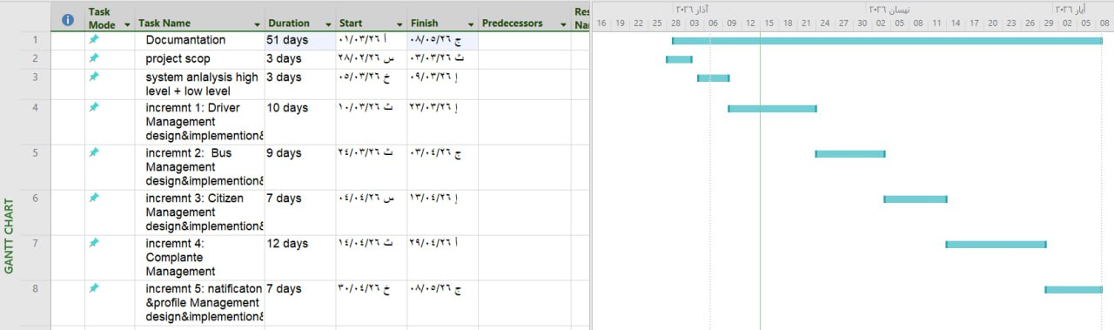

6-Project charter
Project title | Public transport launch center management system
Project start date | 28/5/2026
Project finish date | 15/8/2026
Project manger  Project objectives | Automating and developing transportation and public transit processes in order to manage transport lines and work on organizing the operations conducted at the transport center (garage)
Approach | 1- Define the project scope and objectives.  2- Accurately analyze the system specifications and requirements.  3- Design and analyze the system architecture.  4- Develop the first phase with a focus on access permissions.  5- Test the functions of the first phase and verify its permissions.  6- Second phase: Integrate the system with the state's systems and institutions.  7- Conduct tests on the second phase.  8- Document all phases and their results.

Table 1 project chater

Name | Rule | Responsibilities
Eng.Rania Rajab  Eng .Mohamad Al Balky | supervisor | Highly project management
Mohamad alnasser | Developer | Frontend Development
Mohamad alnasser | Developer | Back end
Mohamad alnasser | Developer | Analyst and tester

7-Roles and Responsibilities
Table 2 responsibilities

8- Risk management

Risk  Title | Risk Description | Raised  Date | Tracking Frequency | State | Impact | Mitigation Plan
Delay in the schedule | Failure to adhere to the schedule due to development complexities or lack of resources. | ٥/٦//٢٠٢٦ | weekly | Active | High | Dividing the project into increments, using tools like a Gantt Chart, with prioritization of tasks.
Conflict in task distribution | Tasks are accumulating on one team member. | ٥/٦//٢٠٢٦ | weekly | Active | Medium | periodic meetings.
Difficulty  Learning new techniques | The team is slow in mastering .NET Docker, which delays delivery. | 10/٦/2026 | weekly | Active | High | Allocating weekly educational sessions.
Problems in interface integration | Conflict between Frontend (React) and Backend (.NET) during development. | 10/٦/2026 | weekly | Active | High | Frequent integration testing, using detailed API documentation, and continuous coordination among team members.
Shortage  Experts  Testing | The appearance of undetected errors due to the absence of a specialized laboratory in the team. | 01/٧/2025 | weekly | Active | High | Applying manual tests (Manual Testing) for each feature and assigning a member to understand the basics of testing.
Table 3 risk management

9- Project Quality Management
To ensure the delivery of a highly reliable software product, the following procedures were adopted:
* Code Review: Periodically reviewing the code to ensure it follows best practices (Clean Code).
* Preliminary Testing: Conducting unit tests for the software logic related to route calculations and bus definitions.
* Acceptance Criteria: Defining precise criteria for each feature before considering it "completed" to ensure it is free of logical errors.

Project Management Tools Used
A set of digital tools was relied upon to organize workflow and document tasks:
* GitHub Projects: to manage programming tasks and distribute them via a Kanban board.
* Google Sheets: to document spreadsheets, technical comparisons, and Gantt charts.

Chapter3 Reference study

Similar applications
"Five leading transportation platforms were selected: three global systems focusing on public transit and navigation, and two regional/global applications focusing on on-demand private ride-hailing."

- Lyft
- Carem
- Moovit
- Transit App
- Citymapper

1.1-Lyft
• A transportation service app that allows users to request private cars to take them from one place to another. It was founded in 2012 in the United States, offering the following features:
1. Individual transportation service that provides private cars to transport individuals from their location to their destination quickly and easily.
2. Shared ride service that allows users to share the ride with other passengers, reducing the cost.
3. Provides larger cars that accommodate more passengers, ideal for families or groups.
4. Luxury car service that offers a premium transportation experience with professional drivers.

1.2-Careem
• Careem was founded in Dubai, United Arab Emirates, by Mudassir Sheikha, Abdullah Elyas, and Tariq Hashmi.
1. Diverse Services: It offers a variety of services, including transportationservices.
2. Transportation Service: It provides private cars for transporting individuals, in addition to options such as Careem GO and Careem XL for groups.
3. Fast Delivery: It offers the Careem NOW service, which allows food to be delivered quickly from restaurants to homes.

1.3-Moovit
1. A global app that provides trip planning.
2. Supports real-time bus tracking.
3. Provides text and audio data for the stations.
4. Relies on artificial intelligence algorithms to reduce waiting time.

1.4-Transit App
1. An app that provides maps and transportation routes
2. Supports real-time notifications for line changes
3. Offers estimated arrival times
4. Used by millions of users in Europe and America

1.5-CityMapper
1. Supports trip planning by integrating more than one mode of transport (bus - microbus - metro)
2. Interactive user interface
3. Comparison of time and cost between transportation options
4. Provides usage reports

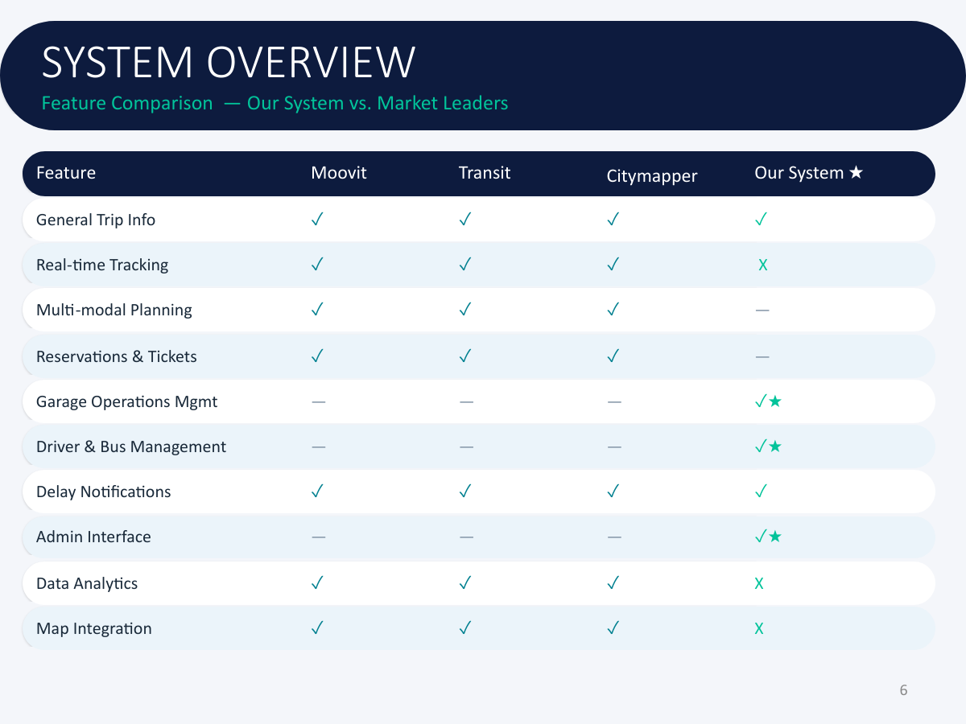
2-Comparison table between systems

3.Modern technologies and frameworks in the field
The field of distributed software system development and intelligent transportation management witnesses significant reliance on frameworks and technical architectures that ensure high efficiency, scalability, and service independence. In this project, the most prominent of these modern technologies were employed:
.NET 8 Environment: The latest framework from Microsoft for building advanced backend services, characterized by high performance, strong security, and full support for building Web APIs.
Microservices Architecture: The modern approach in building large systems by dividing the application into small, independent services that are easy to maintain and develop, instead of traditional monolithic systems.
React Framework: One of the most popular frontend frameworks for developing interactive, responsive user interfaces, relying on reusable components.
Docker Containers Technology: The modern standard environment for packaging software services and ensuring their consistent and stable operation across different operating systems (Windows, Linux), facilitating deployment and instant updates.
Ocelot API Gateway: A modern tool for securing a unified entry point for all user requests, intelligently routing them to the required microservice while handling security and digital verification.
6 Testing and Load Tool: One of the leading modern frameworks in quality engineering, used to simulate intense concurrent requests and test the stability of the software infrastructure under high stress.
4-Theoretical Framework and Reference Studies (Theoretical Framework)
The project relies in its computational and engineering structure on a set of well-established theories and scientific principles in software engineering:
Microservices & API Gateway Architecture: A computational theory that relies on dividing complex systems into completely independent and loosely coupled units, with requests directed to them through a single entry point (Ocelot) to manage routing and security centrally.
Clean Architecture Principles: An engineering theory that relies on the separation of concerns through circular layers, where the core business logic is at the center, completely isolated and independent from databases or external frameworks.
Digital Security Principles (JWT & Cryptography Authentication): Relying on the stateless token protocol based on cryptography to verify user identities and their roles without overloading the server.
Database-per-Service Pattern: A database design theory that ensures data non-interference and independence, where each service has a completely isolated SQL Server database.
5. Modern and Future Directions in the Field (Future Trends in the Field)
This project aligns with modern global trends and can be developed in the future to integrate with the following emerging technologies:
Edge AI & IoT: To process data from bus sensors and track their arrival and departure times instantly on the "edge" without consuming internet packages, which improves the accuracy of trip schedules.
Generative AI & LLMs: Integrating large language models into the "complaints system" to automatically classify citizens' complaints, analyze them, generate smart instant responses, and automatically detect attempts at price manipulation or violations.
MLOps: To build and deploy predictive models that anticipate peak times and passenger congestion at the terminal based on historical trip and seasonal data, and continuously and automatically update these models.

Chapter 4

Analytical study

1-Feasibility study

2-Requirements Elicitation
We carried out the process of deriving the project requirements through the theoretical study of the project, as well as through repeated meetings with the stakeholders (Daraa Garage Manager) and the assistance of our supervisor. The requirements were also derived and collected through the help of studying similar projects.

3-stakeholders
- Bus Drivers :responsible for updating trip ,status , completing routes, and repor ting issues during transit .
- Garage manager :manages drivers , buses , routes ,trips ,and handles
Citizen complaints and and operations .
- Passengers : citizens who book tickets , track trips , view schedules, and submit complaints .

4-functctional requirements

Table 4 function requrment
ID | Titel
FR1 | Garage manger can be add new driver
FR2 | :Garage manger can be update driver
FR3 | :Garage manger can be delete driver
FR4 | : Garage manger can be show driver
FR5 | : Garage manger can be add new vehicle
FR6 | ; Garage manger can be update information vehicle
FR7 | : Garage manger can be delete vehicle
FR8 | : Garage manger can be show vehicle
FR9 | Garage manger can be add new citizen
FR10 | : Garage manger can be update information citizen
FR11 | : Garage manger can be delete citizen
FR12 | : Garage manger can be show citizen
FR13 | : driver and citizen can be send(submit) complaints
FR14 | : driver and citizen can be show complaints
FR15 | Garage manger can be view user complaints
FR16 | : Garage manger can be respond complaints
FR17 | ; Drive can be view trip history
FR18 | : citizen can be view booking history
FR19 | :user can be view profile
FR20 | : user can be edit profile
FR21 | : all actors can be search with filter
;

5-Nonfunctional requirement
Nonfunctional requirement
Security | Authentication using username and password with encryption of user data using a hash algorithm  Implementing permission granting in the authorization system
Performance | The system response time must not exceed 2 seconds when executing basic operations.
Usability | The system interfaces must be simple. The user should be able to complete basic operations (such as booking a trip) easily without training. The system should be usable across different devices (computer, tablet, mobile).
Availability | The system must maintain operational readiness to ensure continuous availability of system services.
Table 5 nonfunctional requirement

6-Prioritization of requirements and the mechanism for their management

ID | Requirement Name | Description | Actor(s) | MoSCoW | Justification
1 | Driver Management | Manage drivers (add, edit, delete, search) | Garage Manager | Must | Core system functionality
2 | Bus Management | Manage buses (add, edit, delete, search) | Garage Manager | Must | Essential for operations
3 | Citizens Management | Manage citizens data | Garage Manager | Must | Required for service delivery
4 | Complaints Management | Handle complaints (send, respond, view) | All Actors | Must | Critical for user interaction
5 | Profile Management | Edit and view user profile | All Actors | Should | Improves user experience
6 | History | View system activity history | All Actors | Should | Useful but not critical
7 | Search & Filter | Search and filter data | All Actors | Could | Enhancement feature
8 | Mobile Application | Mobile version of the system | - | Won’t | Outside the scope of the current project
9 | GPS Integration | Real-time bus tracking | - | Won’t | Needs additional resources
Table 6 MOSCOW

7-system description of features(High level use case diagram)

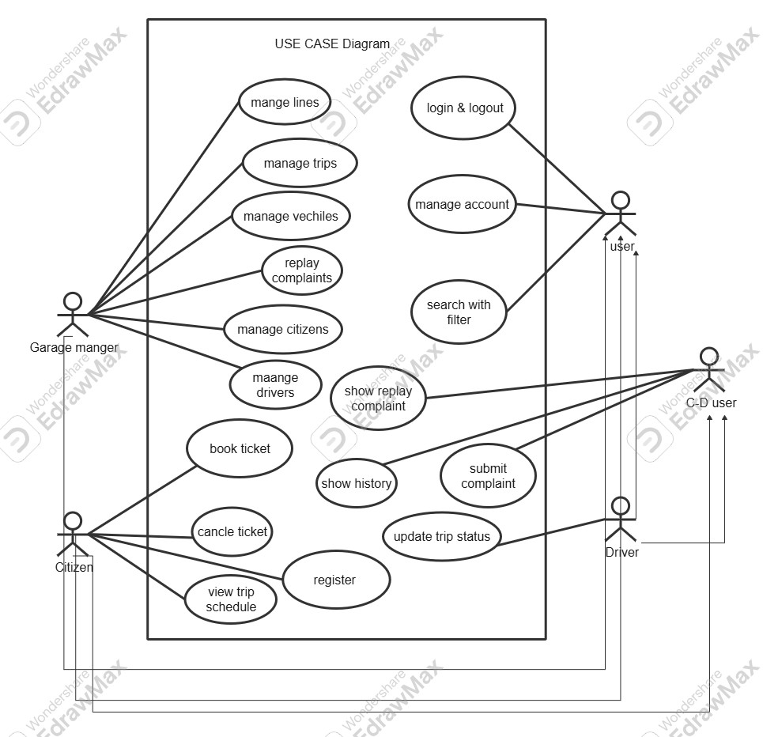

Figure 1 use case high level

7-1-Main Use Case Diagrams
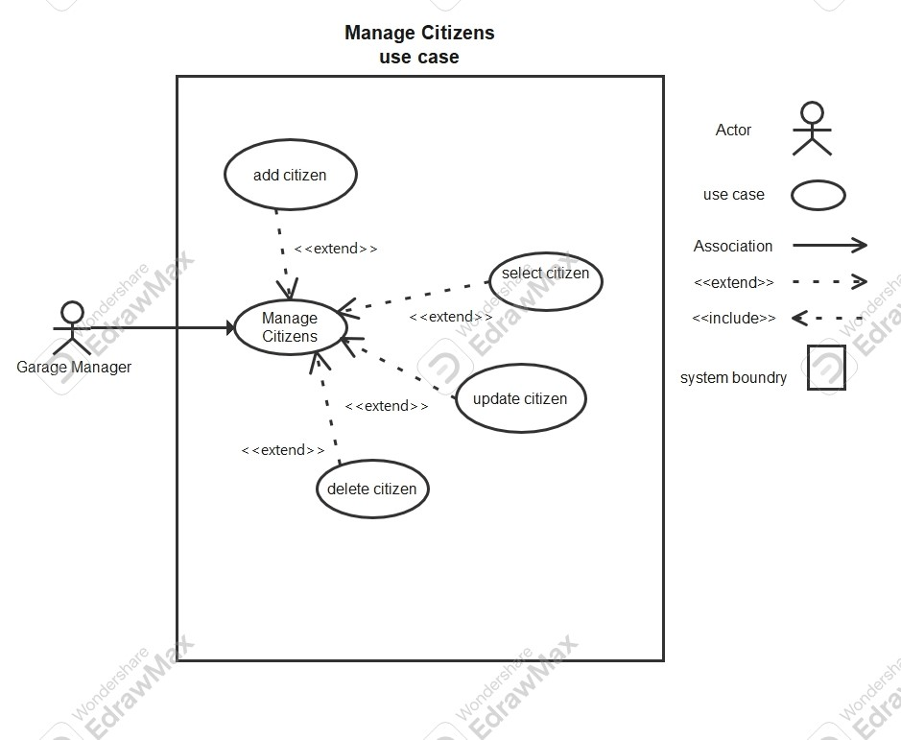
Table 7 use case mange citizens

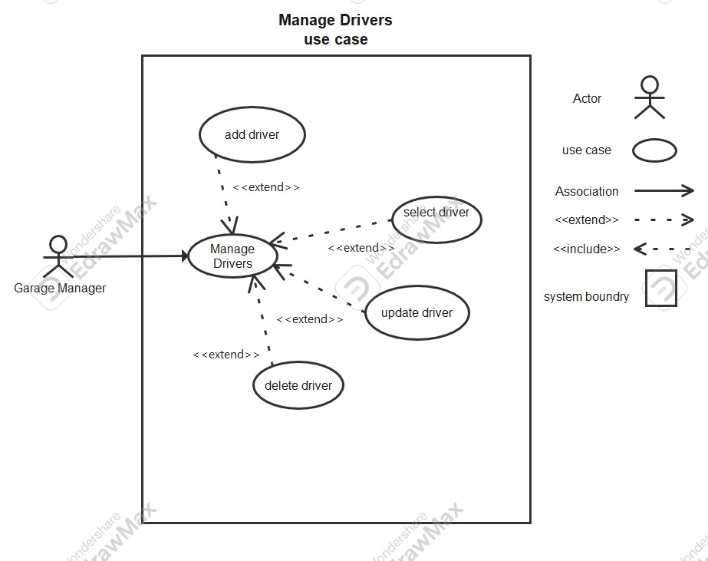
Table 8 use case mange drivers
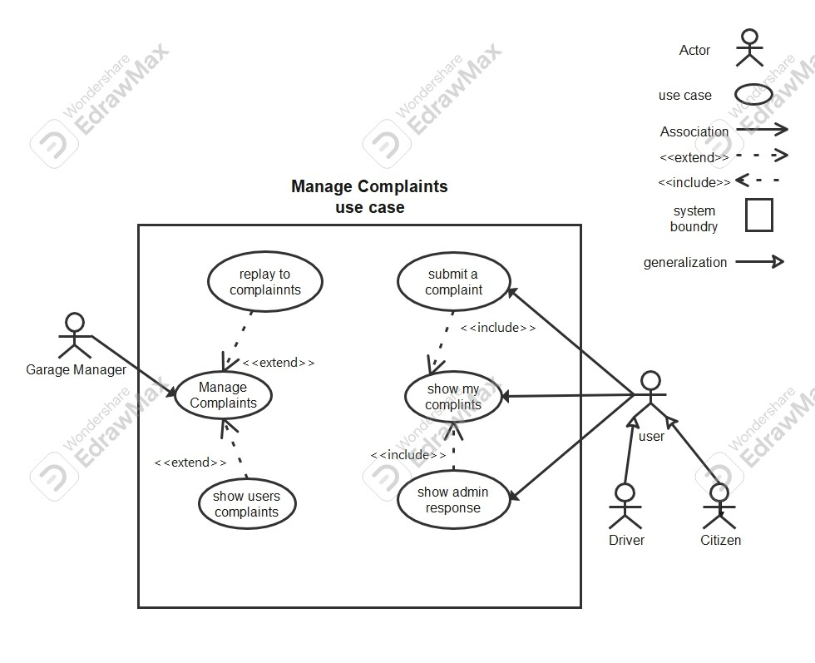
Table 9 use case mange complaints

7-2- use case Descriptions
Table 10 desciption UC-01

Field | Description
Use Case ID | UC-01
Name | Add Driver
Actor(s) | Garage Manager
Preconditions | - User is logged into the system  - Dashboard is loaded- User is on "Manage Drivers" page
Postconditions | - New driver is created and stored in the system  - OR Error message is displayed
Main Flow | 1. User clicks "Manage Drivers"  2. System displays drivers page  3. User clicks "New Driver"  4. System displays driver form  5. User enters required information: - Username, Email, Phone Number - License Number, Issuing Authority - Vehicle Plate, Model, Color - License Expiry, Registration Expiry - License Category - Initial Password  6. User clicks "Create Driver"  7. System validates data  8. System saves driver  9. System displays success message: "Driver created successfully"
Alternative Flow | A1: Cancel Operation  - User clicks "Cancel"- System returns to Manage Drivers page  A2: Validation Error  - Invalid or duplicate data (e.g., email exists)  - System displays error message (e.g., "Email already in use")
Field | Description
Use Case ID | UC-02
Name | Update Driver
Actor(s) | Garage Manager
Preconditions | - User is logged in  - User is on Manage Drivers page  - Driver already exists
Postconditions | - Driver information is updated OR  - No changes are made
Main Flow | 1. User clicks "Edit" on a driver  2. System displays edit form with existing data  3. User modifies driver information: - Username, Phone Number - License details - Vehicle details - Expiry dates - License category  4. User clicks "Update Driver"  5. System asks for confirmation  6. User confirms update  7. System saves changes  8. System displays: "Driver updated successfully"
Alternative Flow | A1: Cancel Update  - User clicks "Cancel"- System discards changes  A2: Validation Error- Invalid data entered  - System shows error message  A3: User Rejects Confirmation  - User cancels confirmation dialog- No update occurs

Table 11 desciption UC-02

Field | Description
Use Case ID | UC-03
Name | Delete Driver
Actor(s) | Garage Manager
Preconditions | - User is logged in  - User is on Manage Drivers page  - Driver exists
Postconditions | - Driver is deleted from the system OR  - Driver remains unchanged
Main Flow | 1. User clicks "Delete" on a driver  2. System displays confirmation message:"Are you sure you want to delete this driver?"  3. User clicks "Delete"  4. System removes driver from database  5. System displays: "Driver deleted successfully"
Alternative Flow | A1: Cancel Delete  - User clicks "Cancel"  - System keeps driver unchanged  A2: Error During Deletion  - System fails to delete driver  - System displays error message
Table 12 descirption UC-03

Field | Description
Use Case ID | UC-04
Name | Show Driver Details
Actor(s) | Garage Manager
Preconditions | - User is logged in  - User is on Manage Drivers page  - Driver exists
Postconditions | - Driver details are displayed
Main Flow | 1. User clicks "Show Details" on a driver  2. System navigates to driver details page  3. System displays full driver information
Alternative Flow | A1: Driver Not Found  - Driver does not exist  - System displays error message
Table 13 descirption UC-04

Field | Description
Use Case ID | UC-05
Name | Add Vehicle
Actor(s) | Garage Manager
Preconditions | - User is logged into the system  - Dashboard is loaded  - User is on "Manage Vehicles" page
Postconditions | - New vehicle is added to the system OR  - Error message is displayed
Main Flow | 1. User navigates to "Manage Vehicles"  2. System displays vehicles page  3. User clicks "New Vehicle"  4. System displays vehicle form  5. User enters vehicle information: - Name - Type - Capacity - Plate Number - Account Status (Active / Inactive)  6. User clicks "Create Vehicle"  7. System validates input  8. System saves vehicle  9. System displays success message: "Vehicle created successfully"
Alternative Flow | A1: Cancel Operation  - User clicks "Cancel"  - System returns to Manage Vehicles page  A2: Validation Error  - Invalid or duplicate data (e.g., plate number exists)  - System displays error message
Table 14 descirption UC-05

Field | Description
Use Case ID | UC-06
Name | Update Vehicle
Actor(s) | Garage Manager
Preconditions | - User is logged in  - User is on Manage Vehicles page  - Vehicle exists
Postconditions | - Vehicle information is updated OR  - No changes are made
Main Flow | 1. User clicks "Edit" on a vehicle  2. System displays edit form with existing data  3. User updates vehicle information: - Name - Type - Capacity - Plate Number - Account Status  4. User clicks "Update Vehicle"  5. System displays confirmation message:"Confirm Update: Are you sure you want to update this vehicle?"  6. User clicks "Update"  7. System saves changes  8. System displays: "Vehicle updated successfully"
Alternative Flow | A1: Cancel Delete  - User clicks "Cancel"  - System keeps vehicle unchanged  A2: Error During Deletion  - System fails to delete vehicle  - System displays error message
Table 15 descirption UC-06

Field | Description
Use Case ID | UC-06
Name | Update Vehicle
Actor(s) | Garage Manager
Preconditions | - User is logged in  - User is on Manage Vehicles page  - Vehicle exists
Postconditions | - Vehicle information is updated OR  - No changes are made
Main Flow | 1. User clicks "Edit" on a vehicle  2. System displays edit form with existing data  3. User updates vehicle information: - Name - Type - Capacity - Plate Number - Account Status  4. User clicks "Update Vehicle"  5. System displays confirmation message:"Confirm Update: Are you sure you want to update this vehicle?"  6. User clicks "Update"  7. System saves changes  8. System displays: "Vehicle updated successfully"
Alternative Flow | A1: Cancel Delete  - User clicks "Cancel"  - System keeps vehicle unchanged  A2: Error During Deletion  - System fails to delete vehicle  - System displays error message
Table 16 uc-06

Field | Description
Use Case ID | UC-07
Name | Delete Vehicle
Actor(s) | Garage Manager
Preconditions | - User is logged in  - User is on Manage Vehicles page  - Vehicle exists
Postconditions | - Vehicle is deleted from the system OR  - Vehicle remains unchanged
Main Flow | 1. User clicks "Delete" on a vehicle  2. System displays confirmation message:"Confirm Delete: Are you sure you want to delete this vehicle?"  3. User clicks "Delete"  4. System removes vehicle from database  5. System displays: "Vehicle deleted successfully"
Alternative Flow | A1: Cancel Delete  - User clicks "Cancel"  - System keeps vehicle unchanged  A2: Error During Deletion  - System fails to delete vehicle  - System displays error message
Table 17 uc-07

Field | Description
Use Case ID | UC-08
Name | Show Vehicle Details
Actor(s) | Garage Manager
Preconditions | - User is logged in  - User is on Manage Vehicles page  - Vehicle exists
Postconditions | - Vehicle details are displayed
Main Flow | 1. User clicks "Show Details" on a vehicle  2. System navigates to vehicle details page  3. System displays full vehicle information
Alternative Flow | A1: Vehicle Not Found  - Vehicle does not exist  - System displays error message
Table 18 uc-08

Field | Description
Use Case ID | UC-09
Name | Add Citizen
Actor(s) | Garage Manager
Preconditions | - User is logged into the system  - Dashboard is loaded  - User is on "Manage Users (Citizens)" page
Postconditions | - New citizen is created and stored in the system OR  - Error message is displayed
Main Flow | 1. User clicks "Manage Users"  2. System displays citizens page  3. User clicks "New Citizen"  4. System displays citizen form  5. User enters required information: - Username, Email, Password, Phone - Account Status (Active / Pending / Suspended) - First Name, Last Name - National ID - Disability Status (None / Deaf / Blind / Wheelchair) - Gender, Date of Birth - City, Region, Current Address - Father Name, Mother Name - Birth Place - Card Number, Card Issue Date - Face Color, Eye Color  6. User clicks "Create Citizen"  7. System validates input  8. System saves citizen data  9. System displays: "Citizen created successfully"
Alternative Flow | A1: Cancel Operation  - User clicks "Cancel"- System returns to citizens page  A2: Validation Error  - Invalid or duplicate data (e.g., email or national ID exists)- System displays error message
Table 19 uc-09

Field | Description
Use Case ID | UC-10
Name | Update Citizen
Actor(s) | Garage Manager
Preconditions | - User is logged in  - User is on Manage Users page  - Citizen exists
Postconditions | - Citizen information is updated OR  - No changes are made
Main Flow | 1. User clicks "Edit" on a citizen  2. System displays edit form with existing data  3. User updates citizen information  4. User clicks "Update Citizen"  5. System displays confirmation message:"Confirm Update: Are you sure you want to update this citizen?"  6. User clicks "Update"  7. System saves changes  8. System displays: "Citizen updated successfully"
Alternative Flow | A1: Cancel Update  - User clicks "Cancel"- System discards changes  A2: Validation Error  - Invalid data entered- System displays error message  A3: Cancel Confirmation  - User cancels confirmation dialog- No update occurs
Table 20 uc-10

Field | Description
Use Case ID | UC-11
Name | Delete Citizen
Actor(s) | Garage Manager
Preconditions | - User is logged in  - User is on Manage Users page  - Citizen exists
Postconditions | - Citizen is deleted from the system OR  - Citizen remains unchanged
Main Flow | 1. User clicks "Delete" on a citizen  2. System displays confirmation message:"Confirm Delete: Are you sure you want to delete this citizen?"  3. User clicks "Delete"  4. System removes citizen from database  5. System displays: "Citizen deleted successfully"
Alternative Flow | A1: Cancel Delete  - User clicks "Cancel"  - System keeps citizen unchanged  A2: Error During Deletion  - System fails to delete citizen  - System displays error message
Table 21 uc-11

Field | Description
Use Case ID | UC-12
Name | Show Citizen Details
Actor(s) | Garage Manager
Preconditions | - User is logged in  - User is on Manage Users page  - Citizen exists
Postconditions | - Citizen details are displayed
Main Flow | 1. User clicks "Show Details" on a citizen  2. System navigates to citizen details page  3. System displays full citizen information
Alternative Flow | A1: Citizen Not Found  - Citizen does not exist  - System displays error message
Table 22 uc-12

Field | Description
Use Case ID | UC-13
Name | Submit Complaint
Actor(s) | Citizen, Driver
Preconditions | - User is logged into the system  - Dashboard is loaded
Postconditions | - Complaint is stored in the system with status "Pending"
Main Flow | 1. User clicks "Complaints" from dashboard  2. System displays complaint form  3. User enters: - Subject - Description  4. User clicks "Submit Complaint"  5. System validates input  6. System saves complaint with status "Pending"  7. System displays message: "Complaint submitted successfully"  8. System displays the complaint under "My Complaints"
Alternative Flow | A1: Cancel Operation  - User leaves the page or cancels- No complaint is submitted  A2: Validation Error  - Missing required fields- System displays error message
Table 23 uc-13

Field | Description
Use Case ID | UC-14
Name | View My Complaints
Actor(s) | Citizen, Driver
Preconditions | - User is logged in
Postconditions | - User sees list of their complaints and responses
Main Flow | 1. User navigates to "Complaints" page  2. System displays user's complaints list  3. Each complaint includes: - Subject - Description - Created Date - Status (Pending / In Review / Resolved / Rejected) - Admin Response (if available)  4. If no response exists, system shows: "No admin response yet"
Alternative Flow | A1: No Complaints Found  - System displays empty state message (e.g., "No complaints submitted yet")
Table 24 uc-14

Field | Description
Use Case ID | UC-15
Name | View Users Complaints
Actor(s) | Garage Manager
Preconditions | - Garage Manager is logged in  - Dashboard is loaded
Postconditions | - Complaints list is displayed
Main Flow | 1. Garage Manager clicks "Complaints"  2. System navigates to complaints page  3. System displays all users complaints  4. Each complaint shows: - Subject - Description - Status (e.g., Pending) - Submitted By (Citizen/Driver) - Date and Time
Alternative Flow | A1: No Complaints Available  - System displays message: "No complaints found"
Table 25 uc-15

Field | Description
Use Case ID | UC-16
Name | Reply to Complaint
Actor(s) | Garage Manager
Preconditions | - Garage Manager is logged in  - Complaints list is displayed  - Complaint exists
Postconditions | - Complaint status is updated  - Admin response is saved and visible to user
Main Flow | 1. Manager selects a complaint  2. Manager clicks "Response"  3. System displays response form with: - Subject (read-only) - Status (In Review / Resolved / Rejected) - Admin Response - Description  4. Manager enters response details  5. Manager clicks "Send Response"  6. System validates input  7. System saves response and updates status  8. System displays confirmation message  9. Response becomes visible in user's "My Complaints"
Alternative Flow | A1: Cancel Response  - Manager clicks "Cancel"  - No response is saved  A2: Validation Error  - Missing or invalid input  - System displays error message
Table 26 uc-16

Field | Description
Use Case ID | UC-17
Name | View Trip History
Actor(s) | Driver
Preconditions | - Driver is logged into the system  - Dashboard is loaded
Postconditions | - Driver can view active trips and trip history
Main Flow | 1. Driver clicks "My Trips" from dashboard  2. System displays trips page  3. System shows Active Trips including: - Trip capacity (e.g., 20 seats) - Status (Scheduled) - Departure date and time - Seats booked (e.g., 20/20)  4. Driver clicks "Show History"  5. System displays Trip History (Last 7 Days)  6. System shows finished trips with: - Trip capacity - Status (Finished) - Departure date and time - Seats information  7. Driver can click "Hide History" to return to active trips view
Alternative Flow | A1: No Trips Available  - System displays message: "No trips available"  A2: No History Found  - System displays: "No trip history available"
Table 27 uc-17

Field | Description
Use Case ID | UC-18
Name | View Booking History
Actor(s) | Citizen
Preconditions | - Citizen is logged into the system  - Dashboard is loaded
Postconditions | - Citizen can view active bookings and booking history
Main Flow | 1. Citizen clicks "My Bookings"  2. System displays bookings page  3. System shows Active Bookings including: - Full Name - Booking Date - Departure Date - Number of Seats - Booking Code  4. Citizen clicks "History" button  5. System displays booking history (finished trips)  6. Each record shows: - Full Name - Booking Date - Departure Date - Seats - Status (Confirmed, Finished)
Alternative Flow | A1: No Bookings Found  - System displays message: "No bookings available"  A2: No History Available  - System displays message: "No booking history found"
Table 28 uc-18

Use Case ID | UC-19
Name | View Profile
Actor(s) | Citizen, Driver, Garage Manager
Preconditions | - User is logged into the system  - Dashboard is loaded
Postconditions | - User profile information is displayed
Main Flow | 1. User clicks "My Profile"  2. System navigates to profile page  3. System displays user information based on role:  Citizen: - Full Name, Email, Phone Number - Disability Status, Address  Driver: - Full Name, Email, Phone Number - License Info (Number, Category, Authority, Expiry) - Vehicle Info (Plate, Model, Color, Registration Expiry)  Garage Manager (Admin): - Full Name, Email, Role, Phone - First Name, Last Name, Gender - Date of Birth, National ID - City, Region, Account Status - Admin Level, Created Date, Last Updated
Alternative Flow | A1: Profile Not Found  - System displays error message
Table 29 uc-19

Field | Description
Use Case ID | UC-20
Name | Update Profile
Actor(s) | Citizen, Driver, Garage Manager
Preconditions | - User is logged in  - Profile page is displayed
Postconditions | - Profile is updated OR  - No changes are made
Main Flow | 1. User clicks "Edit Profile"  2. System enables editable fields based on role:  Citizen can edit: - Full Name - Phone Number - Password (optional) - Disability Status - Address -Cannot edit Email  Driver can edit: - Full Name - Phone Number - Password (optional) - Cannot edit Email - Cannot edit License Info - Cannot edit Vehicle Info  Garage Manager can edit: - Full Name, Phone - First Name, Last Name - Gender, Date of Birth - City, Region - Cannot edit Email - Cannot edit Role / Admin Level  3. User modifies allowed fields  4. User clicks "Save"  5. System validates input  6. System updates profile data  7. System displays: "Profile updated successfully"
Alternative Flow | A1: Cancel Update  - User clicks "Cancel"- System discards changes  A2: Validation Error  - Invalid input data- System displays error message
Table 30 uc-20

Field | Description
Use Case ID | UC-21
Name | Search with Filters
Actor(s) | User (Driver, Citizen, Garage Manager)
Preconditions | - User is logged into the system  - User is on a page that supports search functionality
Postconditions | - Filtered results are displayed based on user criteria
Main Flow | 1. User navigates to a system page (e.g., drivers, trips, bookings)  2. System displays data list with search/filter fields  3. User enters one or more search criteria (e.g., name, ID, date, etc.)  4. User triggers search (typing or clicking search button)  5. System validates input  6. System filters data according to entered criteria  7. System displays matching results
Alternative Flow | A1: No Results Found  - System displays message: "No results found"  A2: Empty Input  - System displays full data list  A3: Invalid Input  - System displays validation error message
Table 31 uc-21

7-3-Activity Diagrams
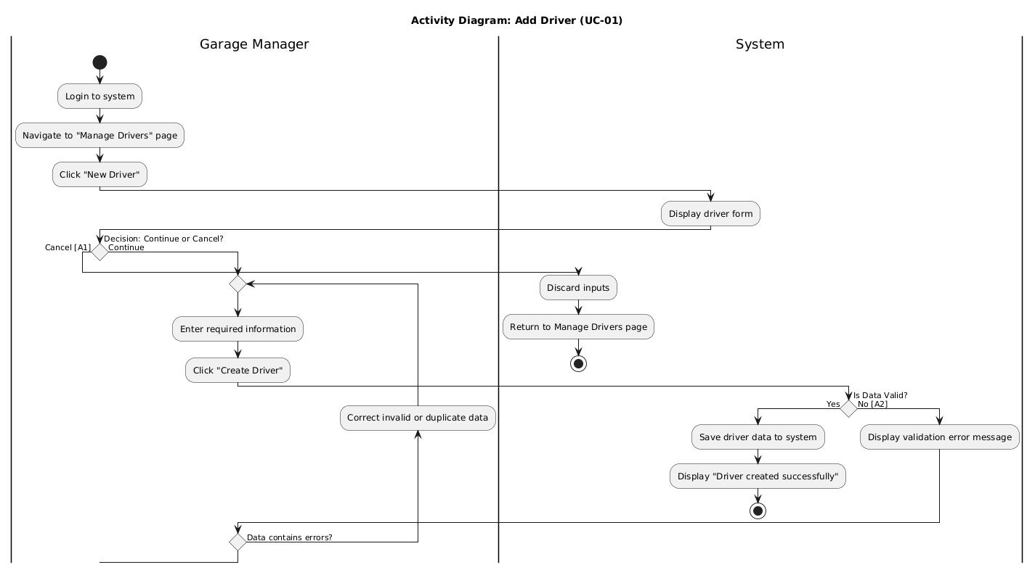
Figure 10 activity UC-1
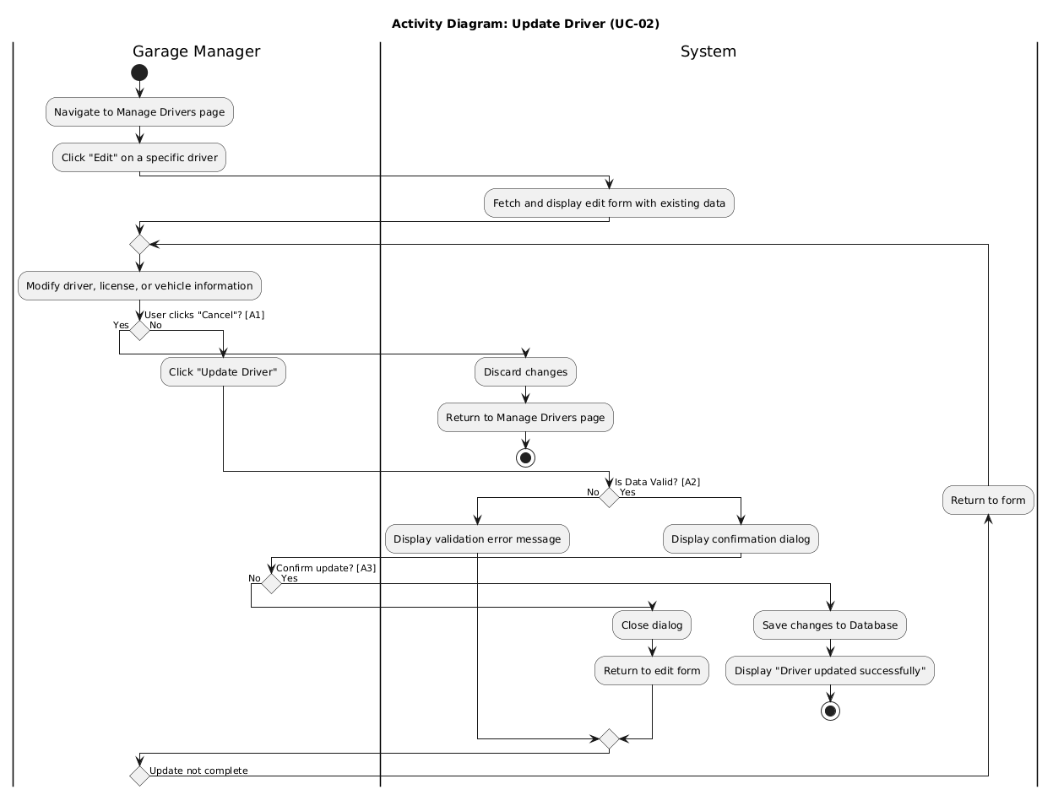
Figure 11 activity UC 2

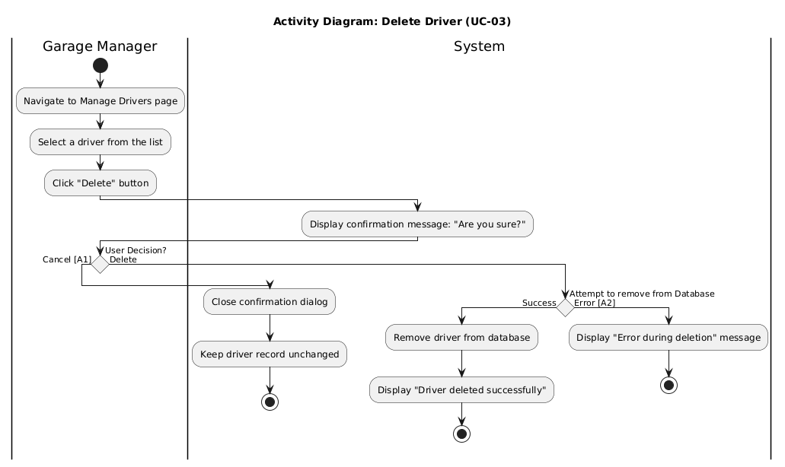
Figure 12activity UC-03
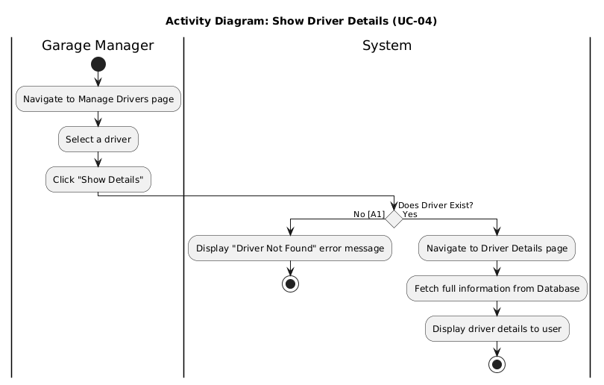
Figure 13 activity UC-4
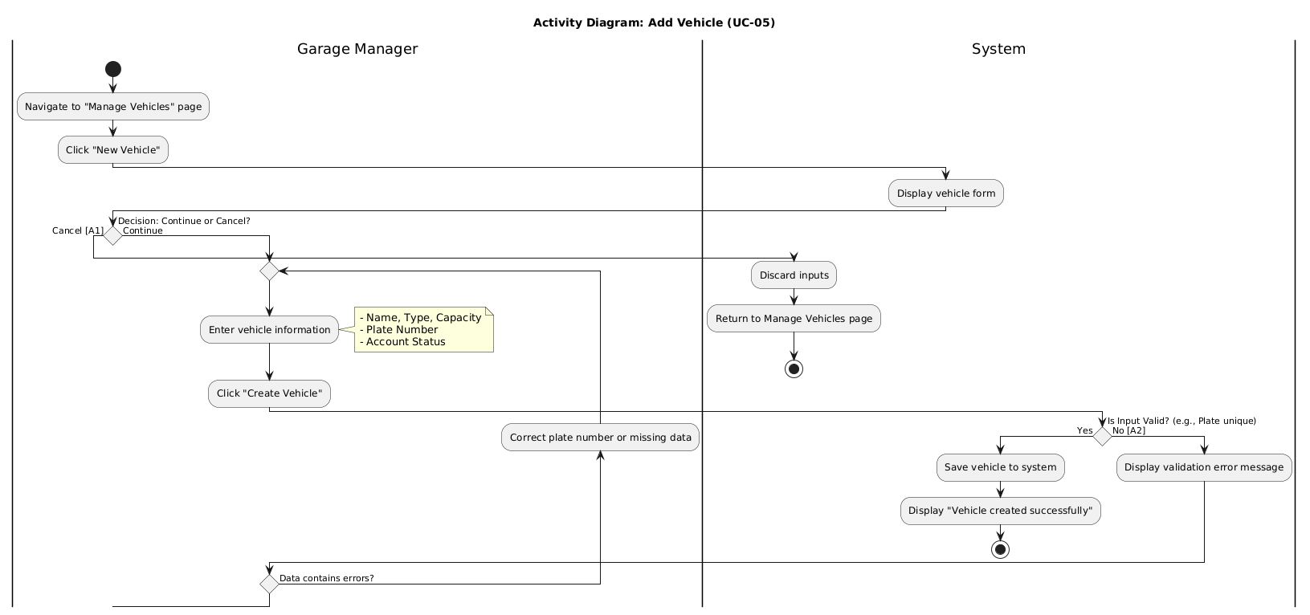Figure 14 activity UC-05

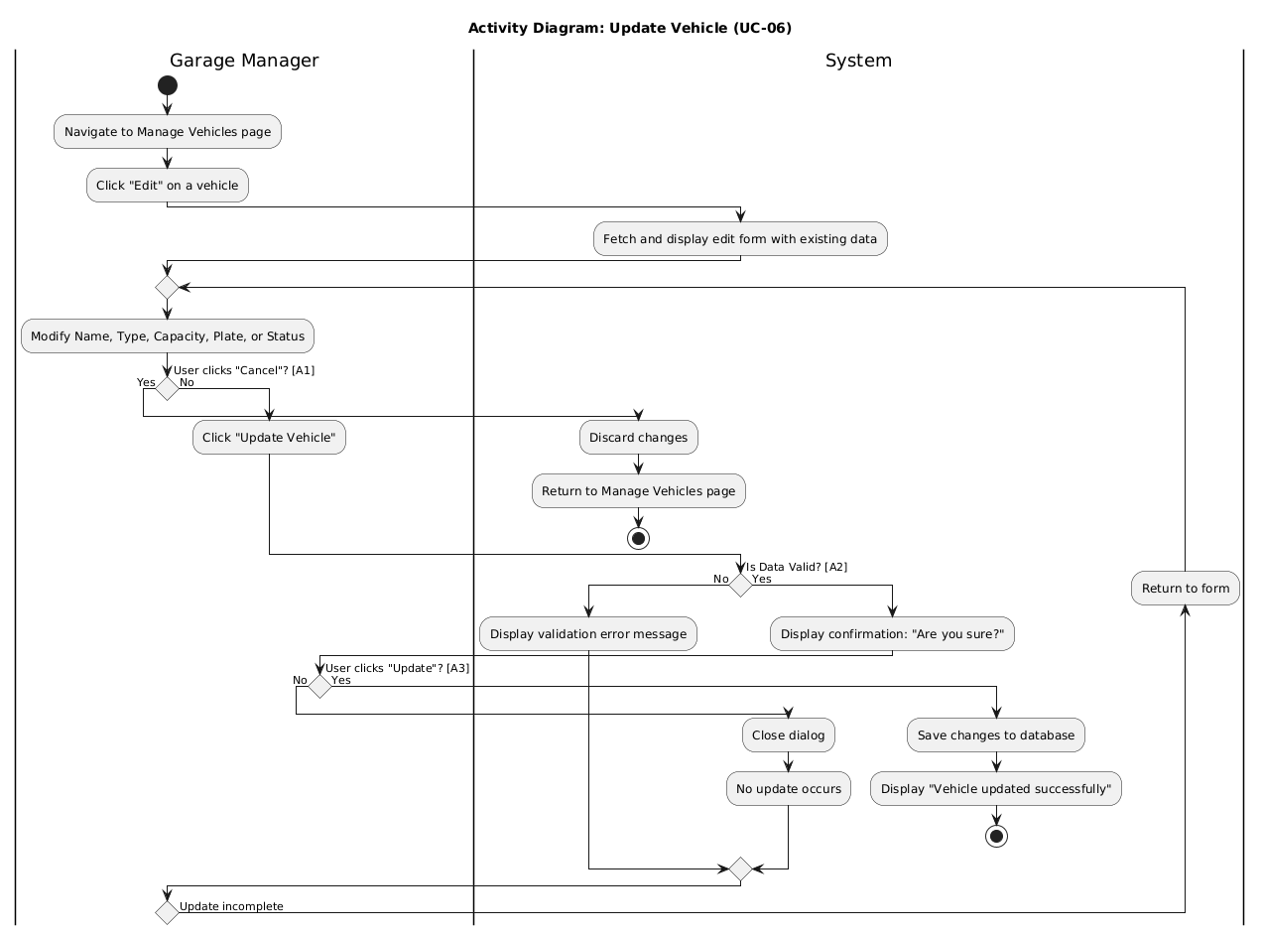
Figure 15 activity UC-06
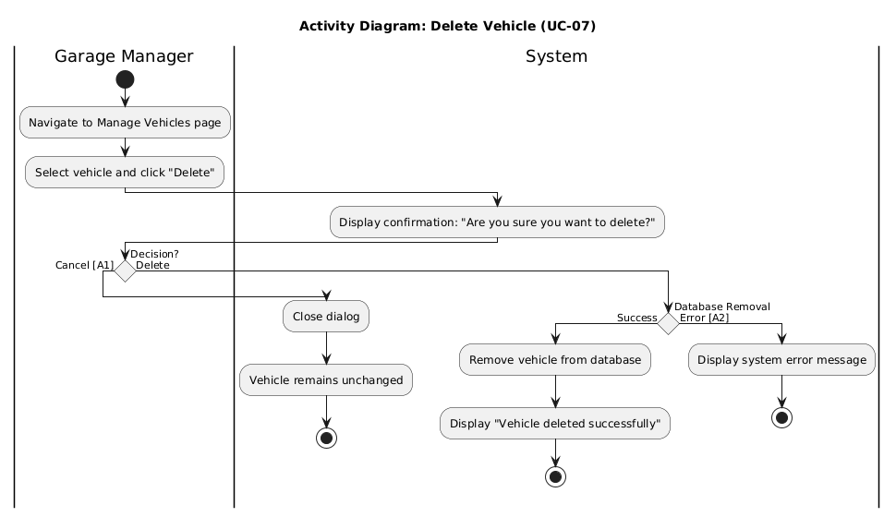
Figure 16 activity UC=7
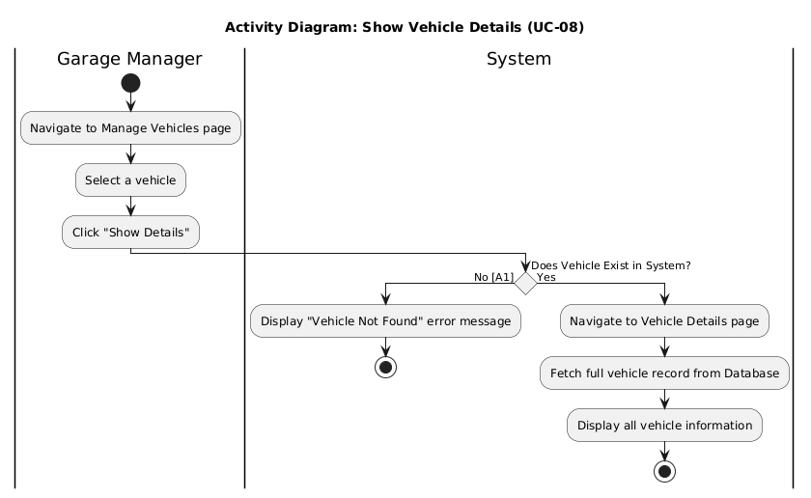
Figure 17 activity UC-08
Figure 18 activity UC-09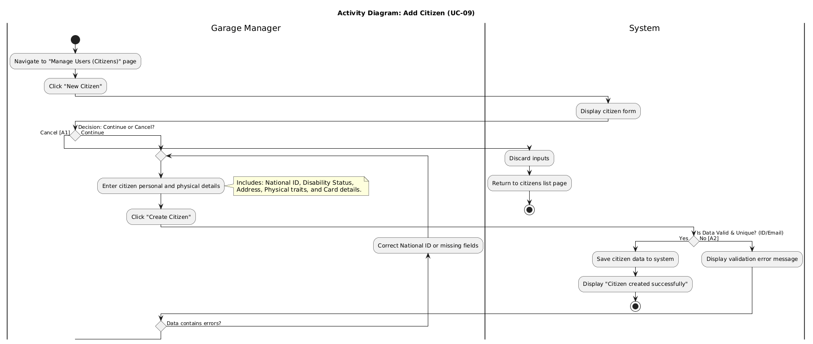
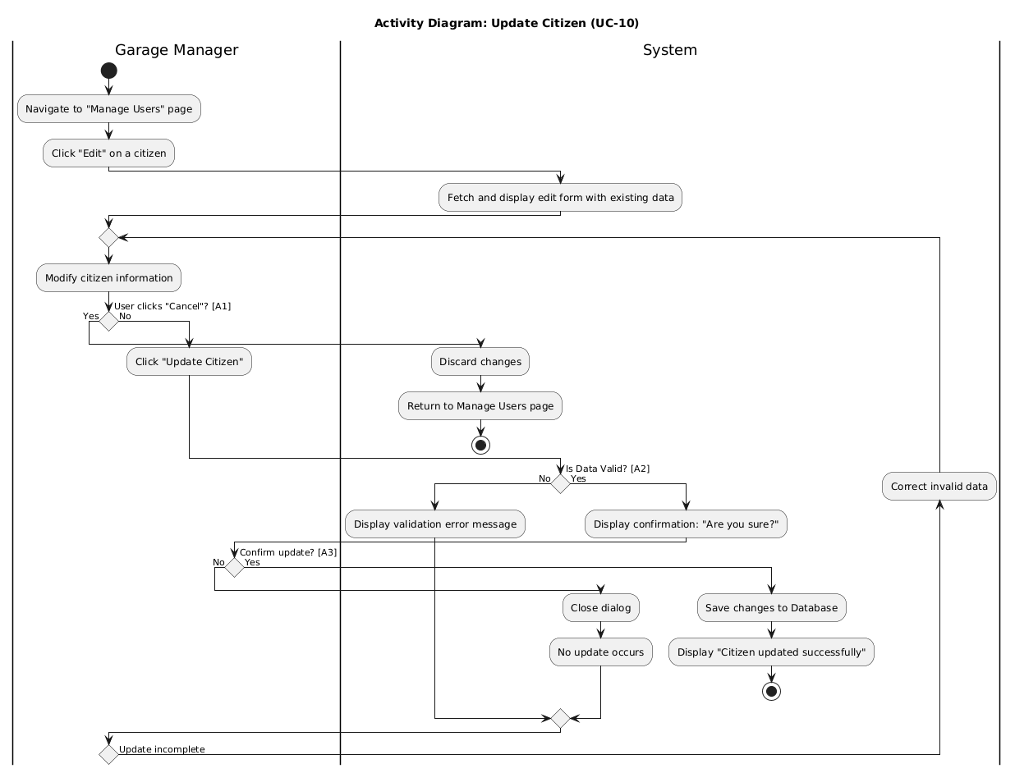
Figure 19 activity UC-10

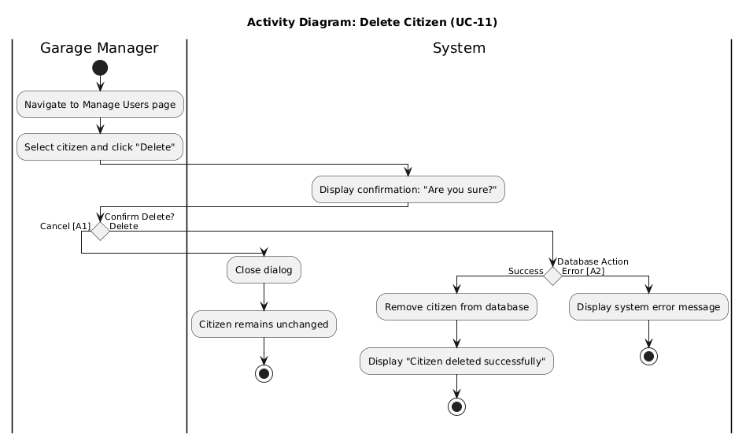
Figure 20 activity UC-11
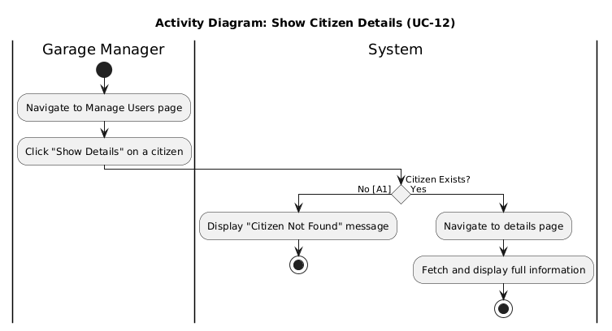
Figure 21 activity UC-12
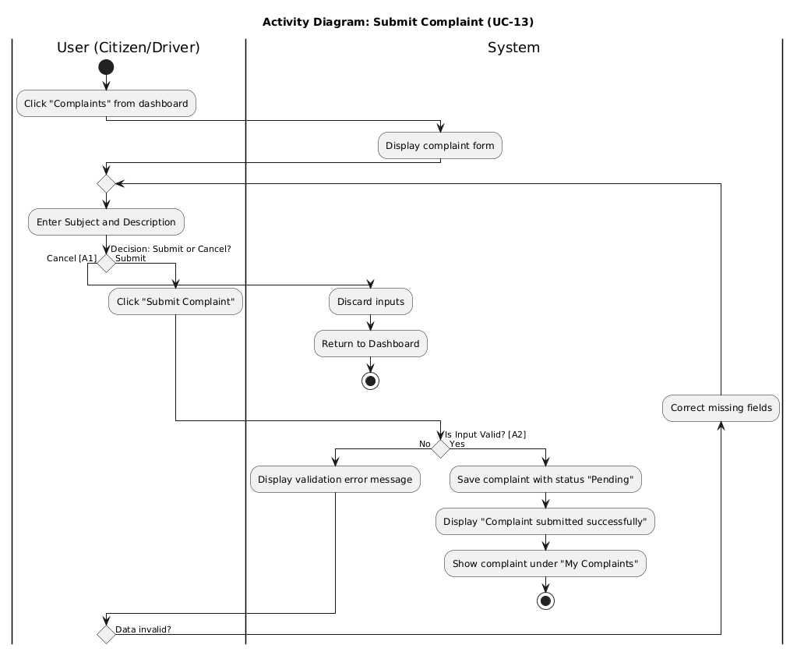
Figure 22 activity UC-13
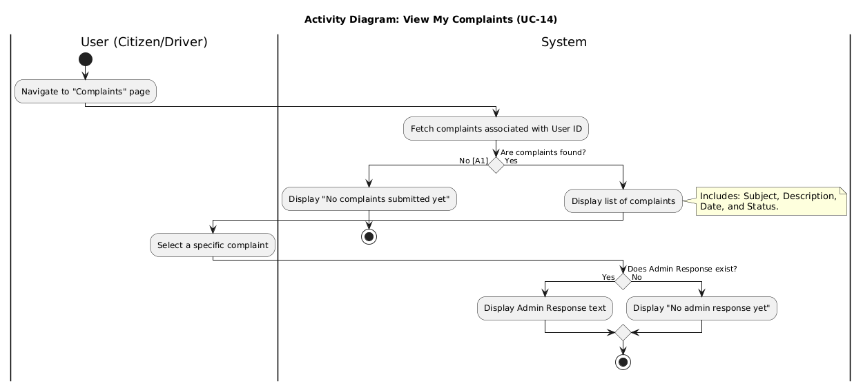
Figure 23 activity UC-14
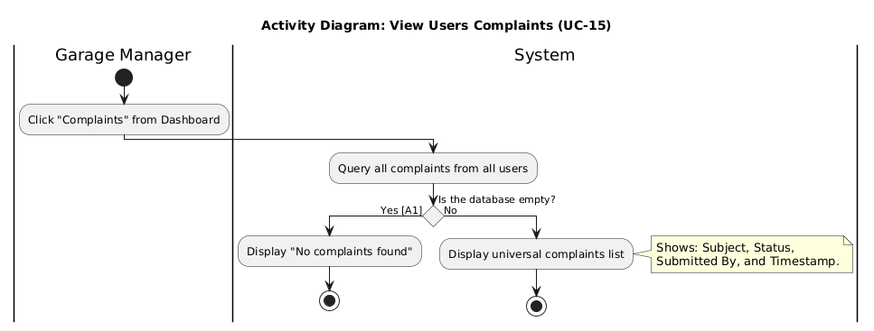
Figure 24 activity UC-15
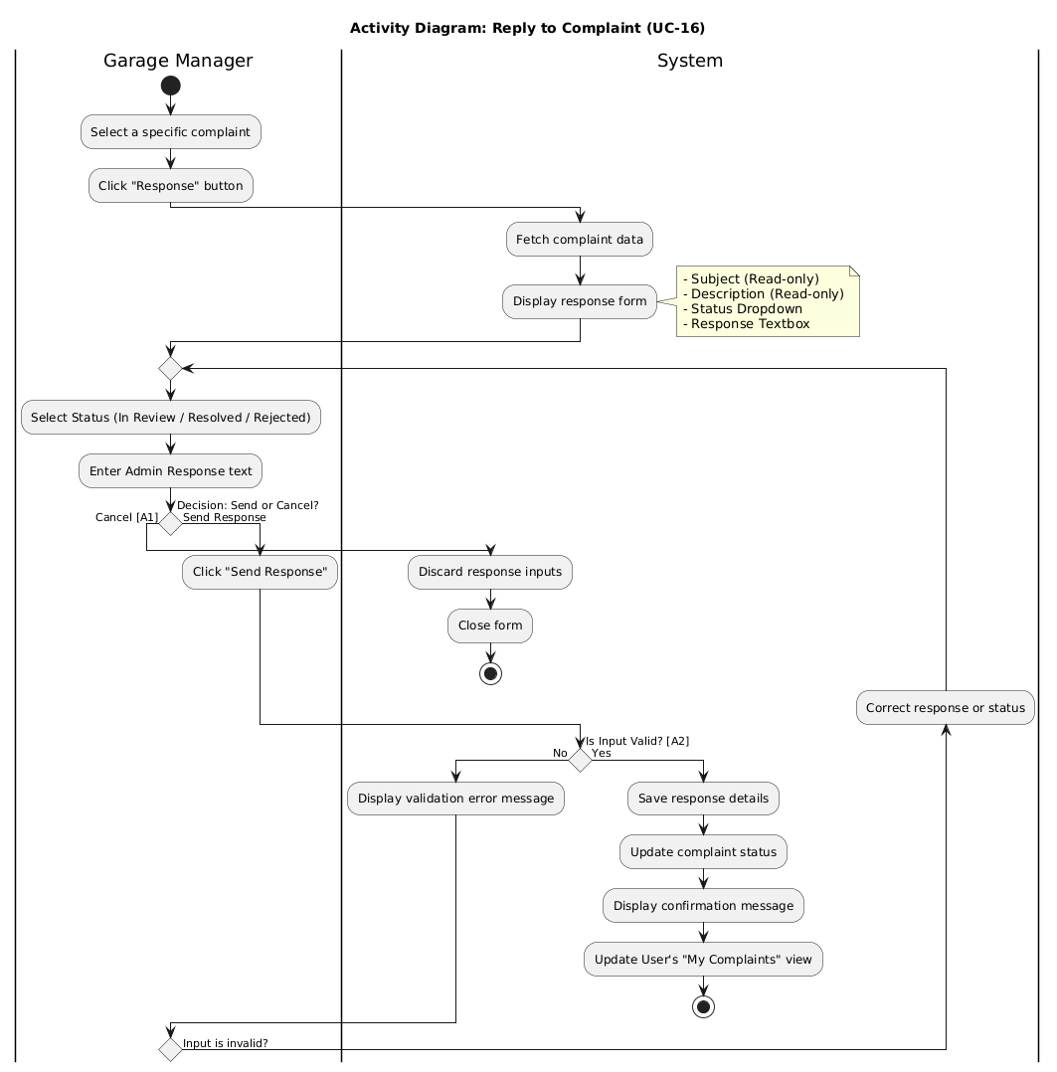
Figure 25 activity UC-16
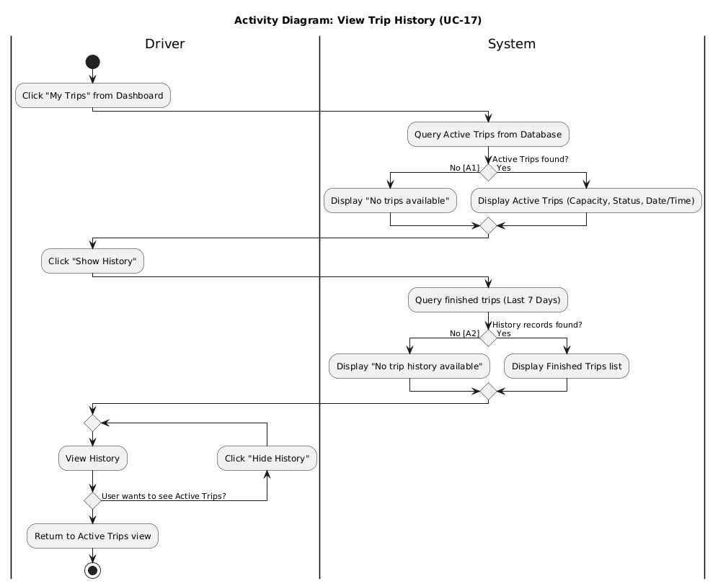
Figure 26 activity UC-17
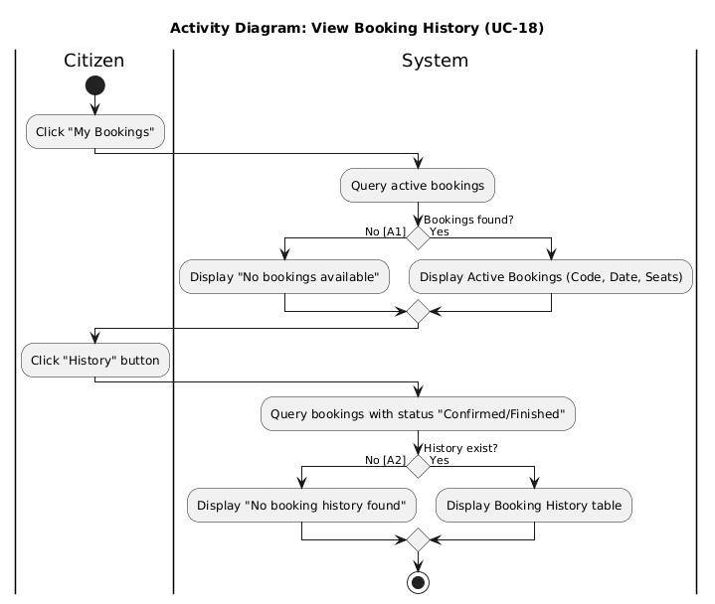Figure 27 activity UC-18
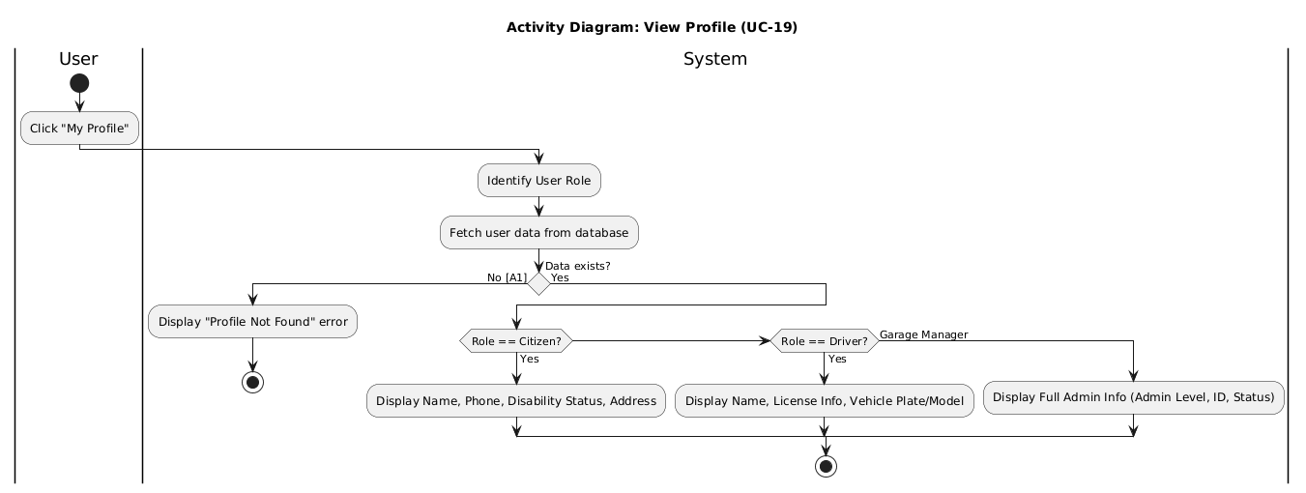
Figure 28 activity UC -19
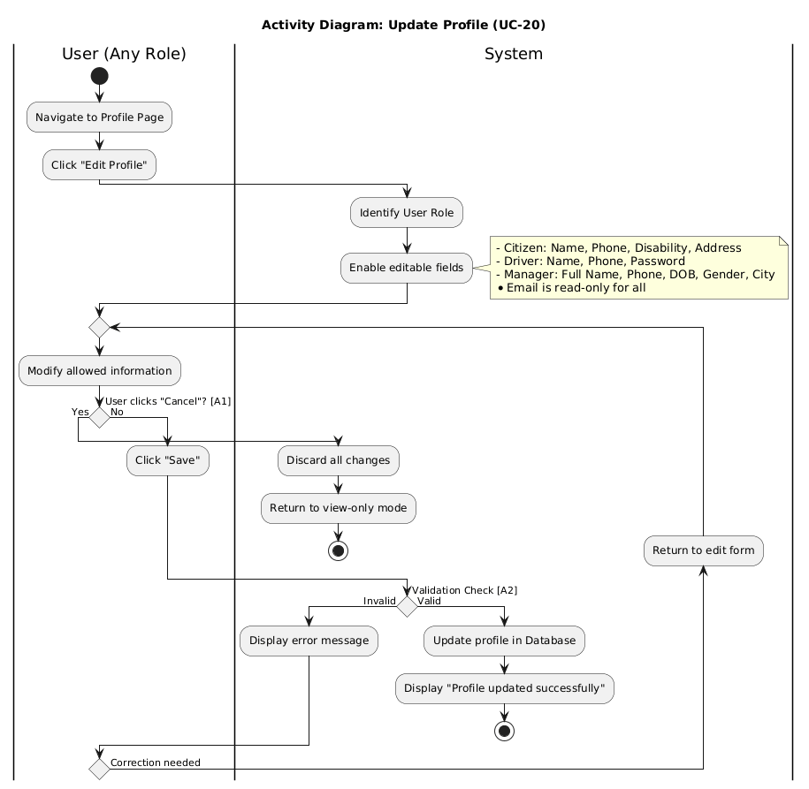
Figure 29 activity UC-20
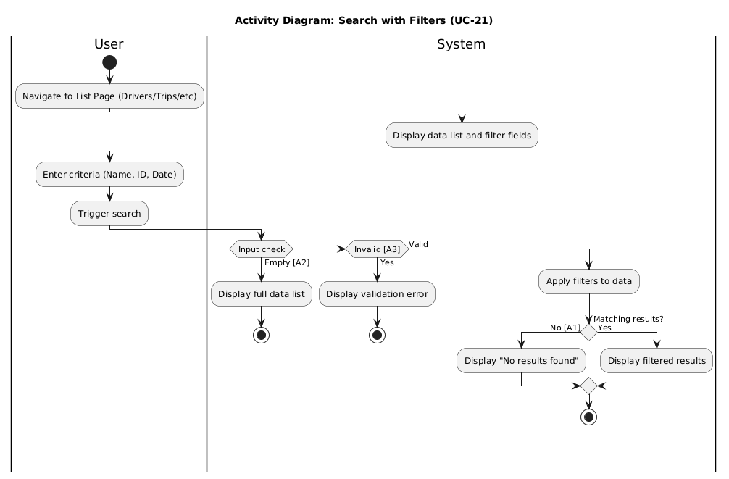
Figure 30 activity UC-21

7-4-Sequence Diagrams
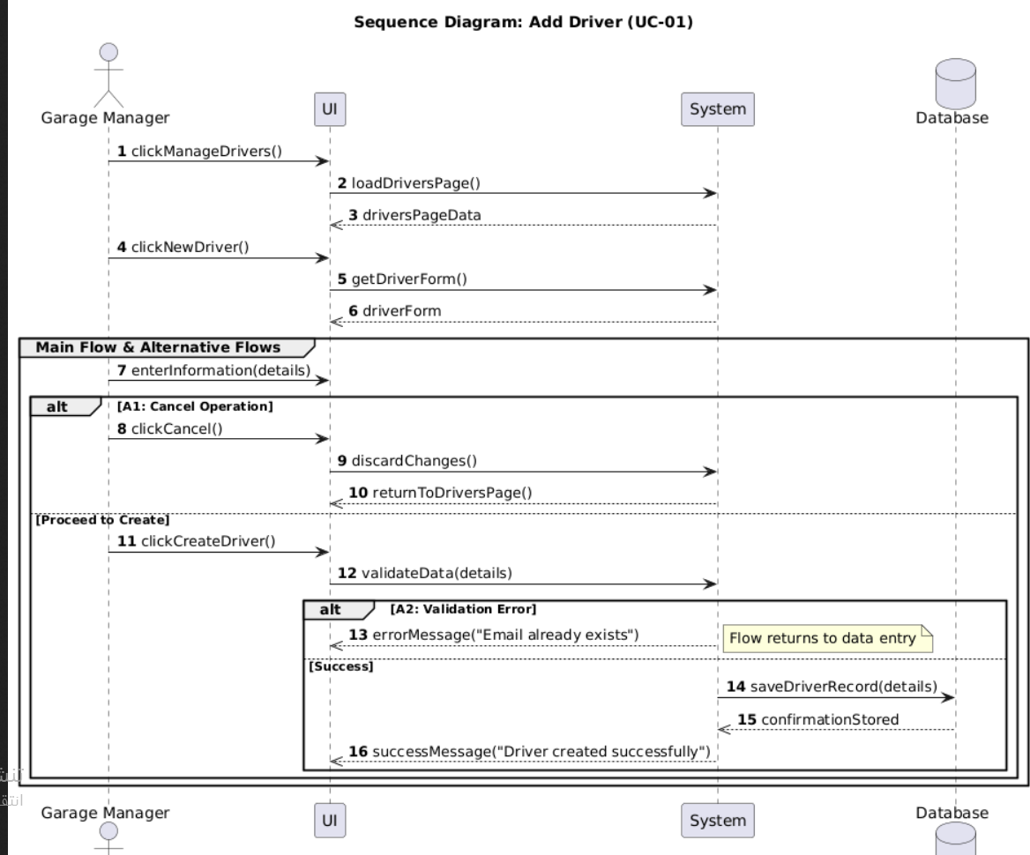
Figure 31 sequence UC-1
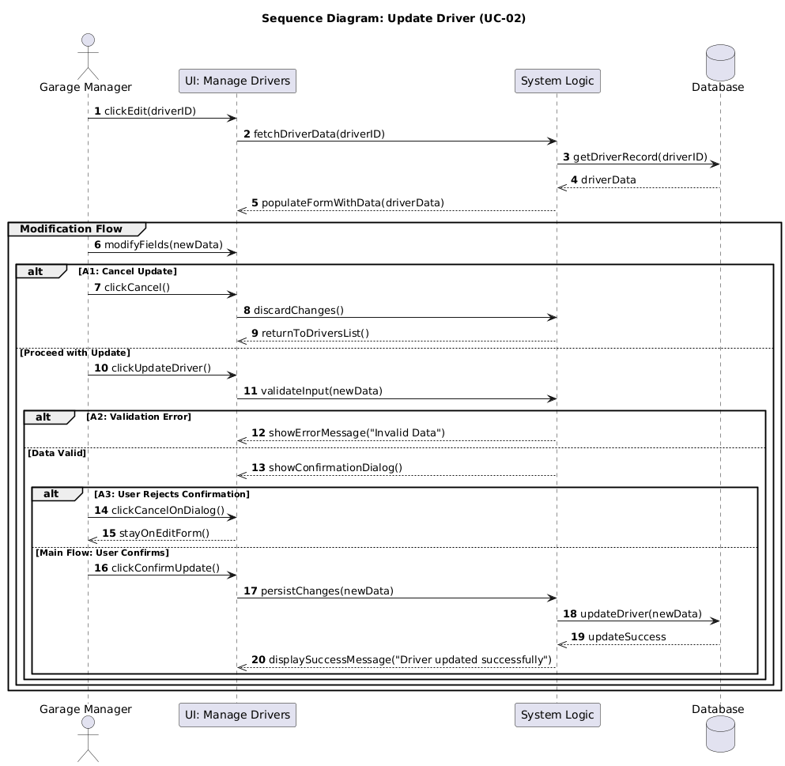
Figure 32 sequence UC-02
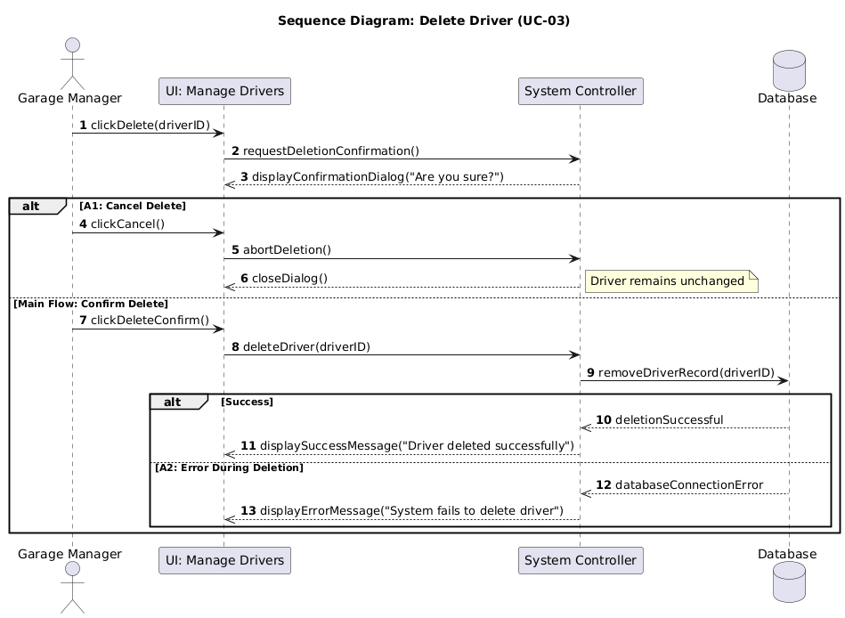
Figure 33 sequence UC-3
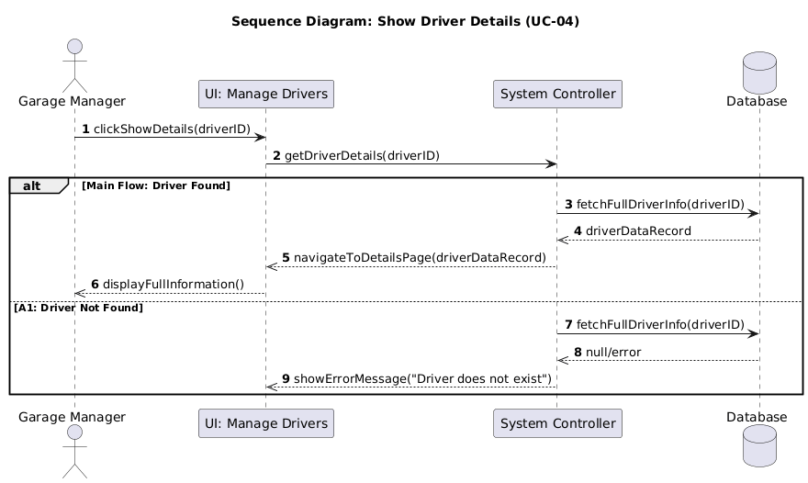
Figure 34 sequnce UC-04
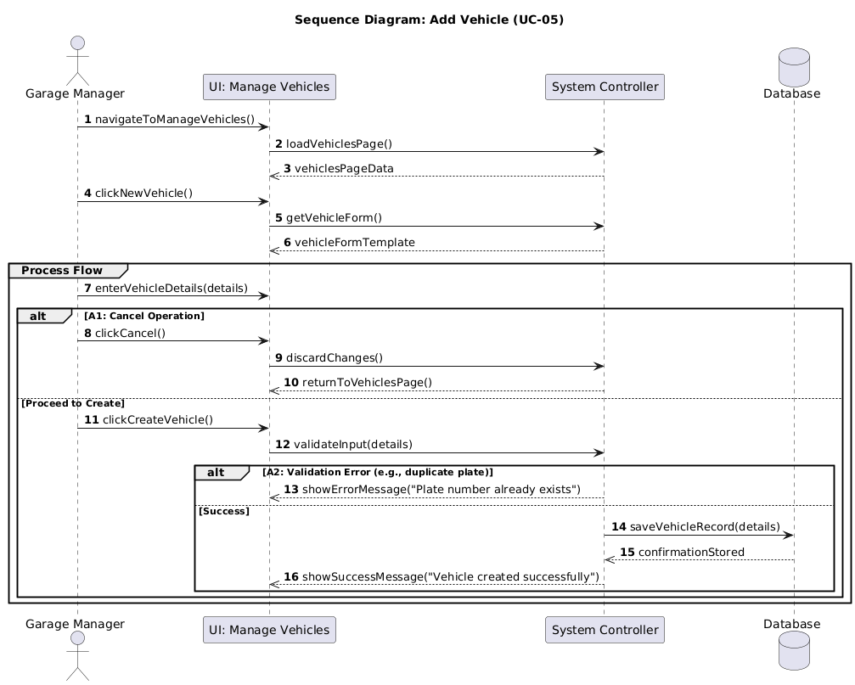
Figure 35 sequence UC-05
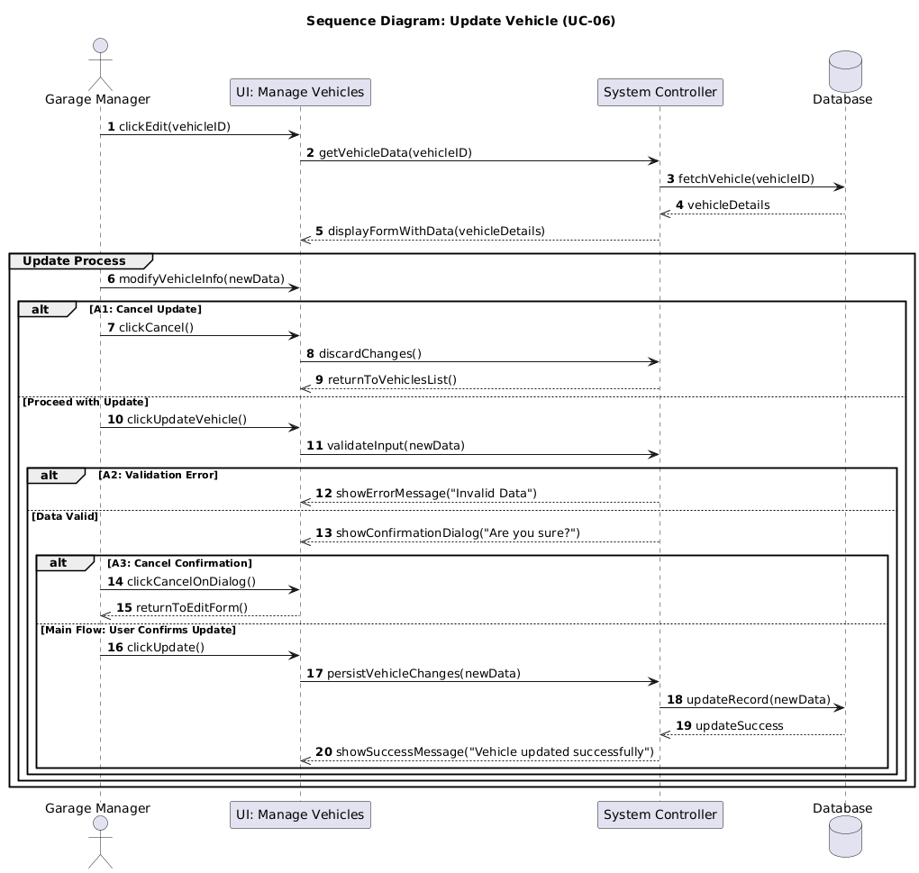
Figure 36 sequence UC-6
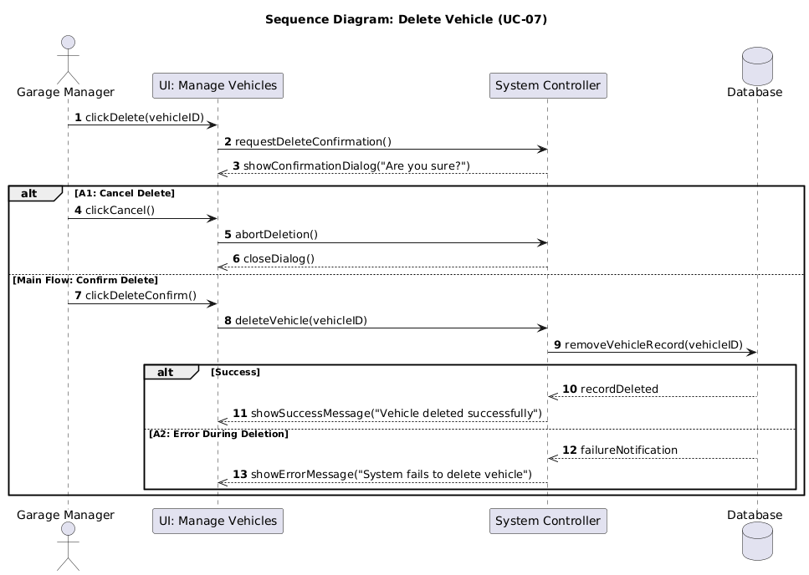
Figure 37 sequence UC-07
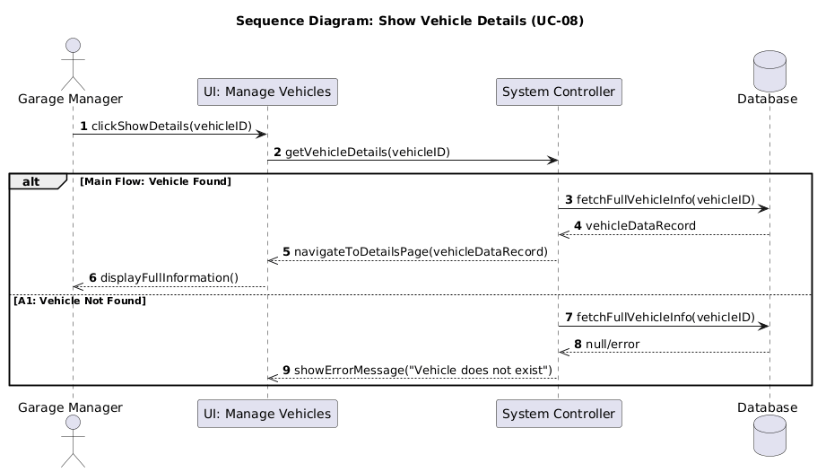
Figure 38 sequence UC-08
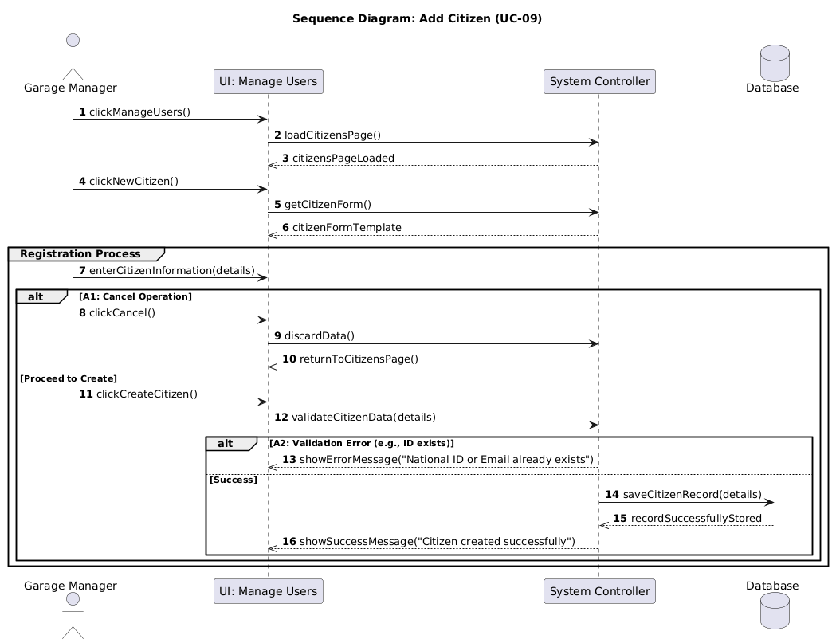
Figure 39 sequence UC-9
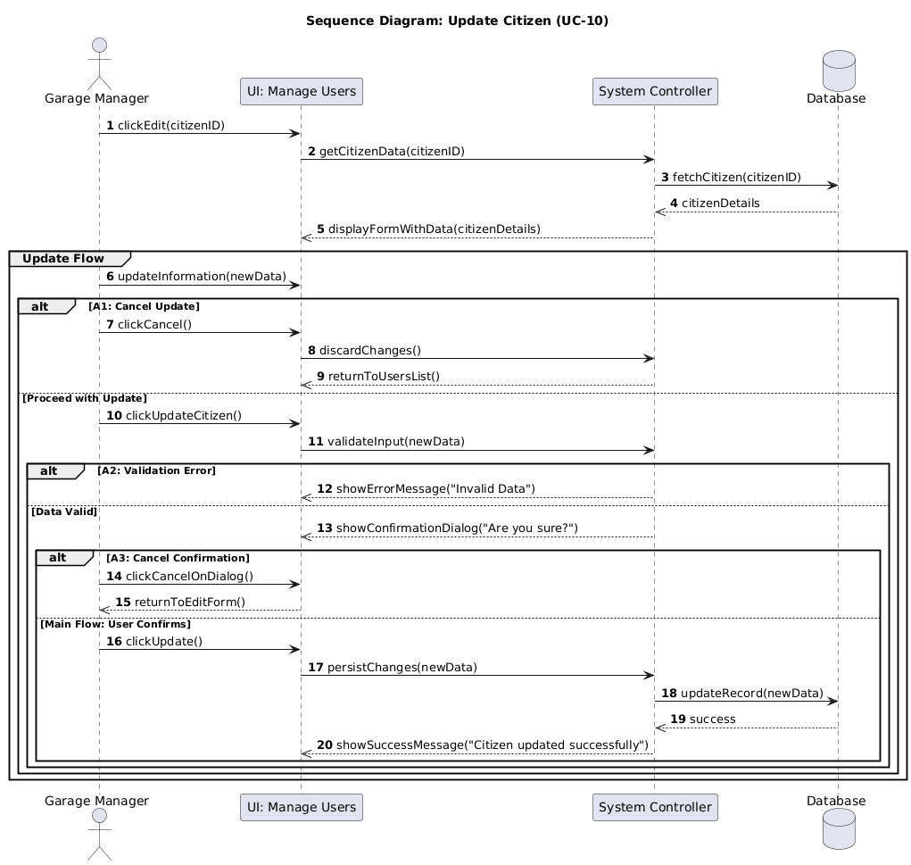
Figure 40 sequence UC-10

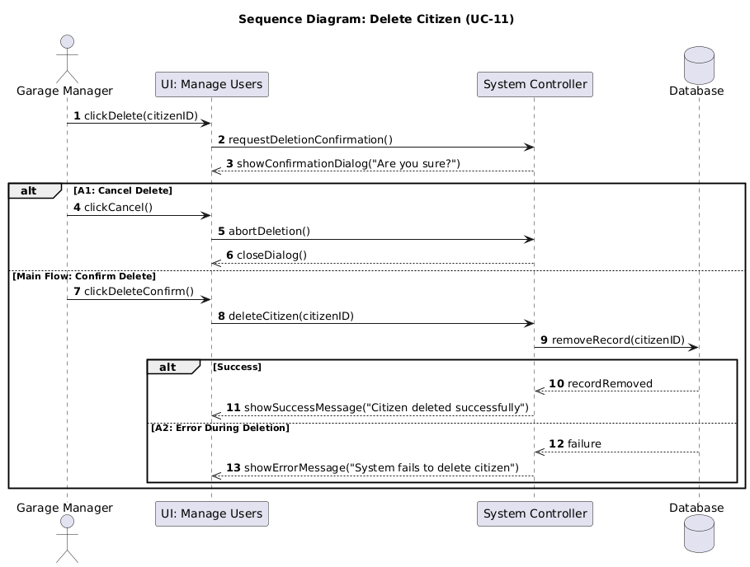
Figure 41 sequence UC-11
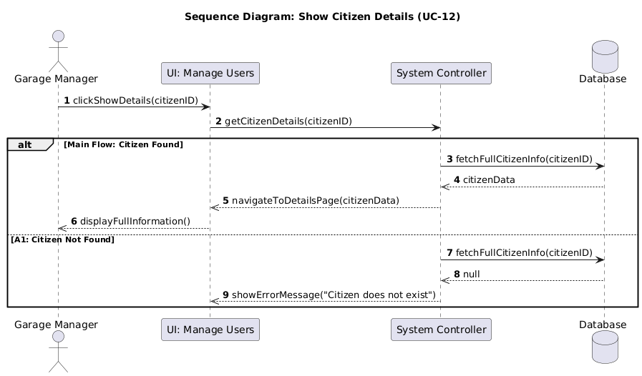
Figure 42 sequence UC-12
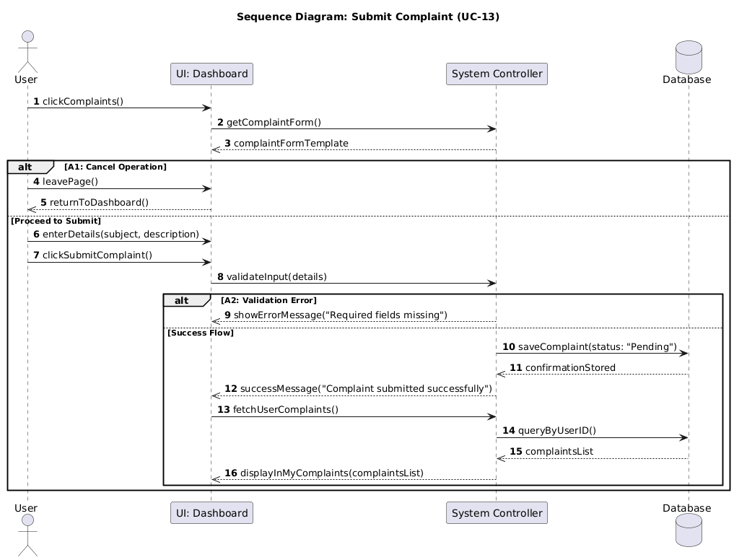
Figure 43 sequence UC-13
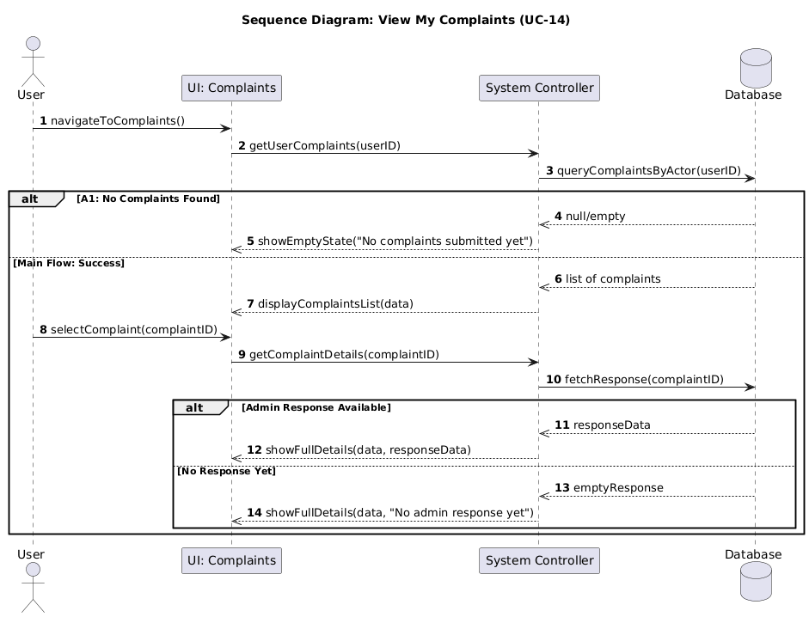
Figure 44 sequce UC-14
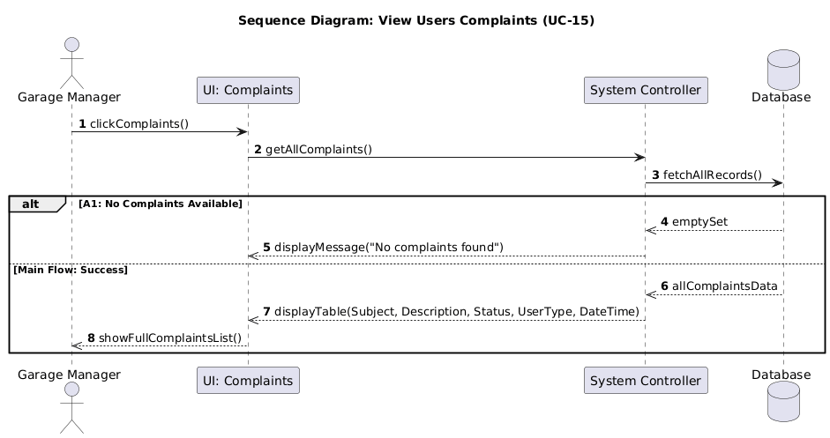
Figure 45 sequence UC-15
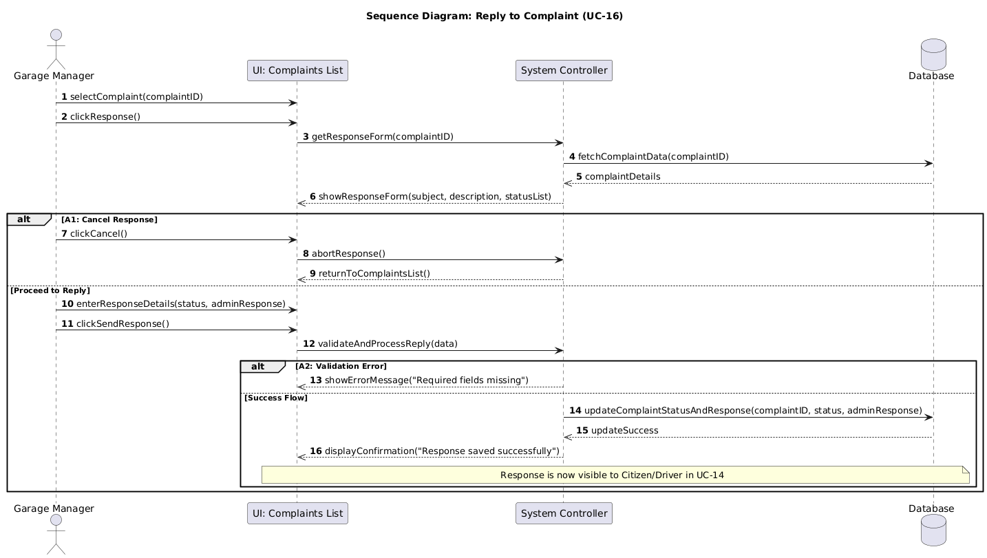
Figure 46 sequence UC-16

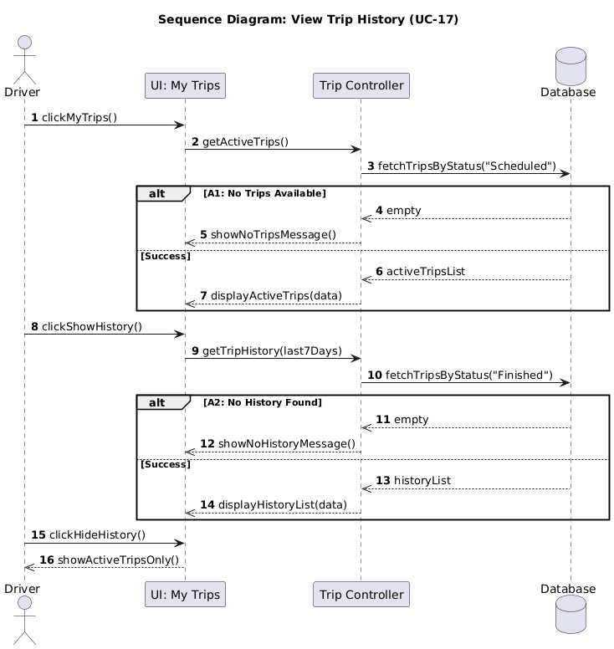
Figure 47 sequence UC-17[
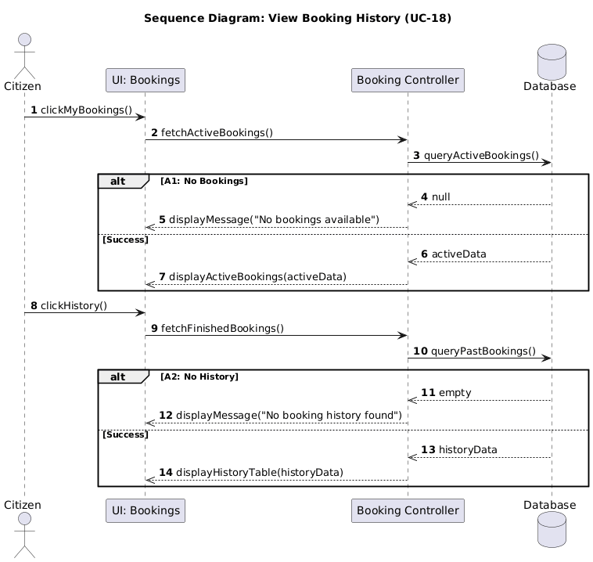
Figure 48 sequence UC-18 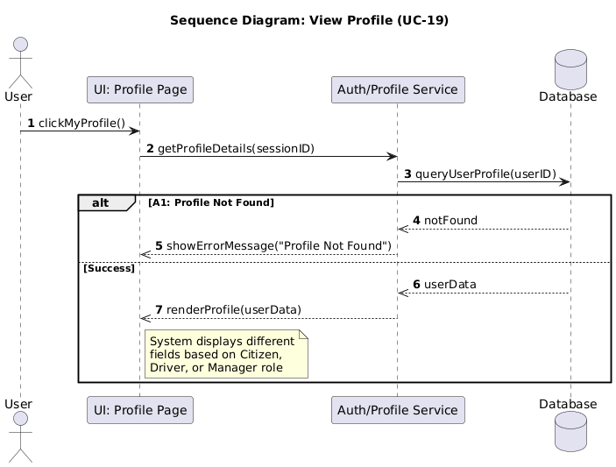
Figure 49 sequence UC-19
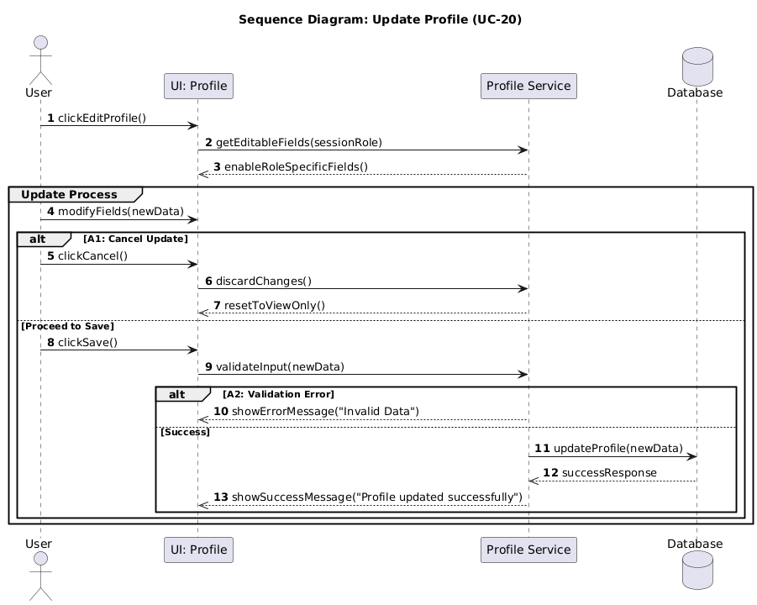
Figure 50 sequence UC-20
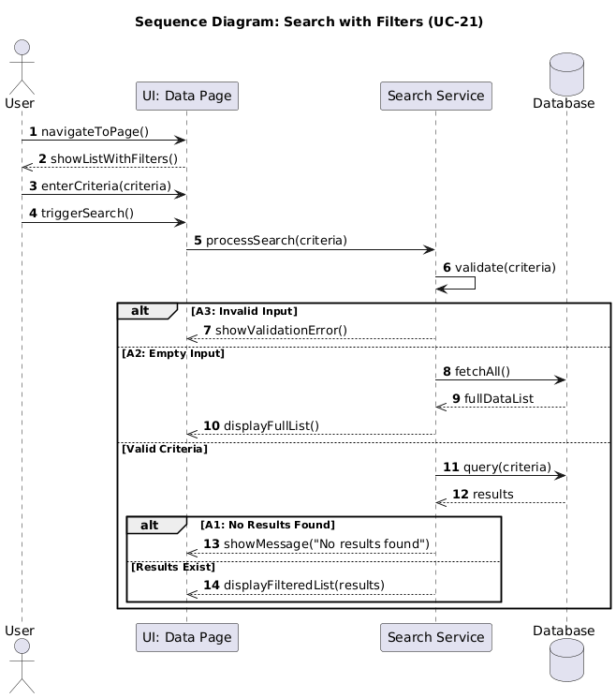
Figure 51 sequence UC-21

7-5-Requirements Traceability Matrix
ID | Title | Associated Dependency | SRS Section | Design Section | Coding | integration Testntgretion | Acceptance test
FR1 | Garage manager can be add new driver | None | Analytical study | Architectural Design | 7.2.2 Authentication Service | 8.2.1.1 Add Driver Test Case Table | يجب تعبئة جميع الحقول الالزامية مثل (المعلومات الشخصية، معلومات الرخصة).
FR2 | Garage manager can be update driver | FR1 | Analytical study | Architectural Design | 7.2.2 Authentication Service | 8.2.1.2 Update Driver Test Case Table | يجب ان تكون التعديلات متوافقة والا تخلق تعارضات في بيانات السائق.
FR3 | Garage manager can be delete driver | FR1 | Analytical study | Architectural Design | 7.2.2 Authentication Service | 8.2.1 Functional Testing | يجب ان لا يكون السائق مرتبط برحلة قائمة أو نشطة عند الحذف.
FR4 | Garage manager can be show driver | FR1 | Analytical study | Architectural Design | 7.2.2 Authentication Service | 8.2.1 Functional Testing | يجب ان يبحث عن سائق بالاسم او بالرقم الوظيفي لعرض بياناته.
FR5 | Garage manager can be add new vehicle | None | Analytical study | Architectural Designn | Vehicle Service | 8.2.1.3 Add Vehicle Test Case Table | يجب ان تكون الحافلة المراد اضافتها غير موجودة مسبقاً بالنظام.
FR6 | Garage manager can be update information vehicle | FR5 | Analytical study | Architectural Design | Vehicle Service | 8.2.1 Functional Testing | يجب ان تكون التعديلات متوافقة والا تخلق تعارضات مع أسطول الحافلات.
FR7 | Garage manager can be delete vehicle | FR5 | Analytical study | Architectural Design | Vehicle Service | 8.2.1.4 Delete Vehcile Test Case Table | يجب ان يكون الحافلة موجودة وان لا تكون مرتبطة بخط مرتبطة برحلات.
FR8 | Garage manager can be show vehicle | FR5 | Analytical study | Architectural Design | Vehicle Service | 8.2.1 Functional Testing | يجب ان يكون الحافلة متاحة مسبقا ومسجلة في الكراج ليتم عرضها.
FR9 | Garage manager can be add new citizen | None | Analytical study | Architectural Design | 7.2.2 Authentication Service | 8.2.1 Functional Testing | يجب تعبئة الحقول الإلزامية للمواطن والتأكد من عدم تكرار الحساب.
FR10 | Garage manager can be update information citizen | FR9 | Analytical study | Architectural Design | 7.2.2 Authentication Service | 8.2.1 Functional Testing | يجب أن تكون البيانات المحدثة للمواطن صحيحة ولا تسبب تعارضات.
FR11 | Garage manager can be delete citizen | FR9 | Analytical study | Architectural Design | 7.2.2 Authentication Service | 8.2.1.9 Delete Citizen Test Case Table | يجب عدم وجود تذاكر فعالة أو رحلات قائمة للمواطن عند الحذف.
FR12 | Garage manager can be show citizen | FR9 | Analytical study | Architectural Design | 7.2.2 Authentication Service | 8.2.1 Functional Testing | يتيح النظام عرض بيانات الحساب والتحقق من وجوده قبل أي عملية.
FR13 | Driver and citizen can be send(submit) complaints | None | Analytical study | Architectural Design | complaint service | 8.2.1.5 Submit Complaint Test Case Table | يجب على المواطن أو السائق تسجيل دخول لإضافة شكوى على النظام.
FR14 | Driver and citizen can be show complaints | FR13 | Analytical study | Architectural Design | complaint service | 8.2.1.5 Submit Complaint Test Case Table | يتيح عرض وتتبع حالة الشكاوى المقدمة ومراقبة الردود عليها.
FR15 | Garage manager can be view user complaints | FR13 | Analytical study | Architectural Design | complaint service | 8.2.1.5 Submit Complaint Test Case Table | يتيح لمدير الكراج استعراض كافة الشكاوى الواردة من المستخدمين.
FR16 | Garage manager can be respond complaints | FR15 | Analytical study | Architectural Design | complaint service | 8.2.1.6 Reply to Complaint Test Case Table | يجب على المدير كتابة رد واغلاق الشكوى وتغيير حالتها برمجياً.
FR17 | Drive can be view trip history | None | Analytical study | Architectural Design | 7.2.4 Trip Service | 8.2.1.8 View Trip History Test Case Table | يجب ان تكون الرحلات متاحة ومعتمدة من ادارة النظام لعرض تاريخها.
FR18 | Citizen can be view booking history | None | Analytical study | Architectural Design | 7.2.3 Booking Service | 8.2.1 Functional Testing | يتيح للمواطن استعراض سجل كافة الحجوزات السابقة والتذاكر الخاصة به.
FR19 | User can be view profile | None | Analytical study | Architectural Design | 7.2.2 Authentication Service | 8.2.1 Functional Testing | يجب أن يكون المستخدم مسجل دخول لحسابه لعرض بيانات ملفه الشخصي.
FR20 | User can be edit profile | FR19 | Analytical study | Architectural Design | 7.2.2 Authentication Service | 8.2.1.7 Update Profile Test Case Table | يجب أن تكون التعديلات متوافقة مع شروط حماية الحساب وتحديث البيانات.
FR21 | All actors can be search with filter | None | Analytical study | Architectural Design | 7.6 User Interface Implementation | _______ | يجب ان يكون النظام متاح لتنفيذ المطلوب وتصفية البيانات بدقة عالية.

7-6-Test Case Descriptions

Add New Driver
Test Case ID | Test Case Name | Precondition | Steps | Expected Result
TC-01 | Successfully Add New Driver | Active account exists | 1. Open add interface  2. Enter data  3. Click Save | Message 'Saved successfully' appears and driver is listed
TC-02 | Duplicate License Number |  | 1. Open add interface  2. Enter data  3. Click Save | Error message (Unique Constraint Error)

Edit Driver Data
Test Case ID | Test Case Name | Precondition | Steps | Expected Result
TC-03 | Edit Driver Successfully | Admin logged in | 1. Open driver management  2. Enter new data  3. Save | Data updated in database
TC-04 | Invalid Data Entry |  | 1. Open driver management  2. Enter new data  3. Save | Invalid data message
TC-05 | Empty Fields |  | Enter incomplete data | Error: All fields required

Bus Management
Test Case ID | Test Case Name | Precondition | Steps | Expected Result
TC-06 | Add Bus |  | 1. Open buses interface  2. Click add  3. Save | Bus added with status Available
TC-07 | Delete Bus | Bus is available | 1. Select bus  2. Click Delete  3. Confirm | Bus removed from list

Complaint
Test Case ID | Test Case Name | Steps | Expected Result
TC-08 | Submit Complaint | 1. Open complaints  2. Add complaint  3. Confirm | Saved as Pending with tracking number
TC-09 | Reply to Complaint | 1. Open complaints list  2. Write reply | Status becomes Replied and notification sent

Profile Management
Test Case ID | Test Case Name | Steps | Expected Result
TC-10 | Change Password | 1. Open profile  2. Enter old password  3. Enter new password twice  4. Confirm | Password updated if old correct

Part Three: Design and Architecture

Chapter 5

Architectural Design

5.1 High-Level System Design
This chapter presents the architectural and technical design of the proposed system. The purpose of this chapter is to describe how the system components interact together in order to satisfy the functional and non-functional requirements identified in the previous chapters.
The system was designed using a modular and scalable architecture to ensure maintainability, flexibility, and ease of future expansion. The overall architecture follows the Microservices Architectural Pattern, where each service is independently developed, deployed, and maintained.

5.1.1 System Block Diagram
The following figure illustrates the high-level architectural design of the proposed system and the interaction between the major system components.
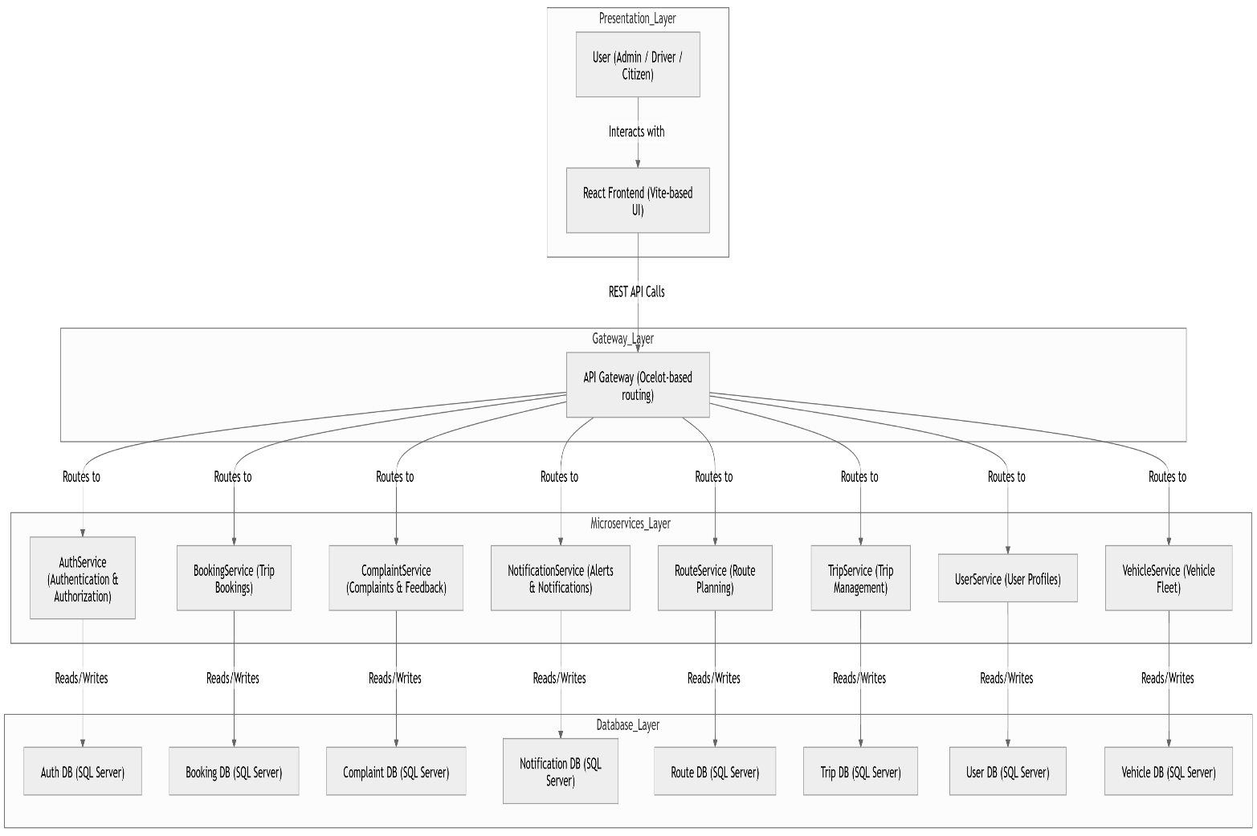

The system architecture consists of four primary layers:
- Presentation Layer
- API Gateway Layer
- Microservices Layer
- Database Layer
The Presentation Layer represents the user interface developed using React and Vite technologies. This layer allows administrators, drivers, and citizens to interact with the system through a modern web interface.
The API Gateway layer acts as a centralized entry point for all client requests. The gateway is implemented using Ocelot and is responsible for request routing, authentication forwarding, and communication management between the frontend and backend services.
The Microservices Layer contains several independent services, each responsible for a specific business domain such as authentication, booking management, complaint handling, notification delivery, route planning, trip management, user management, and vehicle management.
Each microservice owns its dedicated database in order to achieve loose coupling and independent scalability. This approach improves system reliability and follows modern distributed system design principles.

5.1.2 Architectural Pattern
The proposed system adopts the Microservices Architecture pattern. This architectural style divides the system into a collection of small, independent services that communicate through lightweight APIs.
The decision to use microservices was motivated by several factors:
- Improved scalability
- Independent deployment of services
- Easier maintenance and debugging
- Better fault isolation
- Support for distributed development teams
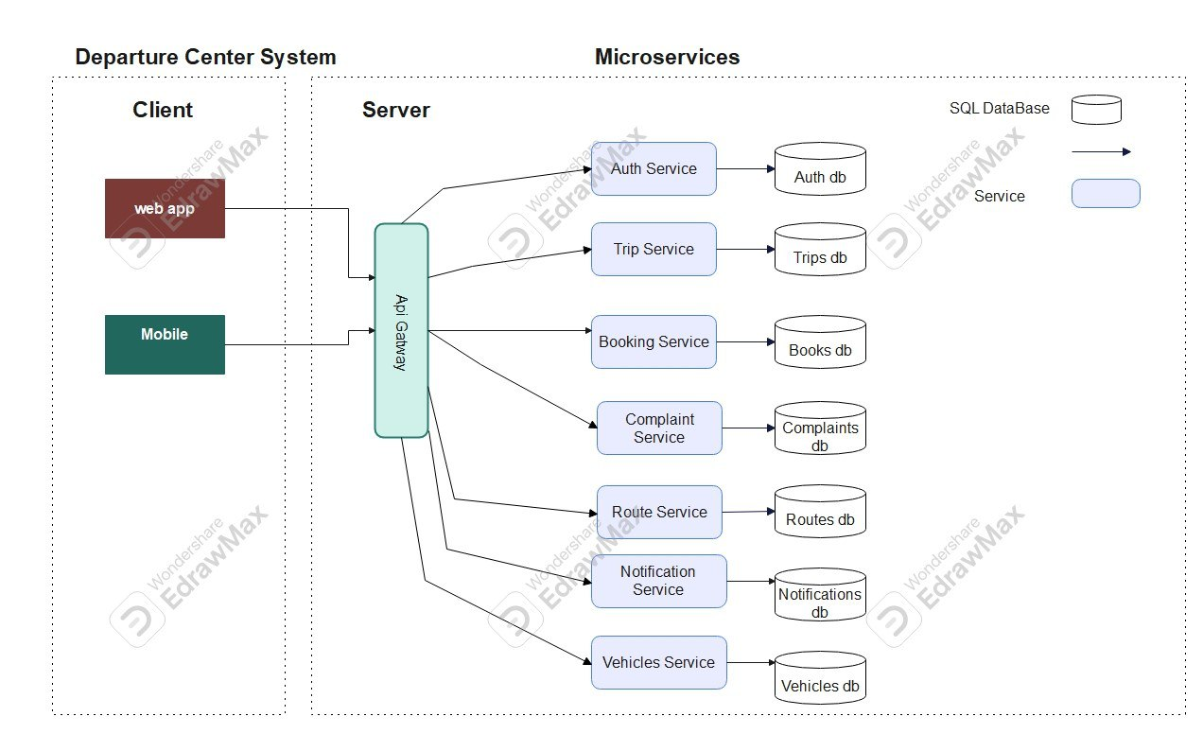
- Flexibility in future system expansion

5.1.3 System Architecture Description
The frontend application communicates with the backend services through RESTful APIs exposed by the API Gateway. After receiving a request, the gateway forwards the request to the appropriate microservice.
Authentication and authorization operations are handled by the AuthService using JWT-based authentication mechanisms. Once authenticated, users can access different system functionalities according to their assigned roles and permissions.
The BookingService manages trip reservations and scheduling operations, while the RouteService handles route planning and optimization functionalities. The NotificationService is responsible for sending alerts and notifications to users regarding bookings, complaints, or system events.
The VehicleService manages fleet information and vehicle-related operations, while the UserService stores and maintains user profile information. ComplaintService enables users to submit and track complaints or feedback related to transportation services.
The architecture was designed to ensure high cohesion within services and loose coupling between services, which improves maintainability and system performance.

5.2 Database Design
The database design defines how system data is structured, stored, and managed. Each microservice maintains its own independent database following the Database-per-Service pattern commonly used in microservices architecture.
This separation improves service autonomy, enhances scalability, and minimizes dependencies between system components.

5.2.1 Entity Relationship Diagram (ERD)
The following diagram illustrates the relationships between the main entities used within the system database.

Trips service
Bookings service
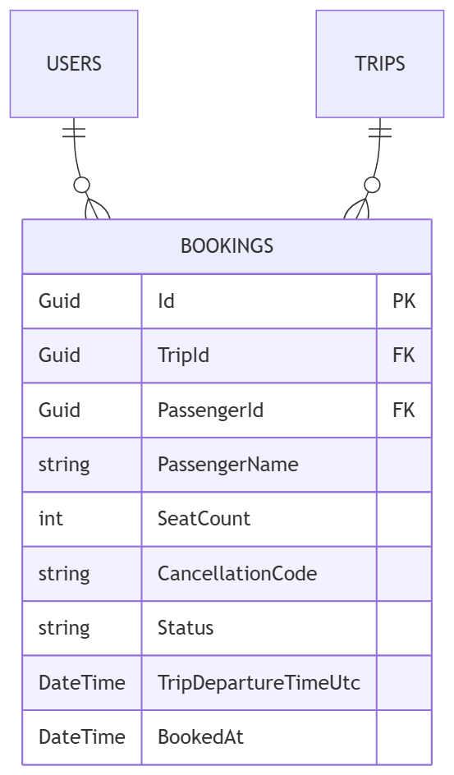
Routes service
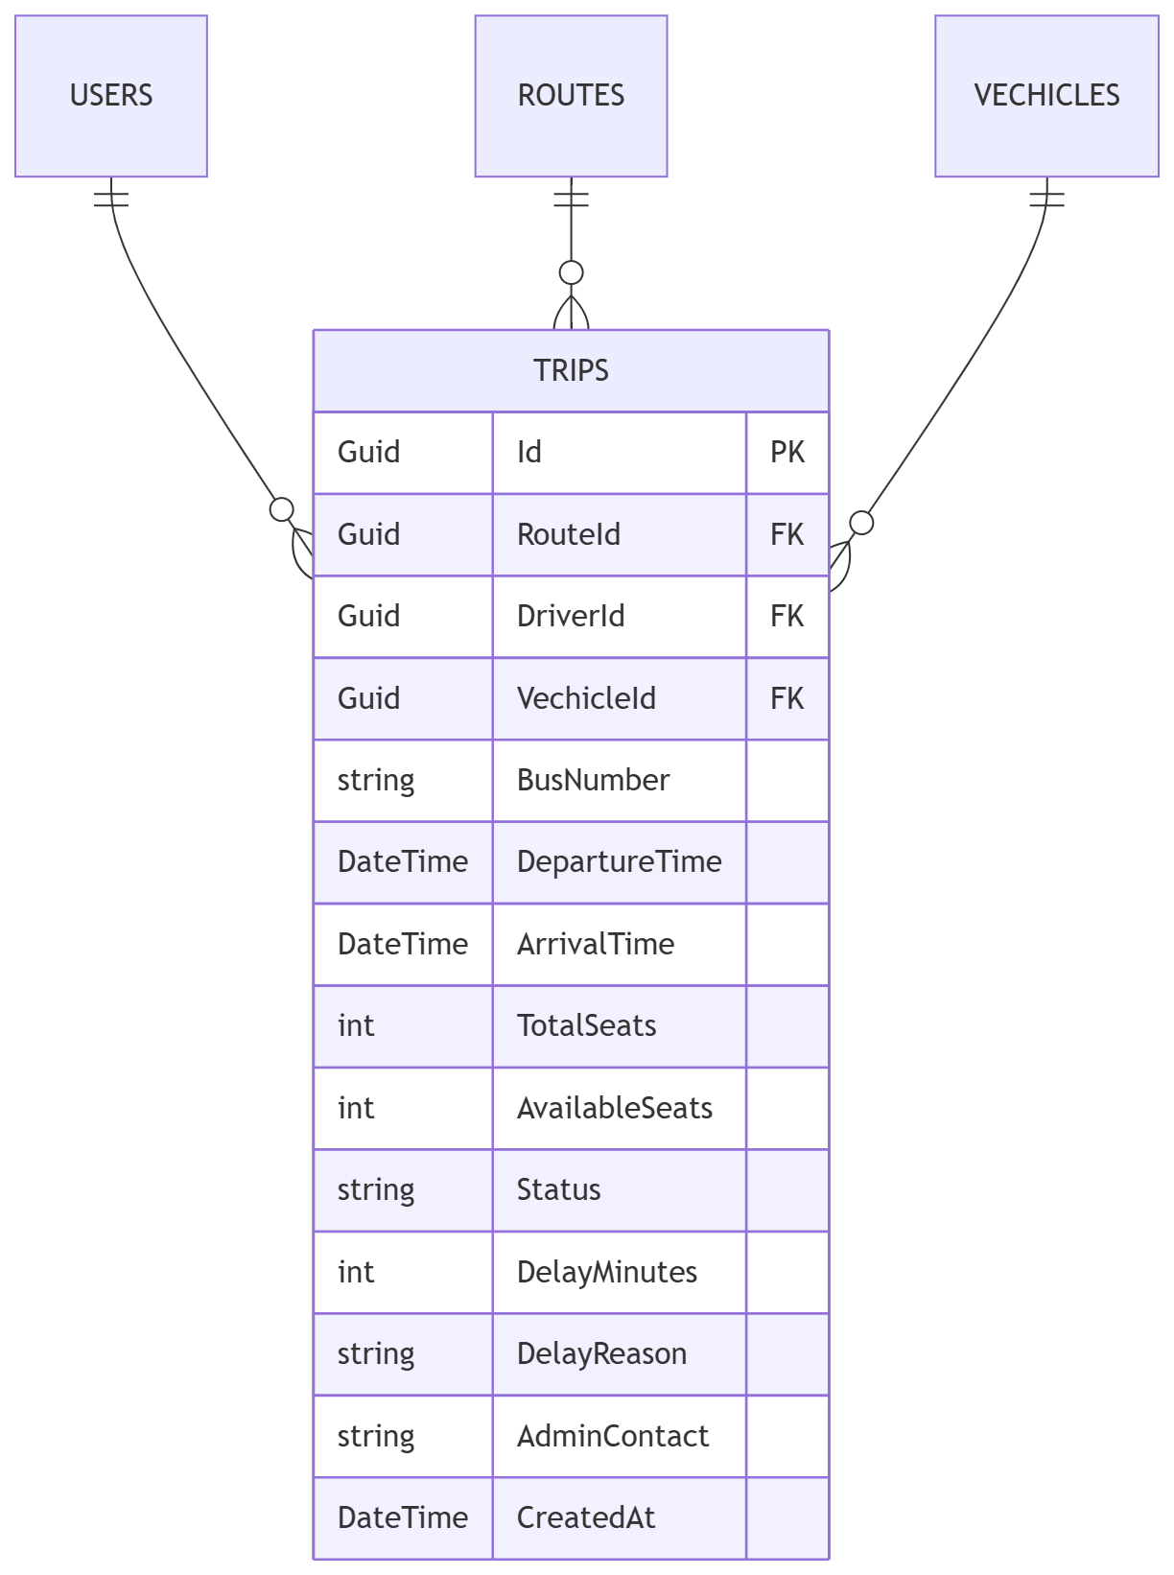
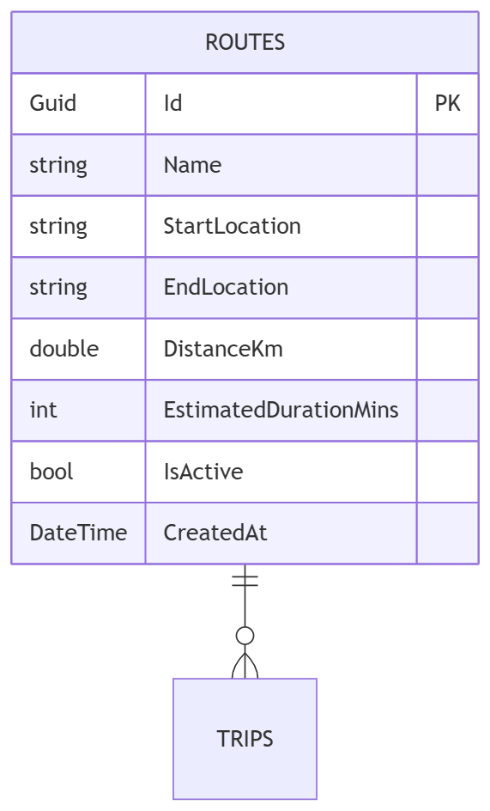

Complaints service
Notifications Service
Vehicles service
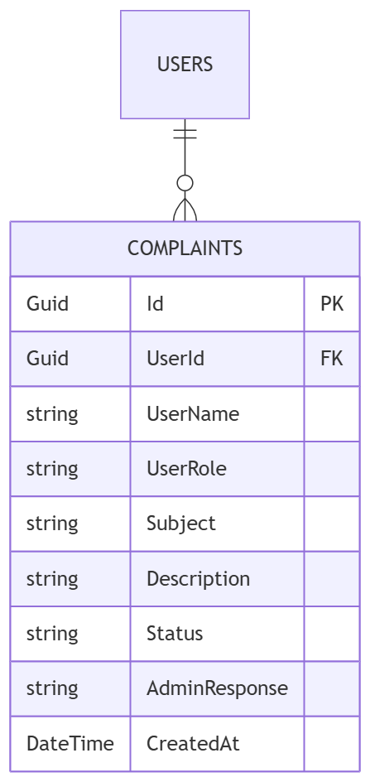
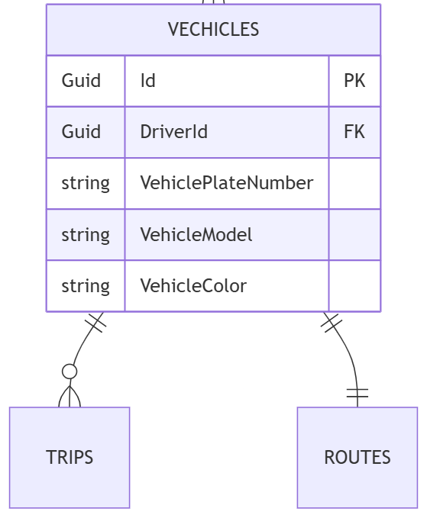
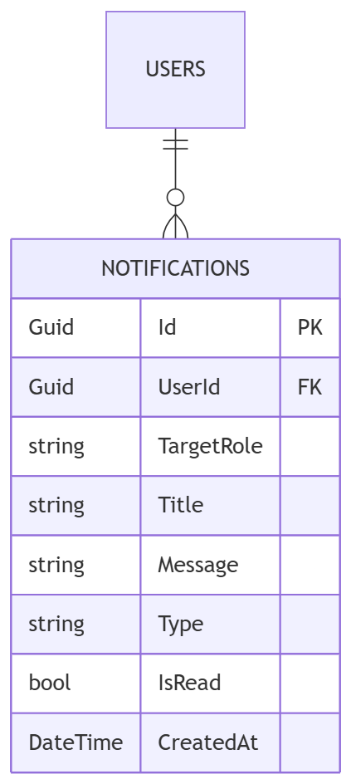

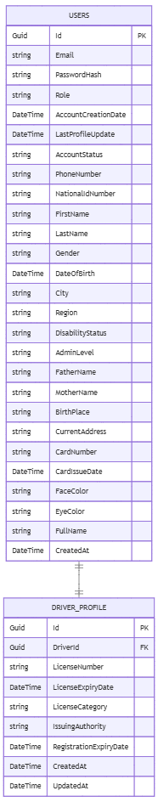

User service

5.2.2 Relational Schema
The relational schema defines the database tables, attributes, and relationships used by the system.

5.2.3 Database Constraints(primary key, Foreign Key, Unique, Check)
Database constraints are rules applied to the database schema to ensure data integrity, consistency, and validity. In the proposed system, Entity Framework Core enforces these constraints at the model level and translates them into corresponding database-level constraints.
These constraints play a critical role in maintaining correct relationships between entities and preventing invalid data operations.

Primary Key Constraint
The Primary Key uniquely identifies each record within a table. Every entity in the system has a primary key, typically represented using a Guid field named Id.
- Ensures each record is uniquely identifiable
- Cannot contain NULL values
- Must be unique for each row
Example:
- Users.Id
- Trips.Id
- Bookings.Id

Foreign Key Constraint
Foreign Keys are used to establish relationships between tables and maintain referential integrity across the system.
They ensure that a record in one table correctly references a valid record in another table.
Examples from the system:
- Bookings.PassengerId → Users.Id
- Trips.DriverId → Users.Id
- Trips.RouteId → Routes.Id
- Complaints.UserId → Users.Id
- Notifications.UserId → Users.Id
- DriverProfiles.DriverId → Users.Id
These relationships ensure consistency across microservices at the logical data level.

Unique Constraint
The Unique constraint ensures that no duplicate values are stored in specific fields where uniqueness is required.
Examples:
- Users.Email → ensures no two users share the same email address
- Routes.Name → ensures each route has a unique name
- Bookings.CancellationCode → ensures each booking cancellation code is unique
- DriverProfiles.DriverId → ensures one driver has only one profile

Check Constraint
Check constraints are used to enforce domain-level validation rules on column values.
They ensure that values stored in the database meet predefined conditions.
Examples:
- AvailableSeats >= 0 in Trips table
- TotalSeats > 0
- Enum fields (e.g., Status, Role) restricted to predefined valid values
These constraints help prevent invalid business logic from being stored in the database.

5.3 API Design
The system exposes RESTful APIs to enable communication between the frontend application and backend microservices.
Each API endpoint follows REST architectural principles and uses standard HTTP methods such as: (GET – POST – PUT – DELETE)

Authentication APIs
Endpoint | Method | Description | Parameters | Return Value | Error Codes
/api/auth/register | POST | Register a new user | User registration data | JWT token and user information | 400, 409
/api/auth/login | POST | Authenticate user login | Email, password | JWT access token | 400, 401

User Management APIs
Endpoint | Method | Description | Parameters | Return Value | Error Codes
/api/users/drivers | GET | Retrieve all drivers | JWT token | List of drivers | 401, 403
/api/users/drivers | POST | Create a new driver | Driver information | Created driver object | 400, 401
/api/users/drivers/{id} | PUT | Update driver information | Driver ID, updated data | Updated driver object | 400, 404
/api/users/drivers/{id} | DELETE | Delete a driver | Driver ID | Deletion confirmation | 404
/api/users | GET | Retrieve all users | JWT token | List of users | 401, 403
/api/users/by-ids | POST | Retrieve users by IDs | List of user IDs | User objects | 400
/api/users/{id} | GET | Retrieve user by ID | User ID | User information | 404
/api/users/{id} | PUT | Update user information | User ID, updated data | Updated user object | 400, 404
/api/users/{id} | DELETE | Delete user | User ID | Deletion confirmation | 404
/api/users/me | GET | Retrieve current user profile | JWT token | Current user profile | 401
/api/users/me | PUT | Update current user profile | Updated profile data | Updated profile | 400, 401
/api/users/admin-contact | GET | Retrieve administrator contact information | JWT token | Contact information | 404

5.3.2 BookingService APIs
Endpoint | Method | Description | Parameters | Return Value | Error Codes
/api/booking | GET | Retrieve all bookings | JWT token | List of bookings | 401
/api/booking/{id} | GET | Retrieve booking by ID | Booking ID | Booking details | 404
/api/booking/my | GET | Retrieve current user's bookings | JWT token | User bookings | 401
/api/booking/my/active | GET | Retrieve active bookings | JWT token | Active bookings | 401
/api/booking/my/history | GET | Retrieve booking history | JWT token | Historical bookings | 401
/api/booking/trip/{tripId} | GET | Retrieve bookings for a trip | Trip ID | Trip bookings | 404
/api/booking | POST | Create a new booking | Booking information | Booking details | 400, 409
/api/booking/cancel | POST | Cancel a booking | Booking ID | Cancellation confirmation | 400, 404

5.3.3 ComplaintService APIs
Endpoint | Method | Description | Parameters | Return Value | Error Codes
/api/complaint | GET | Retrieve all complaints | JWT token | List of complaints | 401
/api/complaint/{id} | GET | Retrieve complaint by ID | Complaint ID | Complaint details | 404
/api/complaint/my | GET | Retrieve current user's complaints | JWT token | User complaints | 401
/api/complaint | POST | Create a new complaint | Complaint information | Complaint details | 400
/api/complaint/{id}/status | PATCH | Update complaint status | Complaint ID, status | Updated complaint | 400, 404
/api/complaint/{id}/respond | PATCH | Respond to a complaint | Complaint ID, response | Updated complaint | 400, 404

5.3.4 RouteService APIs
Endpoint | Method | Description | Parameters | Return Value | Error Codes
/api/route | GET | Retrieve all routes | JWT token | List of routes | 401
/api/route/{id} | GET | Retrieve route by ID | Route ID | Route details | 404
/api/route | POST | Create a new route | Route information | Created route | 400
/api/route/{id} | PUT | Update route information | Route ID, updated data | Updated route | 400, 404
/api/route/{id} | DELETE | Delete route | Route ID | Deletion confirmation | 404

5.3.5 TripService APIs
Endpoint | Method | Description | Parameters | Return Value | Error Codes
/api/trip | GET | Retrieve all trips | JWT token | List of trips | 401
/api/trip/{id} | GET | Retrieve trip by ID | Trip ID | Trip details | 404
/api/trip/driver/{driverId} | GET | Retrieve trips by driver | Driver ID | Driver trips | 404
/api/trip/route/{routeId} | GET | Retrieve trips by route | Route ID | Route trips | 404
/api/trip/active | GET | Retrieve active trips | JWT token | Active trips | 401
/api/trip/history | GET | Retrieve trip history | JWT token | Historical trips | 401
/api/trip/driver/{driverId}/history | GET | Retrieve driver's trip history | Driver ID | Trip history | 404
/api/trip/route/{routeId}/exists | GET | Check route availability | Route ID | Boolean value | 404
/api/trip | POST | Create a new trip | Trip information | Created trip | 400
/api/trip/{id} | PUT | Update trip information | Trip ID, updated data | Updated trip | 400, 404
/api/trip/{id}/status | PATCH | Update trip status | Trip ID, status | Updated trip | 400, 404
/api/trip/{id} | DELETE | Delete trip | Trip ID | Deletion confirmation | 404
/api/trip/{id}/decrement-seat | POST | Decrease available seats | Trip ID | Updated seat count | 400
/api/trip/{id}/increment-seat | POST | Increase available seats | Trip ID | Updated seat count | 400

Driver Profile APIs
Endpoint | Method | Description | Parameters | Return Value | Error Codes
/api/driver/profile/{driverId} | GET | Retrieve driver profile | Driver ID | Driver profile | 404
/api/driver/profile/me | GET | Retrieve current driver's profile | JWT token | Driver profile | 401
/api/driver/profile/admin/all | GET | Retrieve all driver profiles | JWT token | List of driver profiles | 401, 403
/api/driver/profile | POST | Create driver profile | Profile information | Created profile | 400
/api/driver/profile/{driverId} | PUT | Update driver profile | Driver ID, updated data | Updated profile | 400, 404
/api/driver/profile/me | PUT | Update current driver's profile | Updated profile data | Updated profile | 400
/api/driver/profile/{driverId} | DELETE | Delete driver profile | Driver ID | Deletion confirmation | 404

5.3.6 VehicleService APIs
Endpoint | Method | Description | Parameters | Return Value | Error Codes
/api/vehicle | GET | Retrieve all vehicles | JWT token | List of vehicles | 401
/api/vehicle/{id} | GET | Retrieve vehicle by ID | Vehicle ID | Vehicle details | 404
/api/vehicle | POST | Create a new vehicle | Vehicle information | Created vehicle | 400
/api/vehicle/{id} | PUT | Update vehicle information | Vehicle ID, updated data | Updated vehicle | 400, 404
/api/vehicle/{id} | DELETE | Delete vehicle | Vehicle ID | Deletion confirmation | 404

5.3.7 HTTP Response Codes

Status Code | Meaning
200 OK | Request completed successfully
201 Created | Resource created successfully
400 Bad Request | Invalid request data
401 Unauthorized | Authentication required
403 Forbidden | Access denied
404 Not Found | Requested resource not found
409 Conflict | Data conflict occurred
500 Internal Server Error | Unexpected server-side error

5.4 Security and Authorization Design
Security and access control were considered critical aspects during the design and implementation of the proposed system. The system was designed to ensure secure communication between users and backend services while protecting sensitive information and restricting unauthorized access.
The security architecture is based on authentication, authorization, role-based access control, and secure API communication mechanisms.

5.4.1 Authentication Mechanism
The system uses JSON Web Token (JWT) authentication to verify user identities and secure access to protected resources.
When a user successfully logs into the system, the AuthService generates a JWT access token containing the user's identity and assigned role. The generated token is then returned to the client application and attached to subsequent API requests using the Authorization header.
The token contains encoded claims such as:
- User Identifier
- User Role
- Token Expiration Time
- Security Metadata
This mechanism enables stateless authentication and improves scalability in the microservices architecture.

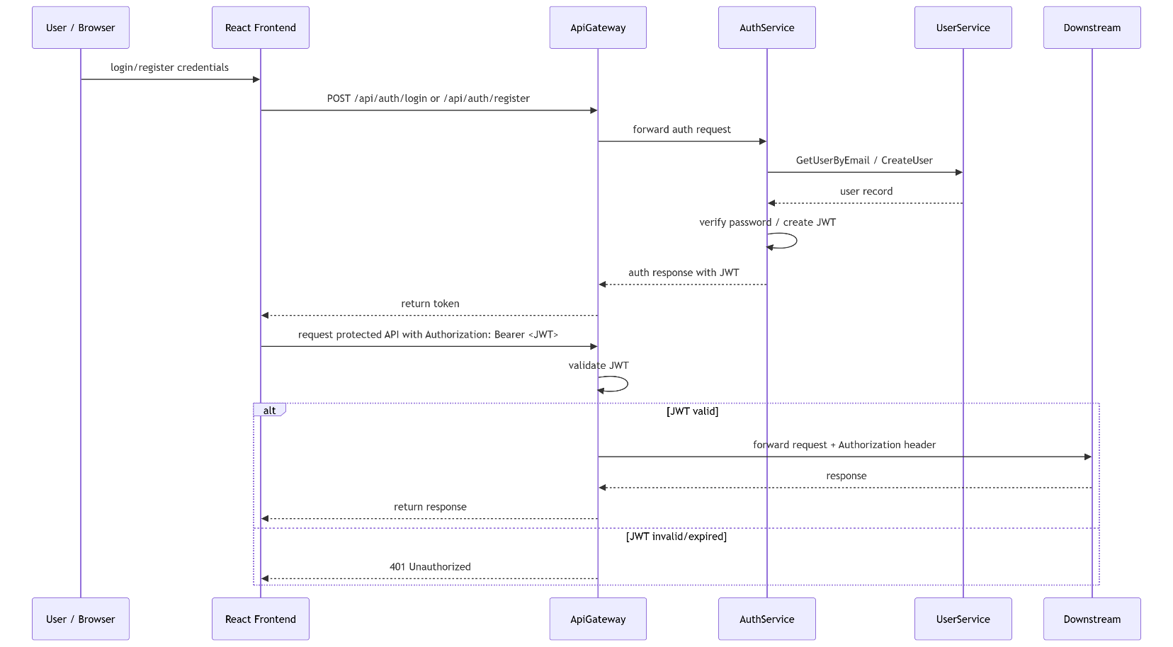
Figure 52 jwt Athentication and Authorization

The authentication workflow follows these steps:
- The user submits login credentials through the frontend application.
- The AuthService validates the provided credentials.
- A JWT access token is generated upon successful authentication.
- The frontend stores the token securely and includes it in future requests.
- The API Gateway validates the token before forwarding requests to backend services.
This approach improves security and minimizes repeated authentication requests between services.

5.4.2 Authorization and Access Control
The system implements Role-Based Access Control (RBAC) to regulate access to system resources and functionalities.
Each authenticated user is assigned a specific role that determines the operations and resources they are permitted to access.
The main user roles implemented in the system are:

Role | Description
Admin | Has full access to system management functionalities
Driver | Manages trips, driver profile, and transportation-related operations
User | Can book trips, submit complaints, and manage personal information

Authorization rules are enforced at both the API Gateway and microservice levels to ensure secure access control.
Protected endpoints require valid authentication tokens and appropriate permissions before access is granted.

5.4.3 Access Levels
Different access levels were implemented to protect sensitive operations and system resources.

Administrative Access
Administrative users have elevated privileges that allow them to:
- Manage users and drivers
- Create and update routes
- Manage vehicles and trips
- View system-wide data and reports
- Handle complaints and notifications
Driver Access
Drivers are granted permissions related to transportation management, including:
- Viewing assigned trips
- Managing driver profiles
- Updating trip statuses
- Accessing route information
User Access
Regular users can perform standard platform operations such as:
- Booking trips
- Viewing booking history
- Submitting complaints
- Managing personal profile information

5.4.4 API Security Measures
Several additional security measures were implemented to improve system protection, including:
- Password hashing
- Secure JWT token validation
- HTTP based communication
- Input validation and request sanitization
- Protected API routes
- Token expiration handling
- Exception and error handling mechanisms
Sensitive operations such as updating passwords or deleting records require authenticated requests and proper authorization privileges.

5.4.5 Security Architecture Overview
The overall security architecture ensures confidentiality, integrity, and controlled access to system resources while maintaining scalability and performance within the distributed microservices environment.
The combination of JWT authentication, role-based authorization, API Gateway validation, and protected service communication provides a secure foundation for the proposed transportation management system.

Part Four:

Implmentation

and Testing

Chapter 6

DEVELOPMENT ENVIRONMENT AND TOOLS

6.1 Introduction
This chapter presents the development environment, tools, frameworks, and technologies used in the implementation of the Departure Center System. The objective of this chapter is to provide a complete technical overview of the system setup in order to ensure reproducibility and maintainability.

6.2 Development Tools and Software
The following tools were used during system development:
- Visual Studio Code (VS Code): Primary code editor used for both frontend and backend development.
- Postman: Used for testing and validating RESTful API endpoints.
- Docker: Used for containerizing microservices and managing system dependencies.
- k6: Used for performance and load testing of the system APIs.
These tools were essential in ensuring efficient development, testing, and deployment workflows.

6.3 Development Environment and System Structure
The system was developed in a hybrid environment using both Windows OS and Windows Subsystem for Linux (WSL). WSL was primarily used to run Docker containers efficiently.
The project structure follows a microservices-based architecture with a clear separation between frontend, backend, and testing components.

6.3.1 Root Directory Structure
The root directory of the project contains the main system components as follows:
DepartureCenterSystemCopy/
├── backend/ # All backend microservices
├── frontend/ # React frontend application
├── k6-tests/ # Performance testing scripts
This structure ensures clear separation between system layers and simplifies development and deployment processes.

6.3.2 Backend Structure
The backend is implemented using a microservices architecture. Each service is independently developed and deployed.
backend/
├── ApiGateway/
├── AuthService/
├── UserService/
├── BookingService/
├── ComplaintService/
├── NotificationService/
├── RouteService/
├── TripService/
├── VehicleService/
Each service is responsible for a specific business domain, and all communication between services is handled through the API Gateway.

6.3.3 Microservice Internal Architecture
Each microservice follows a Clean Architecture pattern consisting of four main layers:
ServiceName/
├── ServiceName.Api/ # REST API layer (Controllers, Middleware)
├── ServiceName.Application/ # Business logic (Services, Interfaces, DTOs)
├── ServiceName.Domain/ # Domain models (Entities, Enums, Interfaces)
└── ServiceName.Infrastructure/ # Data access & external services (Persistence, HttpClients)
This layered architecture ensures:
- Separation of concerns
- High maintainability
- Testability of business logic
- Independent development of layers

6.3.4 Frontend Structure
The frontend is built using React with Vite and follows a modular component-based structure.
frontend/
├── public/ # Static assets
├── src/
│ ├── components/ # Reusable React components
│ ├── context/ # React Context for state management
│ ├── data/ # Mock/sample data
│ └── assets/ # Images, fonts, etc.
This structure improves code reusability and maintains a clean separation between UI components and application logic.

6.3.5 Performance Testing Structure
Performance testing is implemented using k6 and organized in a dedicated directory:
k6-tests/
├── utils/ # Test utilities and helpers
└── scenarios/ # Test scenarios and configurations
This structure allows the definition of multiple load testing scenarios and reusable testing utilities to evaluate system performance under different conditions.

6.4 Programming Languages and Frameworks
The system was implemented using the following technologies:
Backend
- Language: C#
- Framework: .NET 8
- Architecture: Clean Architecture (4-layer structure)
Frontend
- Languages: HTML, CSS, JavaScript
- Framework: React (Vite-based setup)
API Communication
- RESTful APIs
- JSON-based data exchange
- HTTP protocols

6.5 Database Server and Operating System
Database
- SQL Server was used as the primary database management system.
- Each microservice has its own dedicated database to ensure data isolation and scalability.
Operating System
- Windows 10 was used as the main development environment.
- WSL was used to support Docker container execution and Linux-based tooling.

6.6 Dependencies and Libraries
The frontend project uses a modern JavaScript ecosystem managed through package.json.
Frontend Dependencies
{
"react": "^19.2.0",
"react-dom": "^19.2.0",
"react-router-dom": "^7.13.1",
"axios": "^1.13.6",
"tailwindcss": "^4.2.1",
"@tailwindcss/vite": "^4.2.1"
}
Development Dependencies
{
"vite": "^7.3.1",
"eslint": "^9.39.1",
"@vitejs/plugin-react": "^5.1.1",
"@types/react": "^19.2.7",
"@types/react-dom": "^19.2.3"
}
These dependencies support:
- UI development (React)
- Styling (TailwindCSS)
- API communication (Axios)
- Routing (React Router)
- Code quality (ESLint)
- Build tooling (Vite)

6.7 Version Control and Source Code Management
The system uses:
- Git for version control
- GitHub for repository hosting and collaboration
The project follows a structured branching strategy to manage development and feature integration. Each microservice and frontend module is tracked independently to ensure modular development.

6.8 CI/CD Tools
Continuous Integration and Continuous Deployment (CI/CD) tools such as GitHub Actions or Jenkins are planned for future integration.
Currently, the system does not include a fully automated CI/CD pipeline.

6.9 Testing Environment
The system was tested in a local development environment.
Testing Setup
- Backend services were containerized using Docker
- Services were executed locally using localhost
- API testing was performed using Postman
- Load and performance testing were conducted using k6
Performance Testing
k6 scripts were used to simulate multiple concurrent users in order to evaluate system performance under load conditions.
Execution Environment
- Local machine (using WSL)
- Docker containers running microservices locally








SQL Server
CSS3
Postman
Java script
Docker
React
.NET



HTML5

6.10 Summary
The development environment was carefully selected to support scalability, modularity, and efficient microservices development. The combination of .NET 8, React, SQL Server, Docker, and modern development tools provided a robust foundation for implementing the Departure Center System.

Chapter 7

Software Implementation

7.1 Project and File Structure
The DepartureCenterSystem project follows a modular microservices architecture based on the Clean Architecture pattern. The system is divided into independent backend services, a frontend client application, and performance testing modules. This structure improves scalability, maintainability, and separation of concerns.
Root Directory Structure

DepartureCenterSystemCopy/
├── backend/ # All backend microservices
├── frontend/ # React frontend application
├── k6-tests/ # Performance testing scripts
Backend Structure
The backend layer contains all microservices responsible for handling business operations and system functionalities.
backend/
├── ApiGateway/
├── AuthService/
├── UserService/
├── BookingService/
├── ComplaintService/
├── NotificationService/
├── RouteService/
├── TripService/
├── VehicleService/
Each microservice follows a standardized 4-layer Clean Architecture structure:
ServiceName/
├── ServiceName.Api/ # REST API Layer
├── ServiceName.Application/ # Business Logic Layer
├── ServiceName.Domain/ # Domain Models Layer
└── ServiceName.Infrastructure/ # Data Access & External Services Layer
Layer Responsibilities
Layer | Responsibility
API Layer | Handles HTTP requests, controllers, middleware, and routing
Application Layer | Contains business logic, DTOs, interfaces, and services
Domain Layer | Defines entities, enums, and core domain models
Infrastructure Layer | Manages database access, repositories, migrations, and external integrations

Frontend Structure
The frontend application was implemented using React with Vite.
frontend/
├── public/ # Static files
├── src/
│ ├── components/ # Reusable UI components
│ ├── context/ # Global state management
│ ├── data/ # Mock/sample data
│ └── assets/ # Images and static resources
Performance Testing Structure
The system uses k6 for load and performance testing.
k6-tests/
├── utils/ # Shared test utilities
└── scenarios/ # Load testing scenarios
Service Communication Structure
The system uses an API Gateway pattern for centralized routing between the frontend and backend services.
User Request
↓
Frontend (React)
↓
ApiGateway (Ocelot)
├─→ AuthService
├─→ UserService
├─→ BookingService
├─→ ComplaintService
├─→ NotificationService
├─→ RouteService
├─→ TripService
└─→ VehicleService
Each microservice owns a separate SQL Server database to ensure service isolation and independent deployment.

7.2 Modules Implementation
The system was implemented using independent microservices, where each service is responsible for a specific business domain. This modular design improves maintainability, scalability, and fault isolation.

7.2.1 API Gateway
The API Gateway was implemented using Ocelot to provide centralized request routing, authentication forwarding, and communication management between the frontend and backend services.

Main Responsibilities
- Request routing
- JWT authentication forwarding
- Reverse proxy functionality
- Unified API entry point
- Service abstraction from frontend clients
Example Configuration
"ReverseProxy": {
"Routes": {
"auth-route": {
"ClusterId": "auth-cluster",
"Match": {
"Path": "/api/auth/{**catch-all}" }
} },
"Clusters": {
"auth-cluster": {
"Destinations": {
"destination1": {
"Address": "http://authservice:8080/"
}
}
}}

7.2.2 Authentication Service
The AuthService is responsible for user authentication and JWT token generation.
Main Functionalities
- User registration
- User login
- JWT token generation
- Role-based authorization
- Token validation
JWT Implementation Example
var tokenDescriptor = new SecurityTokenDescriptor
{
Subject = new ClaimsIdentity(new[]
{
new Claim(ClaimTypes.NameIdentifier, user.Id.ToString()),
new Claim(ClaimTypes.Role, user.Role)
}),
Expires = DateTime.UtcNow.AddHours(2),
SigningCredentials = new SigningCredentials(
new SymmetricSecurityKey(
Encoding.UTF8.GetBytes(jwtSettings.SecretKey)),
SecurityAlgorithms.HmacSha256Signature)
};

7.2.3 Booking Service
The BookingService manages all booking-related operations within the system.
Main Functionalities
- Create bookings
- Cancel bookings
- Retrieve booking details
- Manage passenger reservations
- Validate booking states
Booking Creation Logic
public async Task<BookingDto> CreateBookingAsync(CreateBookingDto dto)
{
var booking = new Booking
{
PassengerId = dto.PassengerId,
TripId = dto.TripId,
PassengerName = dto.PassengerName,
Status = BookingStatus.Confirmed,
BookedAt = DateTime.UtcNow
};
await _bookingRepository.AddAsync(booking);
await _bookingRepository.SaveChangesAsync();
return MapToDto(booking);
}

7.2.4 Trip Service
The TripService manages trip scheduling and trip-related operations.
Main Functionalities
- Create trips
- Manage trip schedules
- Assign drivers
- Retrieve trip information
- Validate trip capacity
Protected Endpoint Example
[HttpPost]
[Authorize(Roles = "Admin")]
public async Task<IActionResult> Create(CreateTripDto request)
{
var token = HttpContext.Request.Headers["Authorization"]
.ToString()
.Replace("Bearer ", "");
var trip = await _tripService.CreateTripAsync(request, token);
return CreatedAtAction(nameof(GetById), new { id = trip.Id }, trip);
}

7.2.5 Vehicle Service
The VehicleService is responsible for vehicle management and tracking.
Main Functionalities
- Vehicle registration
- Vehicle updates
- Vehicle assignment
- Capacity management
Controller Example
[HttpGet("{id}")]
public async Task<IActionResult> GetById(Guid id)
{
var vehicle = await _vehicleService.GetVehicleByIdAsync(id);
if (vehicle == null)
return NotFound();
return Ok(vehicle);
}

7.3 API Implementation
The system APIs were implemented using ASP.NET Core Web API following RESTful principles.
API Characteristics
- Attribute-based routing
- JWT authentication
- Role-based authorization
- Asynchronous operations
- Dependency injection
- Standard HTTP status codes
Controller Implementation Example
[ApiController]
[Route("api/[controller]")]
public class AuthController : ControllerBase
{
private readonly IAuthenticationService _authService;
public AuthController(IAuthenticationService authService)
{
_authService = authService;
}
[HttpPost("login")]
[AllowAnonymous]
public async Task<IActionResult> Login(LoginDto request)
{
var result = await _authService.LoginAsync(request);
return Ok(result);
}
}
HTTP Methods Used
Method | Purpose
GET | Retrieve resources
POST | Create resources
PUT | Update resources
DELETE | Remove resources

Common HTTP Status Codes
Status Code | Description
200 OK | Successful request
201 Created | Resource created successfully
400 Bad Request | Invalid request
401 Unauthorized | Authentication required
403 Forbidden | Access denied
404 Not Found | Resource not found
500 Internal Server Error | Unexpected server error

7.4 Data Access Layer Implementation
The data access layer was implemented using Entity Framework Core with SQL Server databases.

DbContext Example
public class BookingDbContext : DbContext
{
public DbSet<Booking> Bookings { get; set; }
protected override void OnModelCreating(ModelBuilder modelBuilder)
{
modelBuilder.Entity<Booking>(entity =>
{
entity.HasKey(e => e.Id);
entity.Property(e => e.PassengerName)
.IsRequired()
.HasMaxLength(150);
entity.HasIndex(e => e.CancellationCode)
.IsUnique();
});
}
}

Repository Pattern Implementation
public class BookingRepository : IBookingRepository
{
private readonly BookingDbContext _dbContext;
public BookingRepository(BookingDbContext dbContext)
{
_dbContext = dbContext;
}
public async Task<Booking?> GetByIdAsync(Guid id)
{
return await _dbContext.Bookings.FindAsync(id);
}
public async Task AddAsync(Booking booking)
{
await _dbContext.Bookings.AddAsync(booking);
}
public async Task SaveChangesAsync()
{
await _dbContext.SaveChangesAsync();
}
}
EF Core Features Used
- DbContext and DbSet mapping
- Database migrations
- LINQ queries
- Asynchronous database operations
- Entity relationships and constraints

7.5 Business Logic Layer Implementation
The business logic layer was implemented inside the Application layer of each microservice.
Main Responsibilities
- Input validation
- Business rule enforcement
- DTO mapping
- Inter-service communication
- Exception handling
- Logging
Service Implementation Example
public class BookingManagementService : IBookingService
{
private readonly IBookingRepository _bookingRepository;
public BookingManagementService(
IBookingRepository bookingRepository)
{
_bookingRepository = bookingRepository;
}
public async Task CancelBookingAsync(Guid id, string reason)
{
var booking = await _bookingRepository.GetByIdAsync(id);
if (booking == null)
throw new KeyNotFoundException("Booking not found");
booking.Status = BookingStatus.Cancelled;
booking.CancellationReason = reason;
await _bookingRepository.UpdateAsync(booking);
await _bookingRepository.SaveChangesAsync();
}
}

7.6 User Interface Implementation
The frontend application was implemented using React and Vite to provide a responsive and interactive user interface.
Frontend Technologies
Technology | Purpose
React | User interface development
Vite | Frontend build tool
React Context API | State management
Axios | API communication
CSS | Styling and layout

Main Frontend Components
- Authentication pages
- Trip management pages
- Booking interfaces
- Complaint management
- Dashboard interfaces
Example React Component
function LoginForm() {
const [email, setEmail] = useState("");
const [password, setPassword] = useState("");
const handleSubmit = async (e) => {
e.preventDefault();
await axios.post("/gateway/auth/login", {
email,
password
});
};
return (
<form onSubmit={handleSubmit}>
<input
type="email"
onChange={(e) => setEmail(e.target.value)}
/>
<input
type="password"
onChange={(e) => setPassword(e.target.value)}
/>
<button type="submit">
Login
</button>
</form>
);
}

Example React Component
1.register
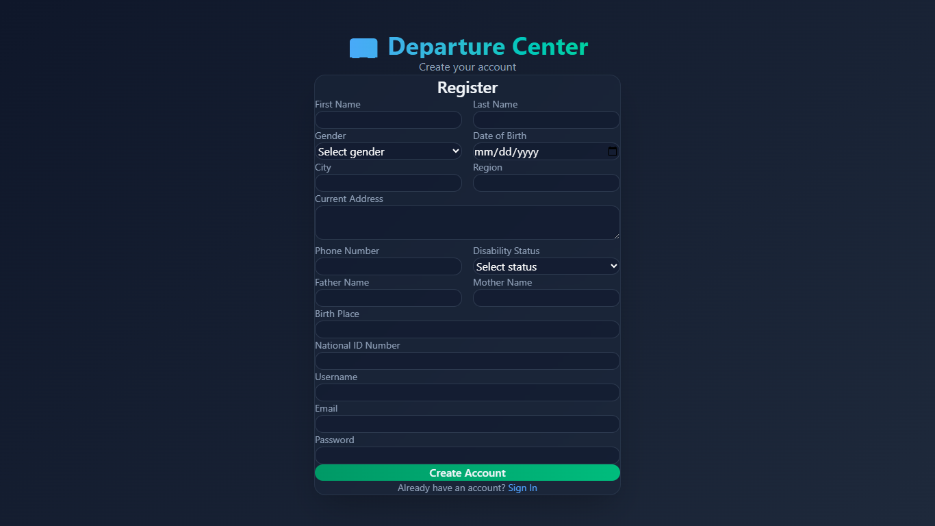
Figure 53 interface register
2.login
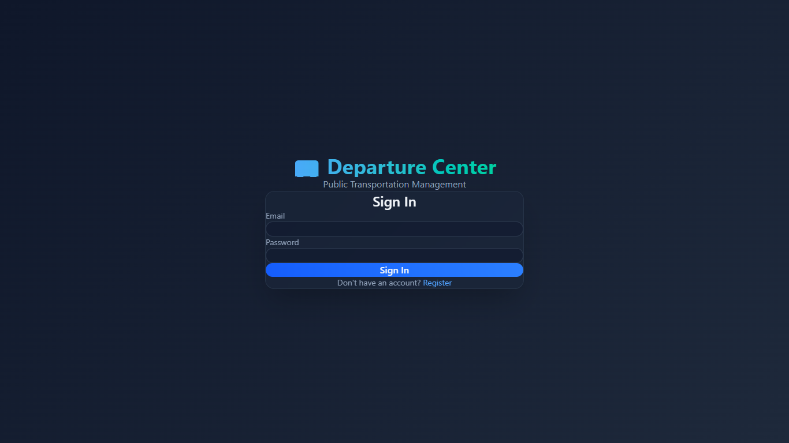
Figure 54 interface login
3.Admin Manage users
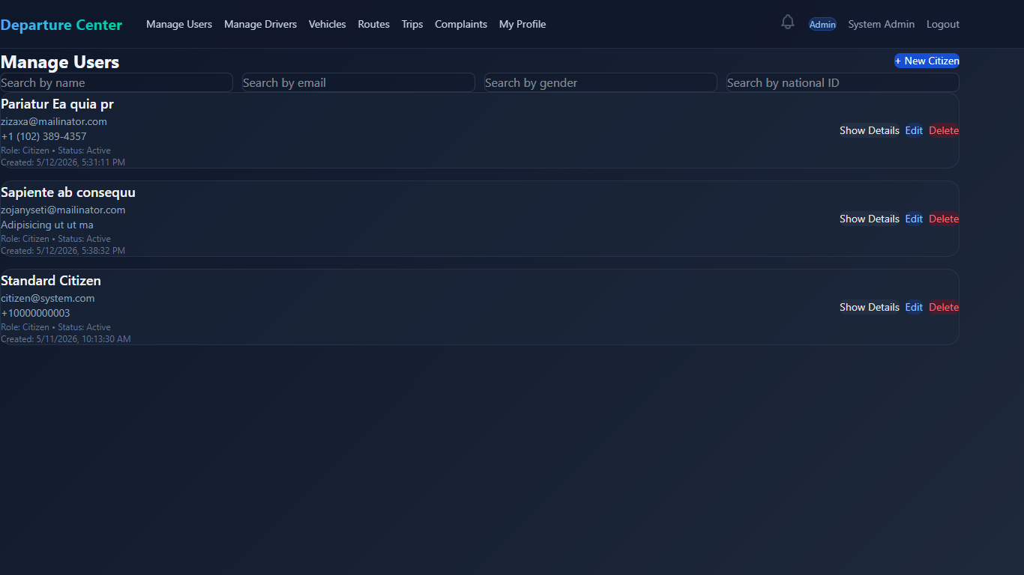
Figure 55 interfadce adman users
4.Admin add user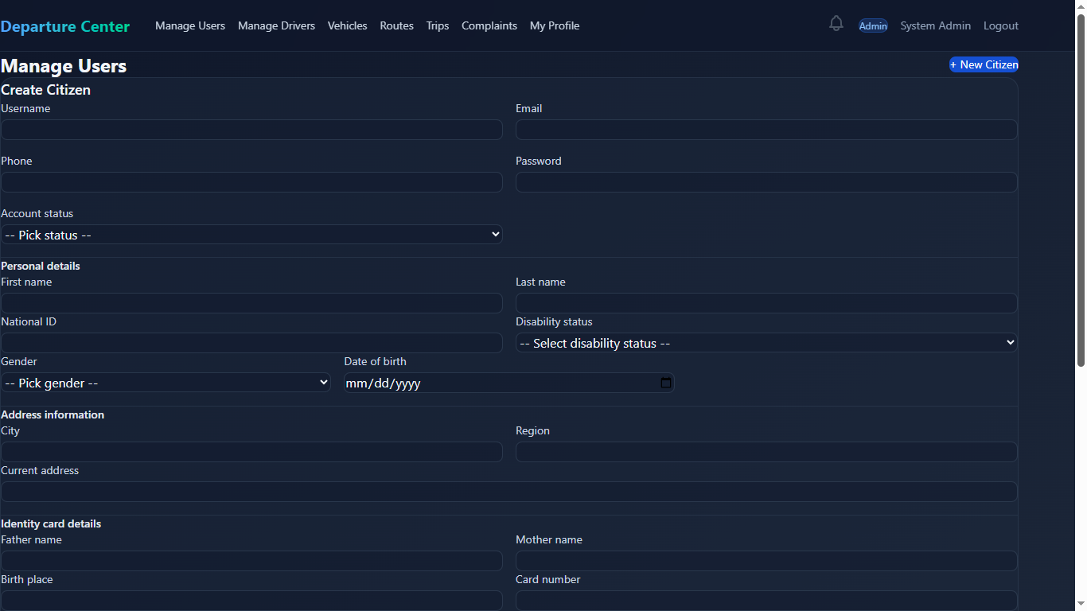
Figure 56 interface add user
5.Admin edit user
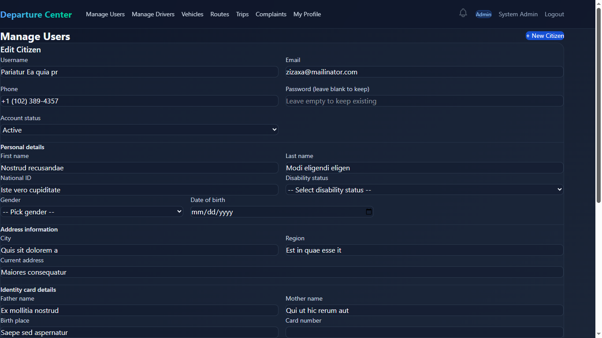
Figure 57 interface edit user
6.Admin select user (show user details)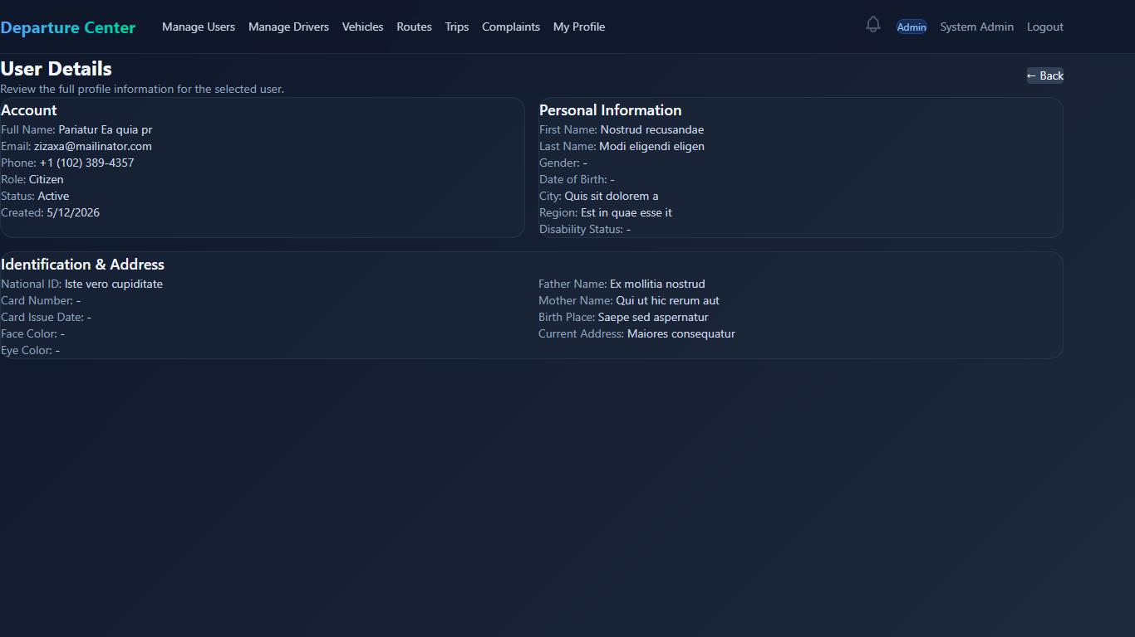
Figure 58 interface show user details
7.Admin Manage Drivers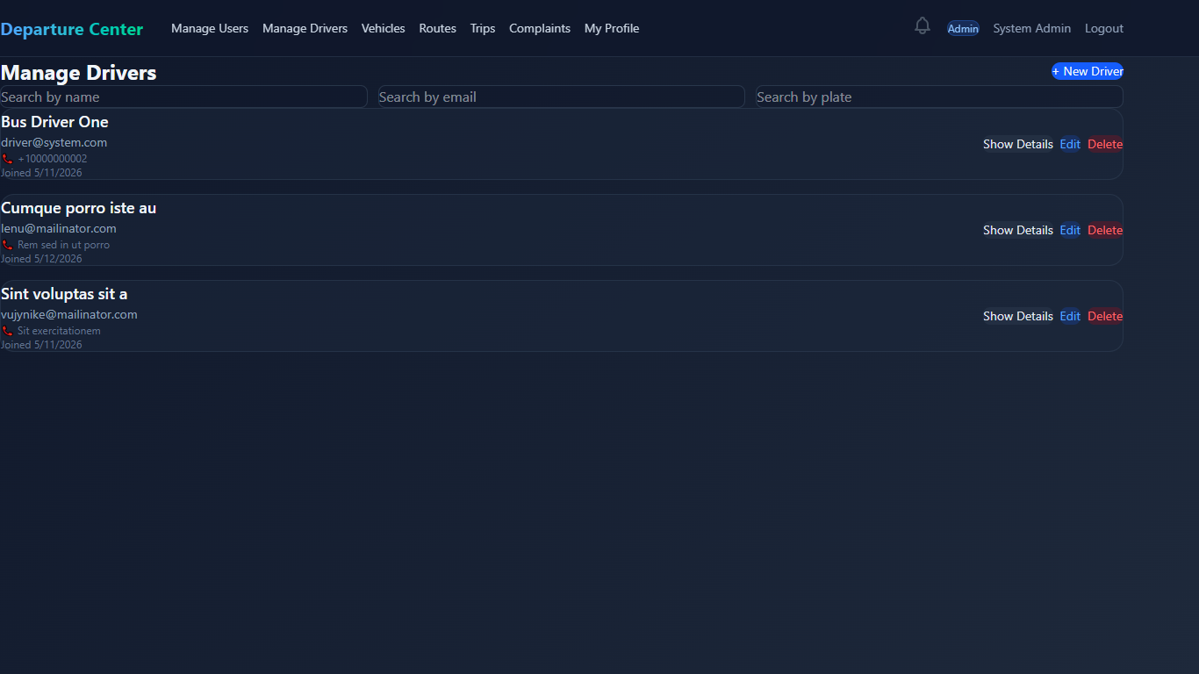
Figure 59 interface mange drivers
8.Admin Add Driver
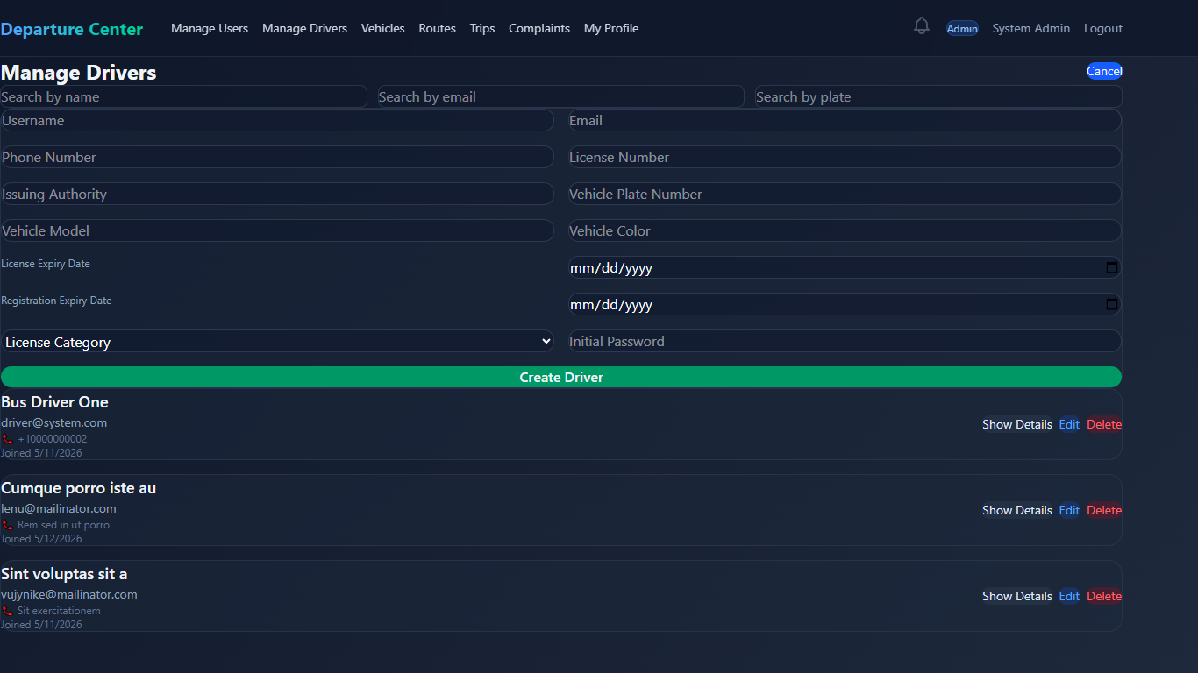
Figure 60 interface add driver
9.Admin update Driver
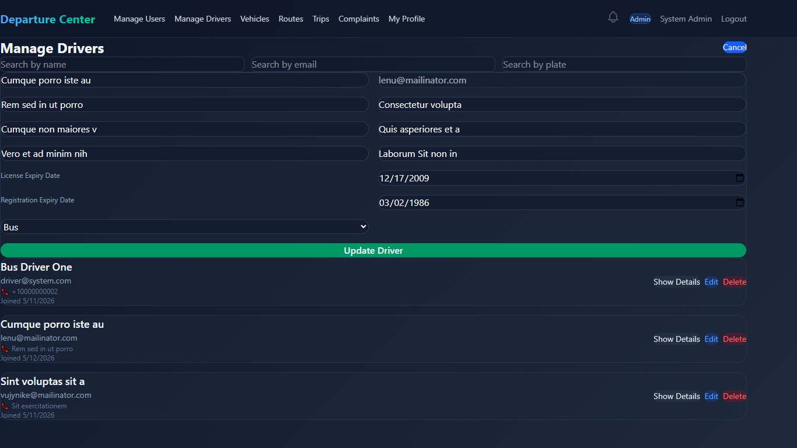
Figure 61 interface update driver
10.Admin show Driver details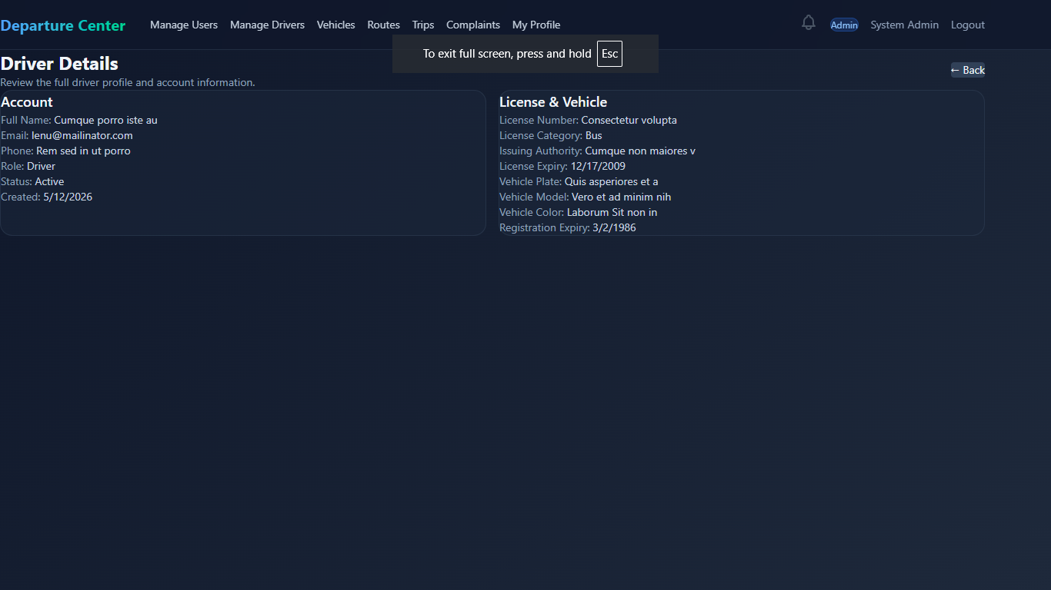
Figure 62 interface show driver derails
11.Admin Manage Vehicles
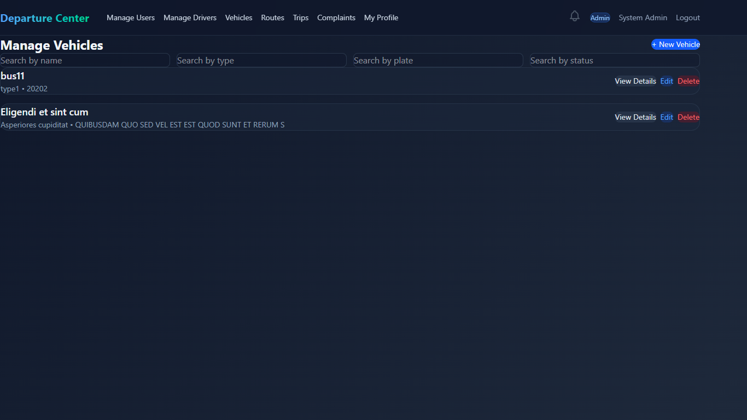
Figure 63 interface mange vehicles
12.Admin Add Vehicle
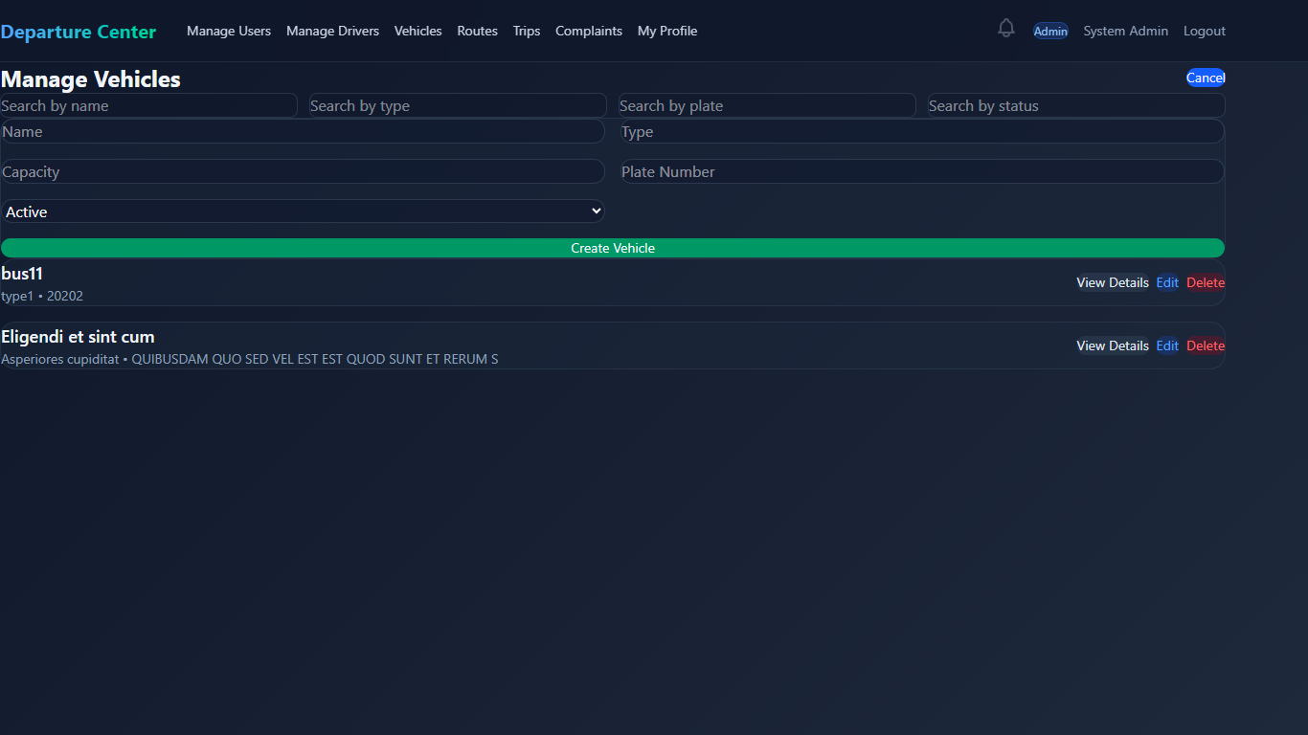
Figure 64 interface add vehicle
13.Admin update Vehicle
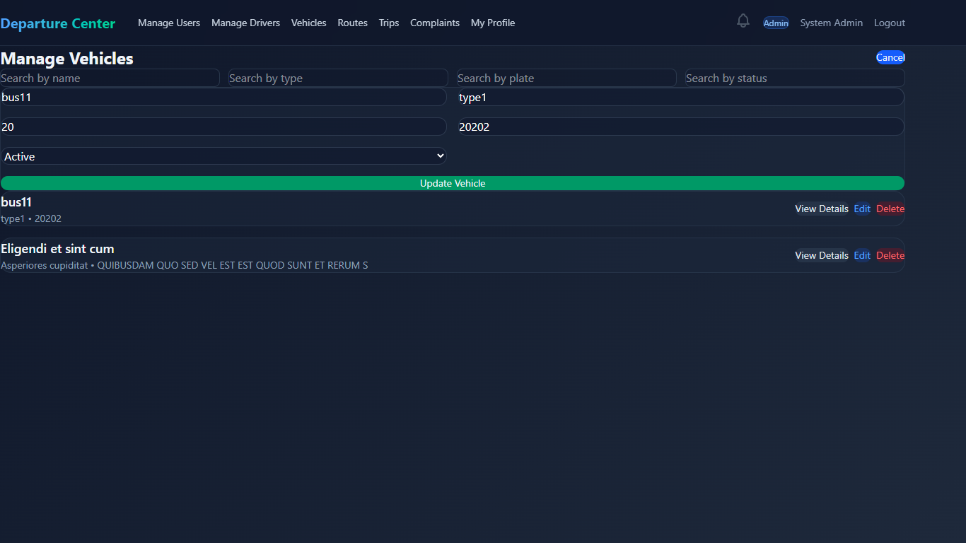
Figure 65 interface update vehicle
14.Admin show Vehicle Details
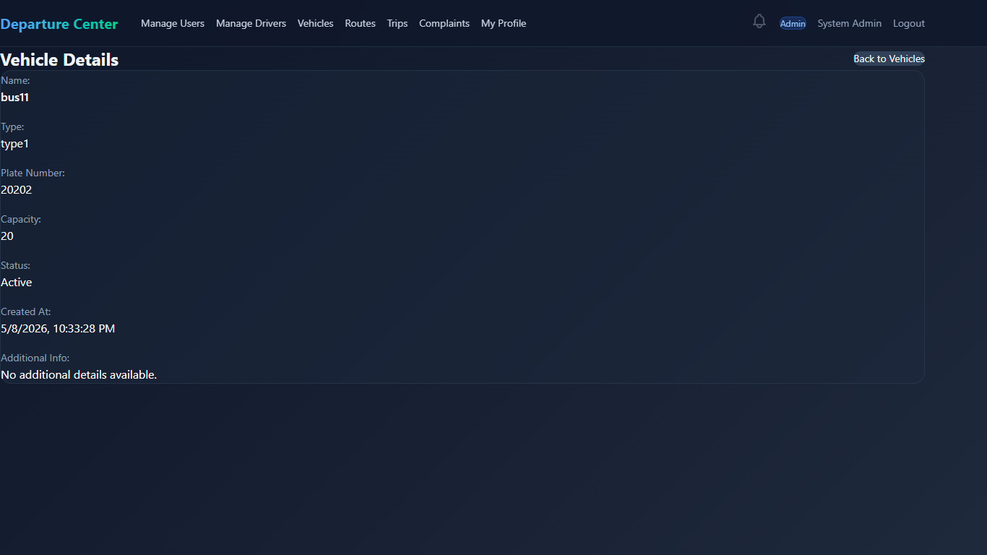
Figure 66 intreface show vehicle detalils
15.Admin Logout (same all users)
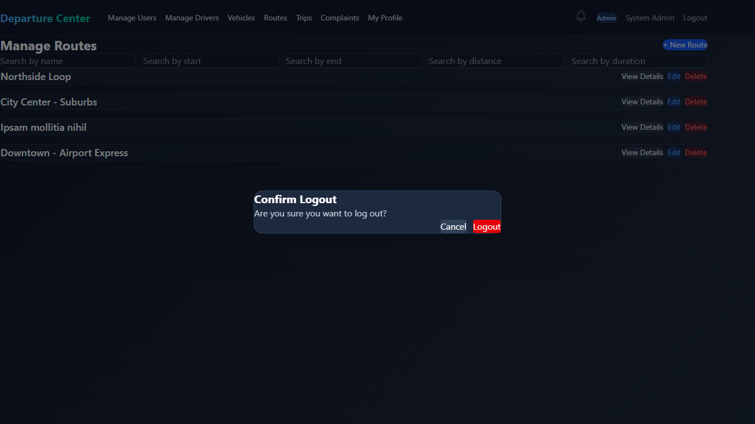
Figure 67 interface logout
16.Admin Manage Routes
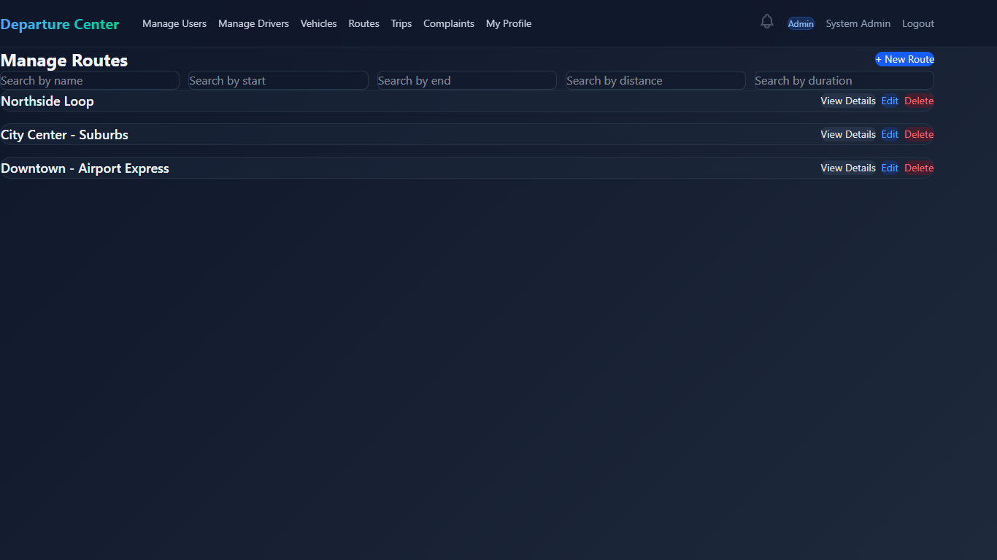
Figure 68 interface manage routes
17.Admin Add Route
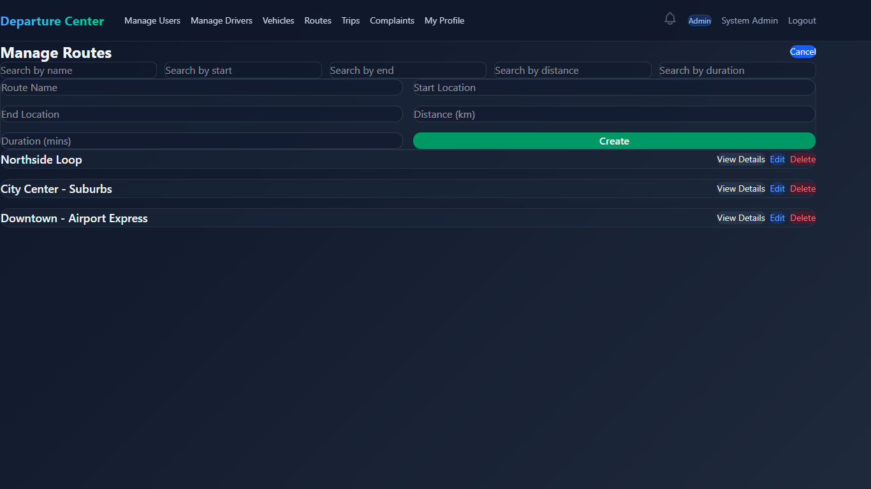
Figure 69 interface admin add rouit
18.Admin update Routes
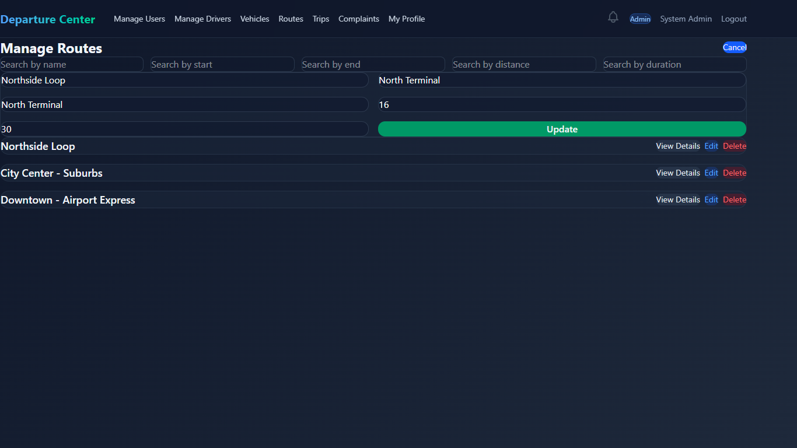
Figure 70 interface update routes
19.Admin show Route Details
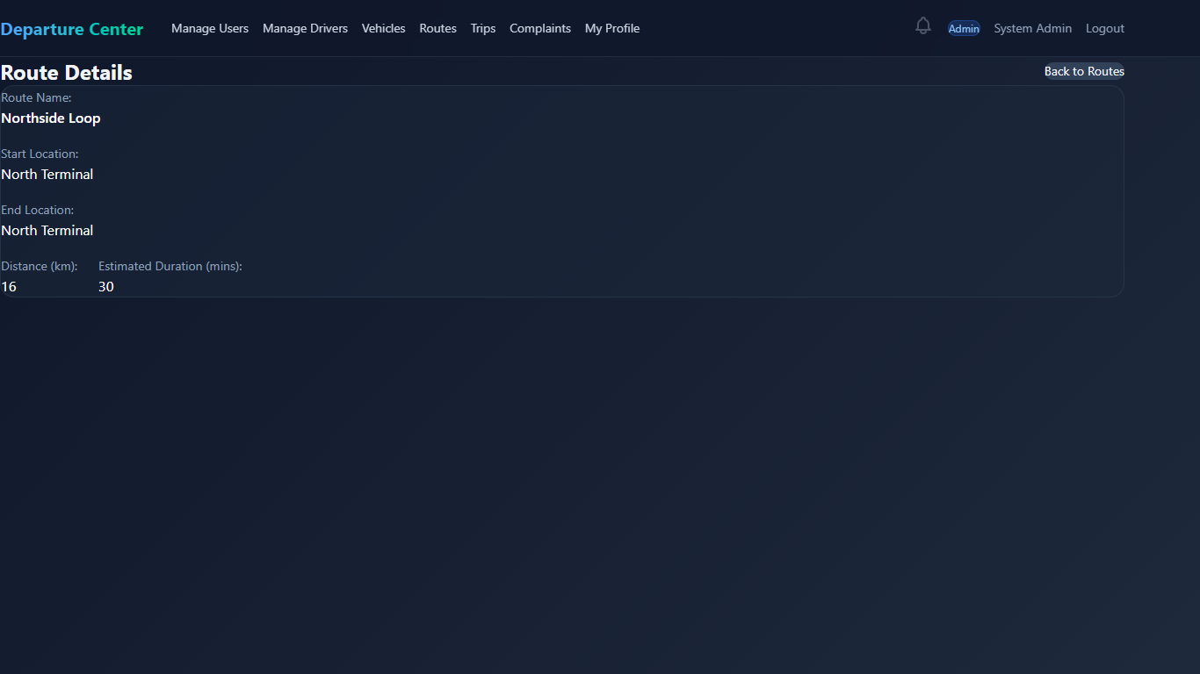
Figure 71 interface show route details
20.Admin Manage Trips
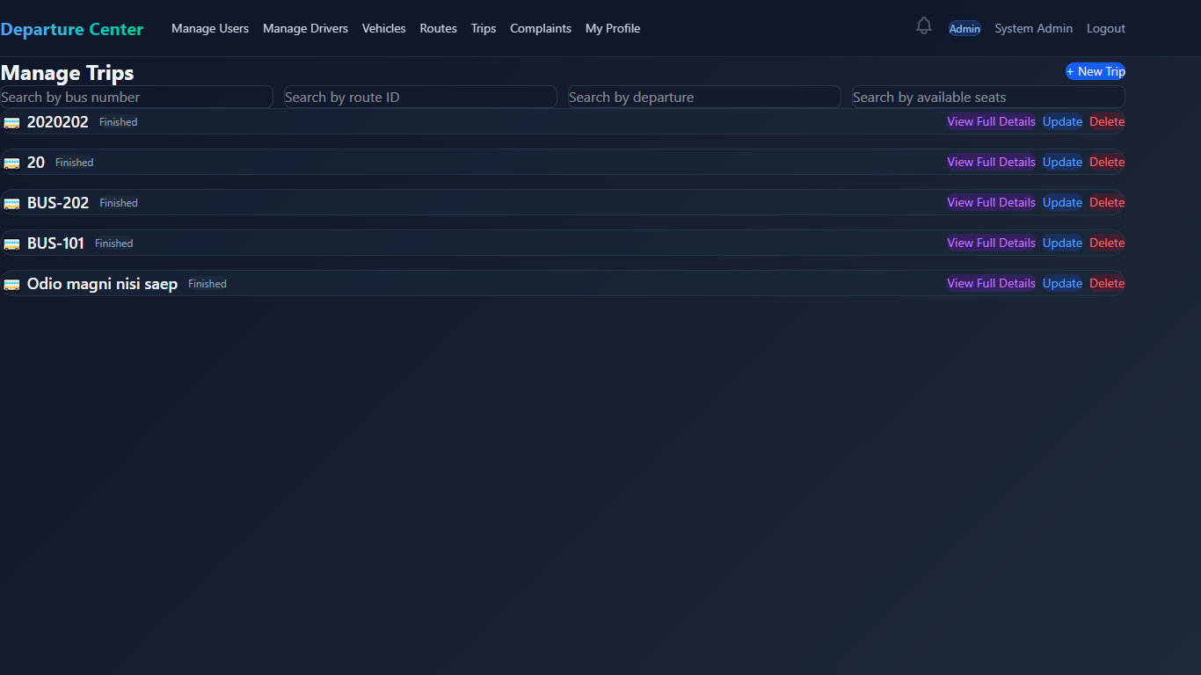
Figure 72 interface manage trips
21.Admin Add Trip
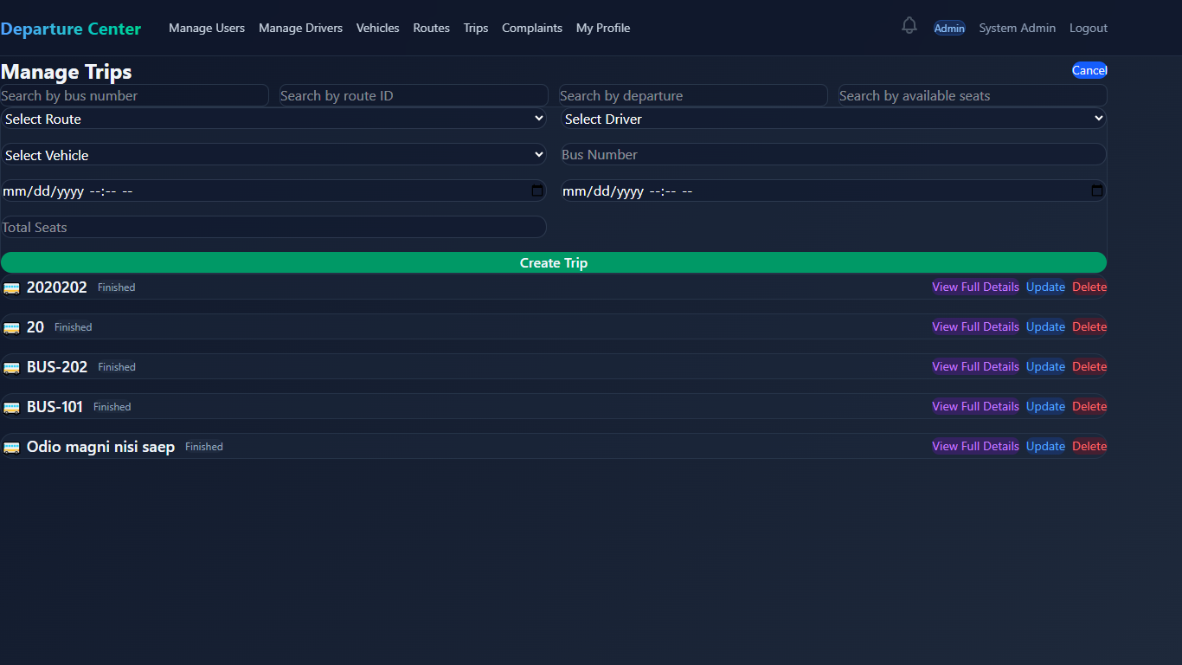
Figure 73 interface add trip
22.Admin Update Trip
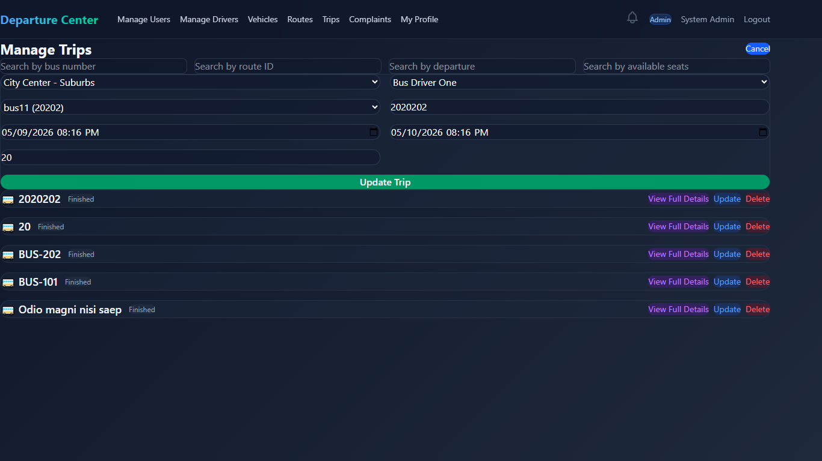
Figure 74 interface add trip
23.Admin show Trip Details
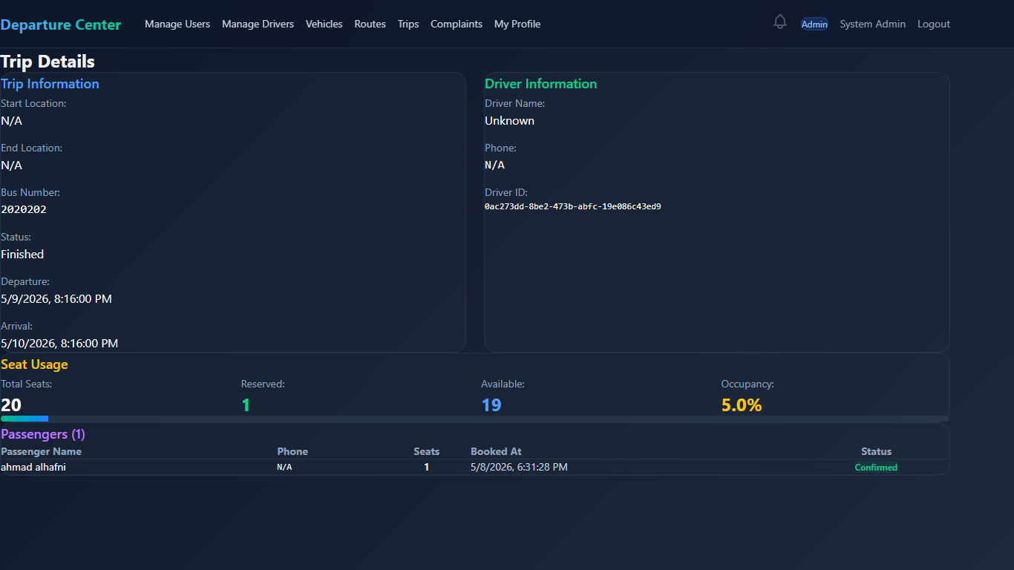
Figure 75 interface show trip details
24.Admin Manage Complaints
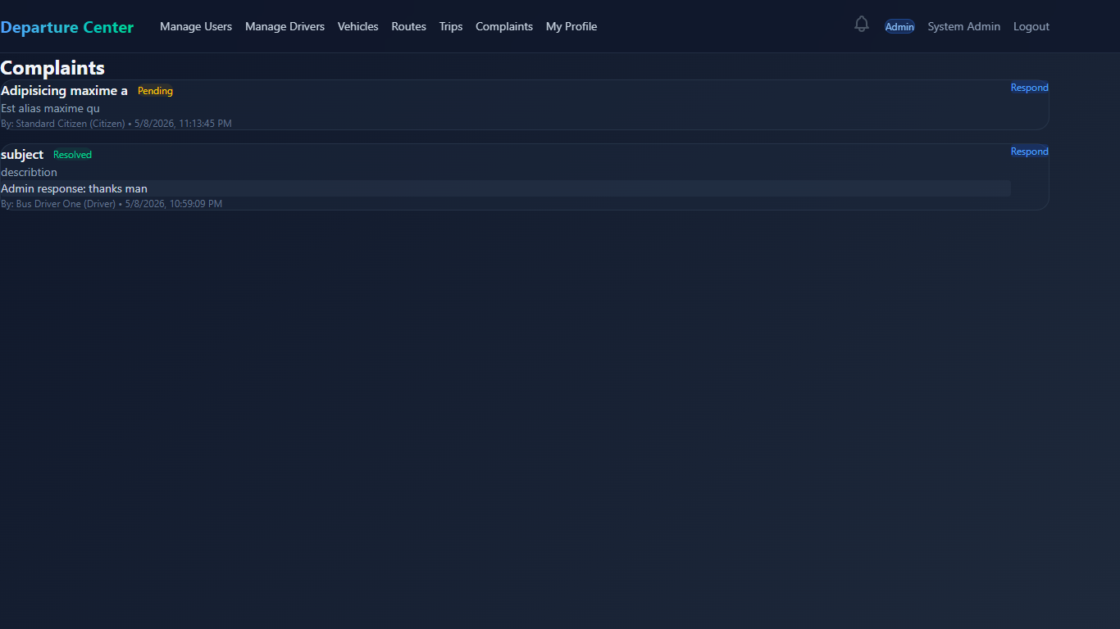
Figure 76 interface mange complaints
25.Admin Response to a Complaint
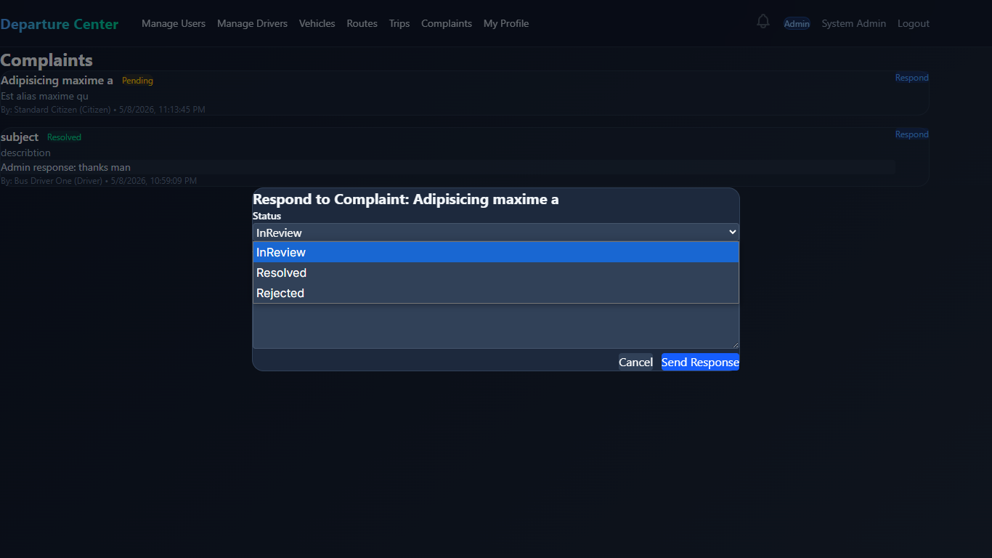
Figure 77 interface respose to a complaint
26.Admin Manage Profile
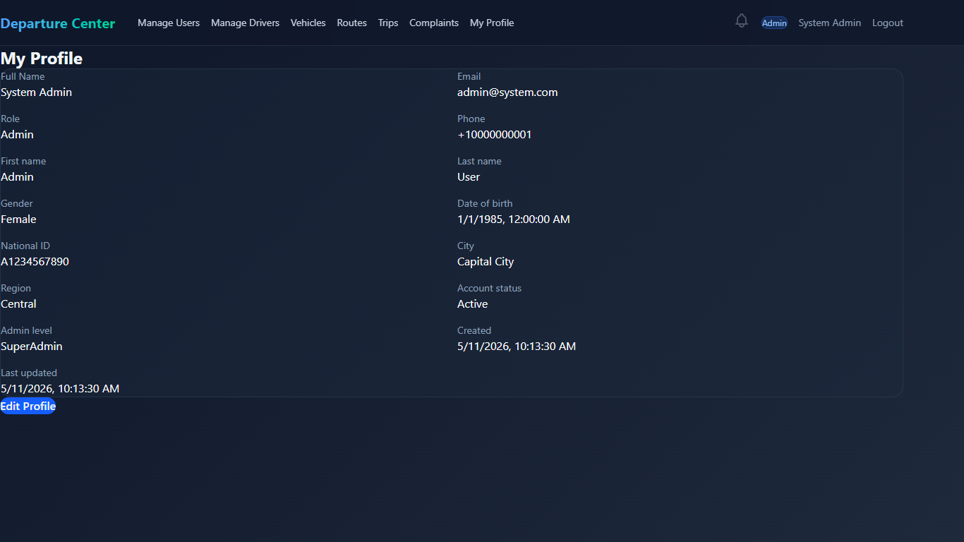
Figure 78 interface manage profile
27.Admin edit Profile info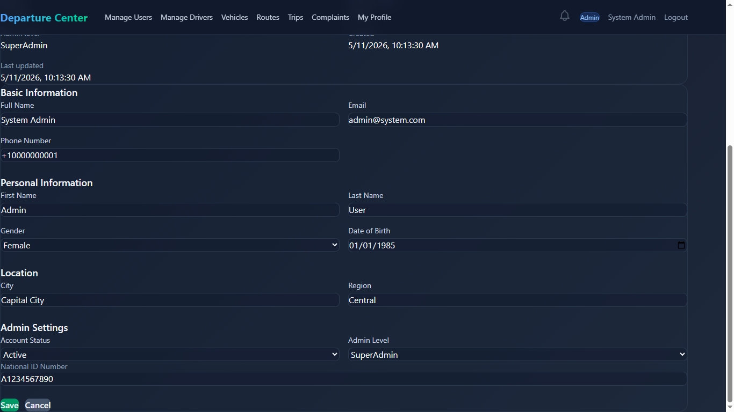
Figure 79 interface edit profile info
28.Driver Manage Trips
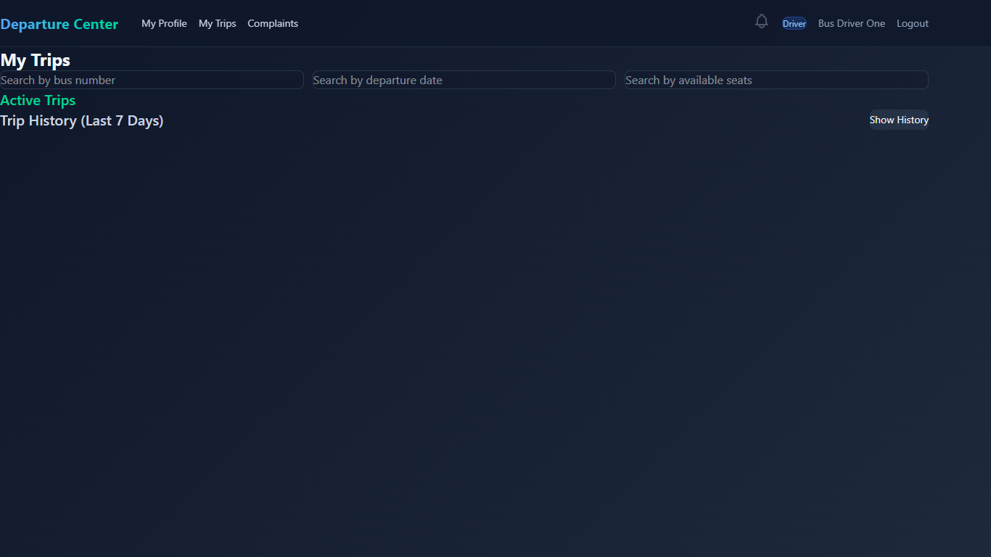
Figure 80 interface driver manage trips
29.Driver Manage complaints
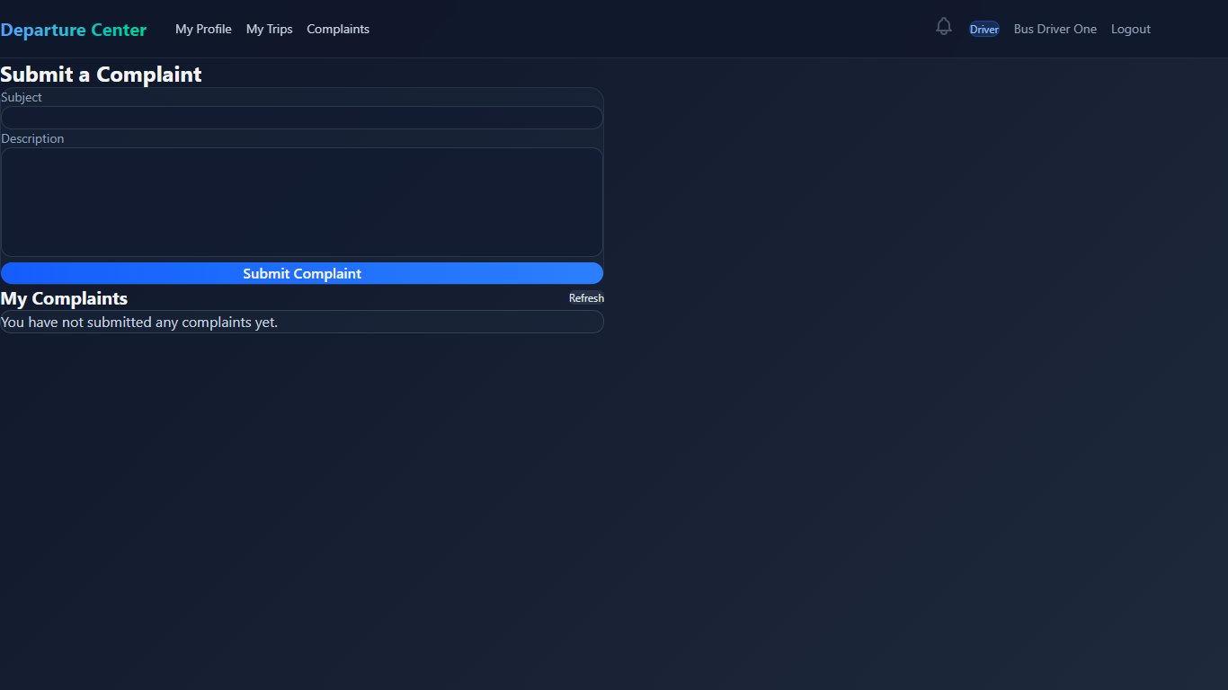
Figure 81 interface driver manage complaints
30.Citizen Manage Profile
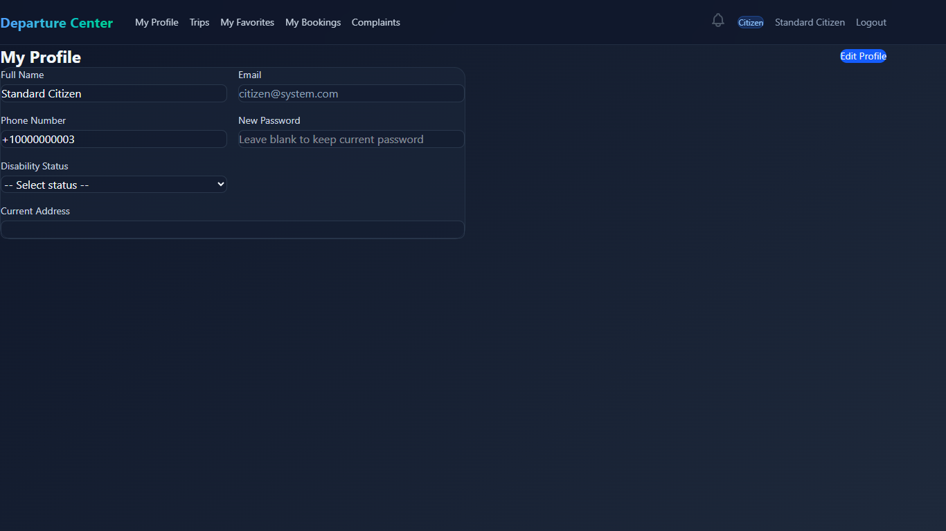
Figure 82 interface citizen manage profile
30.Citizen Edit Profile info
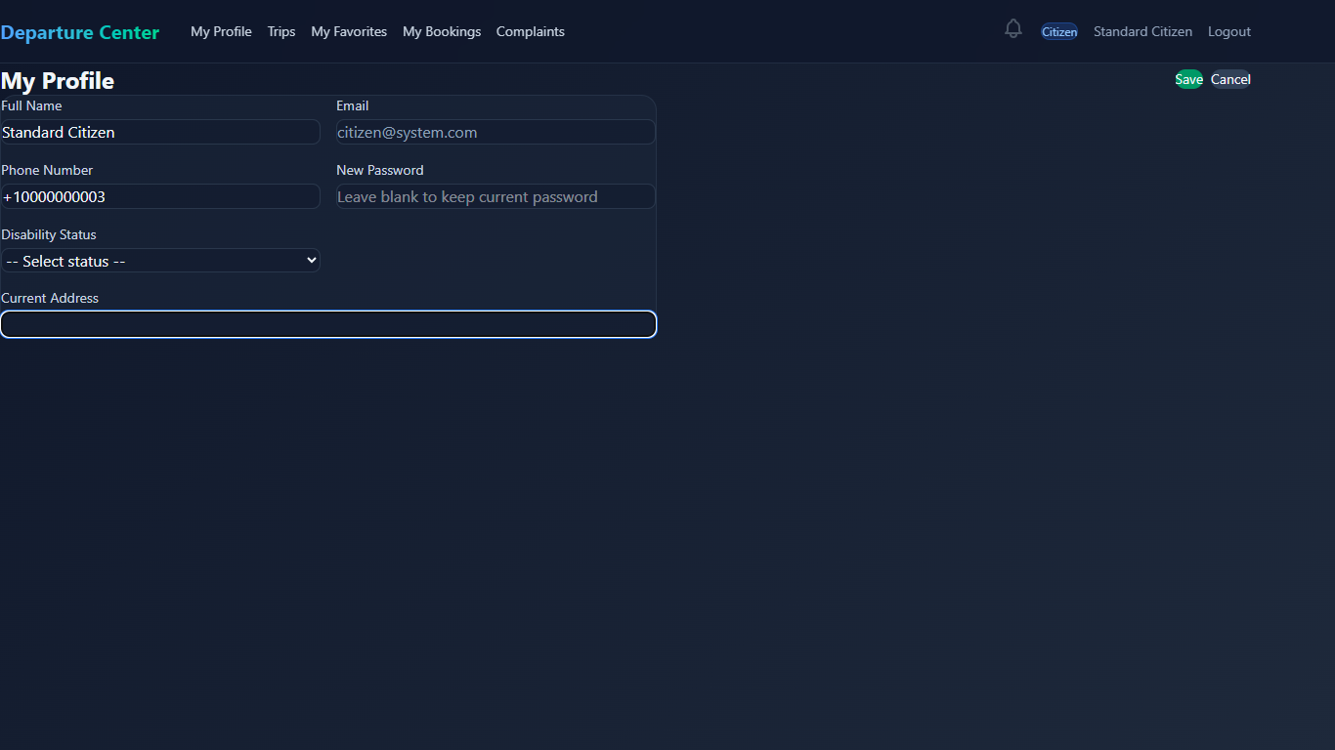
Figure 83 interface citizen edit progile info
31.Citizen Available Rotes Page
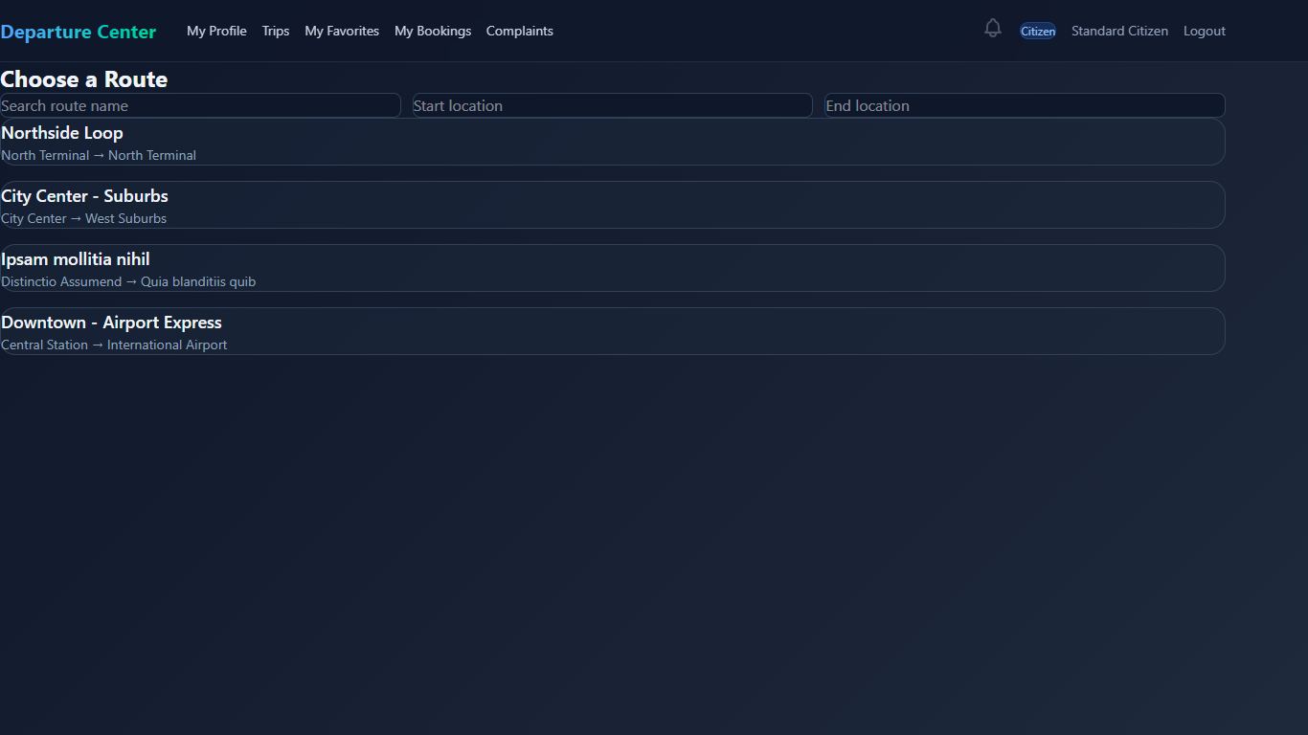
Figure 84 interface citizen avalabel rotes pasge
32.Citizen Trips inside a Route page and booking page
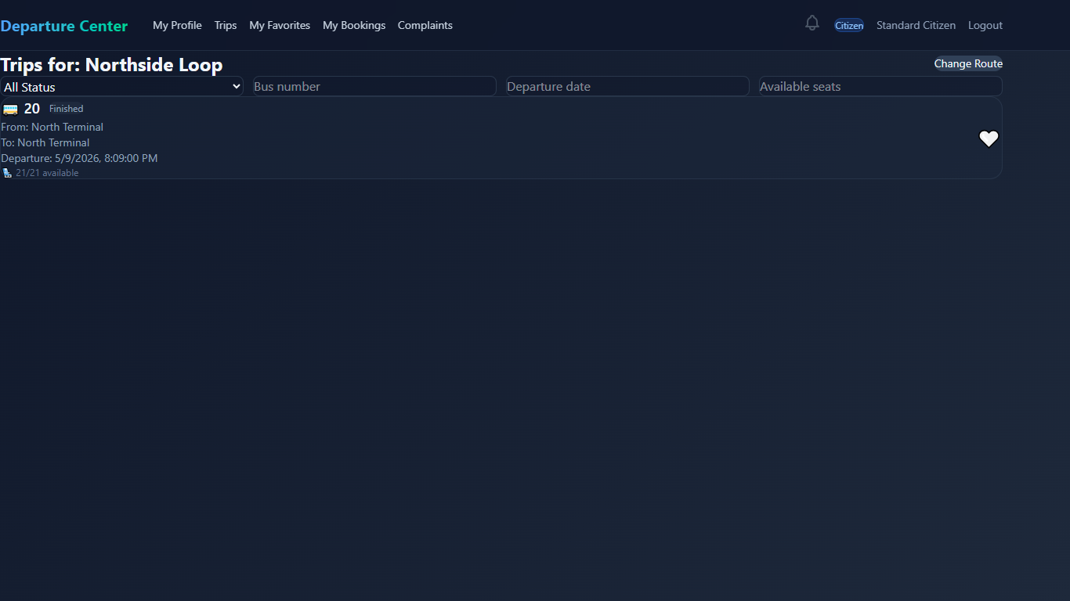
Figure 85 interface Citizen Trips inside a Route page and booking page
33.Citizen My Favorite Page
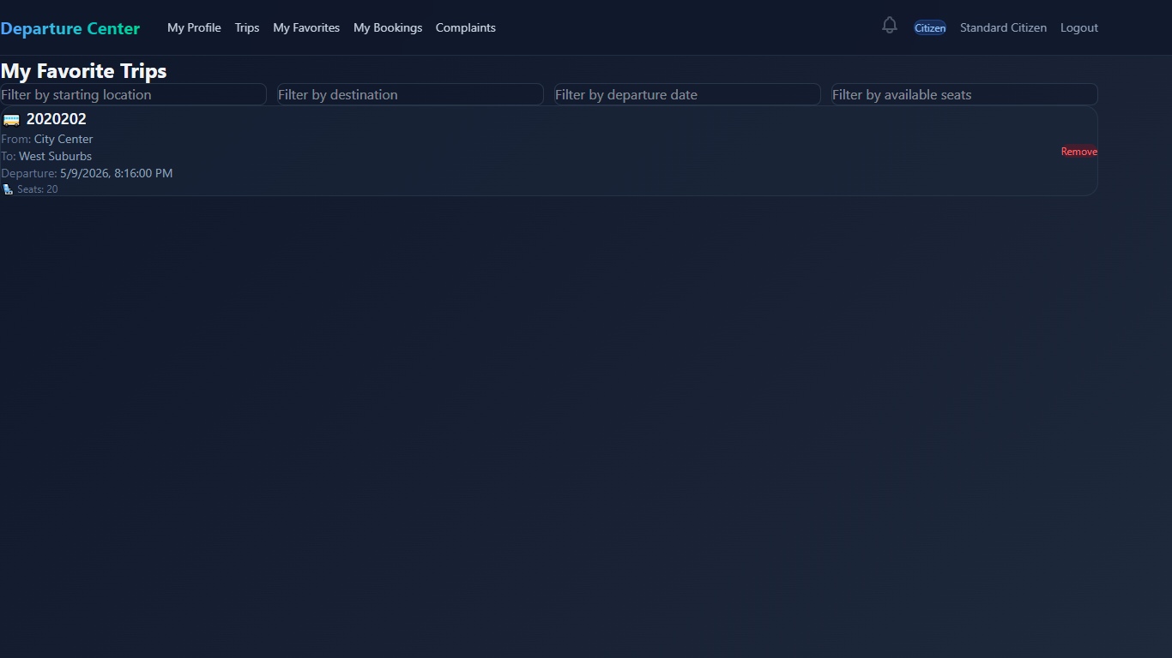
Figure 86 interface my favorite trips
34.Citizen My Bookings Page
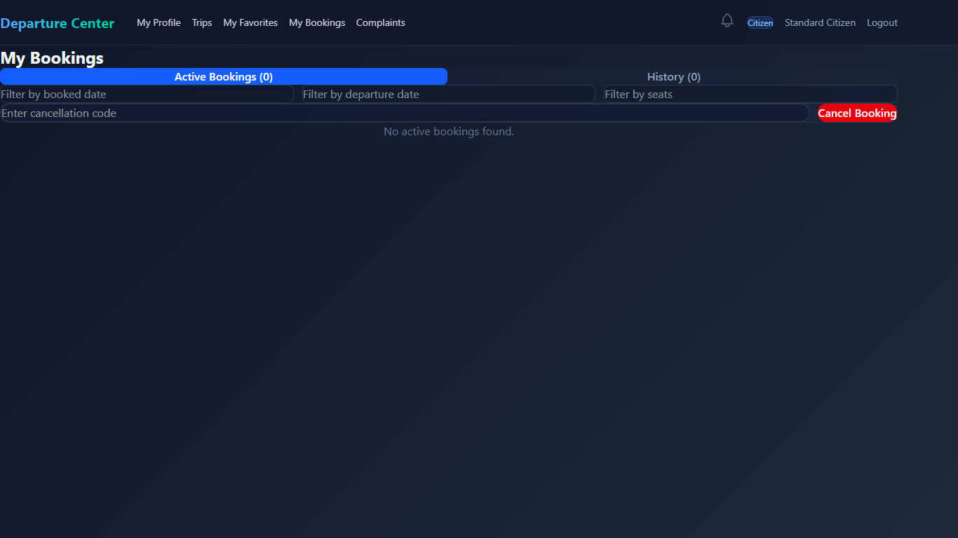
Figure 87 interface my booking page
35.Citizen My History Bookings Page
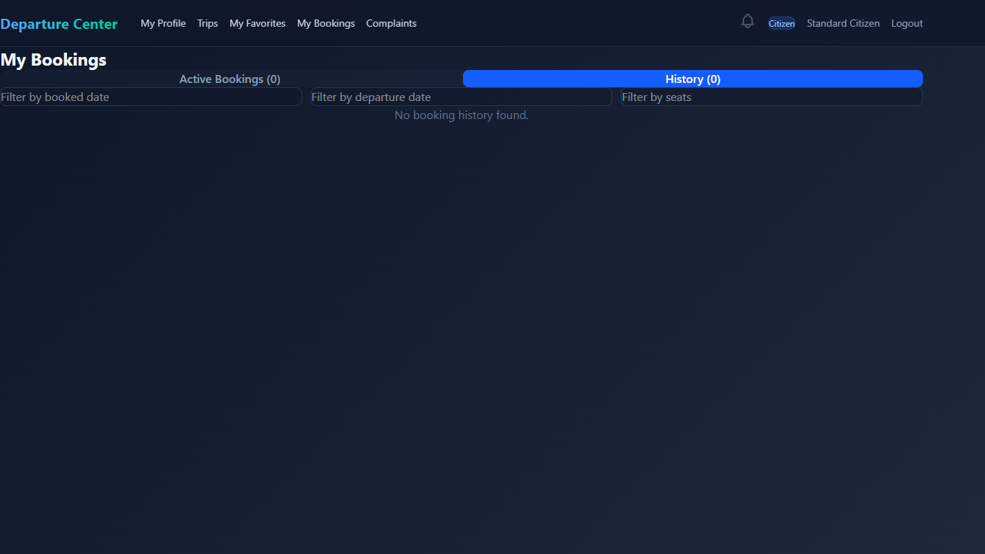
Figure 88 interface my history
36.Citizen Manage Complaints Page
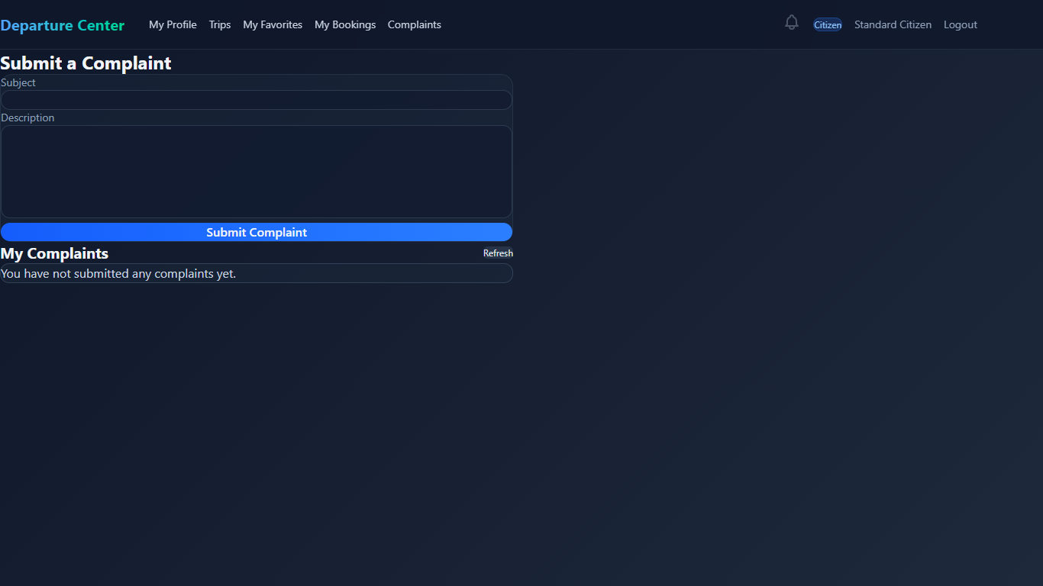
Figure 89 interface citizen complaints

7.7 Performance Testing Implementation
The system performance was tested using k6 load testing scripts.
Testing Objectives
- Measure API response time
- Evaluate concurrent user handling
- Detect bottlenecks
- Test system stability under load
k6 Test Example
import http from 'k6/http';
import { sleep } from 'k6';
export default function () {
http.get('http://localhost:5000/api/trips');
sleep(1);
}
Testing Scenarios
- Concurrent booking requests
- Authentication stress testing
- Trip retrieval performance
- Gateway routing performance

7.8 Summary
The DepartureCenterSystem implementation follows a scalable microservices architecture combined with Clean Architecture principles. The system was implemented using ASP.NET Core, React, SQL Server, Docker, and Entity Framework Core. Each service was independently structured and deployed, enabling better maintainability, scalability, and extensibility. The use of JWT authentication, API Gateway routing, repository patterns, dependency injection, and load testing tools contributed to building a robust and production-oriented software system.

Chapter 8

Testing

and Evaluation

8.1 Testing Plan
The testing phase of the DepartureCenterSystem project was designed to ensure that the system functions correctly, performs efficiently under different workloads, and maintains acceptable security and reliability standards. The testing process focused primarily on API validation, performance testing, load testing, and security assessment.
The testing activities were performed throughout the development lifecycle to continuously validate system stability and functionality.
Testing Objectives
The main objectives of the testing process were:
- Verify that all APIs function correctly
- Ensure stable communication between microservices
- Validate authentication and authorization mechanisms
- Measure system performance under different workloads
- Detect bottlenecks and performance limitations
- Evaluate system behavior during stress conditions
- Assess the security posture of exposed APIs
Testing Tools Used
Tool | Purpose
Postman | Manual API testing and endpoint validation
k6 | Load and performance testing
Docker Compose | Test environment orchestration

8.2 Types of Tests
The project included multiple categories of testing to evaluate different aspects of the system.

8.2.1 Functional Testing
Functional testing was performed manually using Postman to validate API behavior and business workflows.
Functional Testing Scope
- User registration
- User authentication
- JWT token validation
- Trip retrieval
- Booking creation
- Complaint submission
- Authorization and role validation

8.2.1.1 Add Driver Test Case Table
Test Case ID | Use Case ID | Test Case Name | Preconditions | Test Steps | Test Data | Expected Result | Status
TC-01 | UC-01 | Add Driver | User is logged in, dashboard is loaded, and user is on Manage Drivers page | 1. Click "Manage Drivers"  2. Click "New Driver"  3. Enter valid driver information 4. Click "Create Driver" | Valid Username, Email, Phone Number, License Number, Vehicle Details, Expiry Dates, License Category, Password | System validates data, saves the new driver, and displays message: "Driver created successfully" | Pass
TC-02 | UC-01 | Add Driver with Duplicate Email | User is logged in, dashboard is loaded, and user is on Manage Drivers page | 1. Click "Manage Drivers"  2. Click "New Driver"  3. Enter driver information using an existing email  4. Click "Create Driver" | Email: existing@test.com | System displays error message: "Email already in use" and the driver is not created | Pass

8.2.1.2 Update Driver Test Case Table
Test Case ID | Use Case ID | Test Case Name | Preconditions | Test Steps | Test Data | Expected Result | Status
TC-01 | UC-02 | Update Driver | User is logged in, on Manage Drivers page, and driver already exists | 1. Click "Edit" on a driver  2. System displays edit form  3. Modify valid driver information 4. Click "Update Driver"  5. Confirm update | Updated Username, Phone Number, License Details, Vehicle Details, Expiry Dates, License Category | System saves changes and displays message: "Driver updated successfully" | Pass
TC-02 | UC-02 | Update Driver with Invalid Data | User is logged in, on Manage Drivers page, and driver already exists | 1. Click Edit on a driver  2.Modifydriver information with invalid data  3.ClickUpdate Driver | Invalid Phone Number or invalid expiry date | System displays validation error message and does not save changes | Pass

8.2.1.3 Add Vehicle Test Case Table
Test Case ID | Use Case ID | Test Case Name | Preconditions | Test Steps | Test Data | Expected Result | Status
TC-01 | UC-05 | Add Vehicle | User is logged in, dashboard is loaded, and user is on Manage Vehicles page | 1.Navigate to Manage Vehicles  2. Click "New Vehicle"  3. Enter valid vehicle information 4.Click "Create Vehicle" | Name: Truck A, Type: Heavy, Capacity: 5000kg, Plate Number: ABC123, Status: Active | System validates data, saves the new vehicle, and displays message: "Vehicle created successfully" | Pass
TC-02 | UC-05 | Add Vehicle with Duplicate Plate Number | User is logged in, dashboard is loaded, and user is on Manage Vehicles page | 1.Navigate to "Manage Vehicles  2. Click "New Vehicle"  3. Enter vehicle information using existing plate number  4. Click "Create Vehicle" | Plate Number: Existing123 | System displays error message for duplicate plate number and vehicle is not created | Pass

8.2.1.4 Delete Vehcile Test Case Table
Test Case ID | Use Case ID | Test Case Name | Preconditions | Test Steps | Test Data | Expected Result | Status
TC-01 | UC-07 | Delete Vehicle | User is logged in, on Manage Vehicles page, and vehicle exists | 1. Click "Delete" on a vehicle  2. System shows confirmation message  3. Click "Delete" to confirm | Existing Vehicle Record | System removes the vehicle from database and displays message: "Vehicle deleted successfully" | Pass
TC-02 | UC-07 | Cancel Vehicle Deletion | User is logged in, on Manage Vehicles page, and vehicle exists | 1. Click "Delete" on a vehicle  2. System shows confirmation message  3. Click "Cancel" | Existing Vehicle Record | System keeps the vehicle unchanged and no deletion occurs | Pass

8.2.1.5 Submit Complaint Test Case Table
Test Case ID | Use Case ID | Test Case Name | Preconditions | Test Steps | Test Data | Expected Result | Status
TC-01 | UC-13 | Submit Complaint | User is logged in and dashboard is loaded | 1. Click "Complaints" from dashboard  2. System displays complaint form  3. Enter valid subject and description  4. Click "Submit Complaint" | Subject: Late Bus, Description: The bus arrived 30 minutes late | System validates input, saves complaint with status "Pending", displays success message, and shows complaint under "My Complaints" | Pass
TC-02 | UC-13 | Submit Complaint with Missing Required Fields | User is logged in and dashboard is loaded | 1. Click "Complaints" from dashboard  2. Leave subject or description empty  3. Click "Submit Complaint" | Missing Subject or Description | System displays validation error message and complaint is not submitted | Pass

8.2.1.6 Reply to Complaint Test Case Table
Test Case ID | Use Case ID | Test Case Name | Preconditions | Test Steps | Test Data | Expected Result | Status
TC-01 | UC-16 | Reply to Complaint | Garage Manager is logged in, complaints list is displayed, and complaint exists | 1. Select a complaint 2. Click "Response"  3. System displays response form  4. Enter valid status and admin response  5. Click "Send Response" | Status: Resolved, Admin Response: Issue has been fixed, Description: Bus schedule adjusted | System validates input, saves response, updates complaint status, displays confirmation message, and response becomes visible in user's "My Complaints" | Pass
TC-02 | UC-16 | Reply to Complaint with Missing Input | Garage Manager is logged in, complaints list is displayed, and complaint exists | 1. Select a complaint  2. Click "Response"  3. Leave required fields empty  4. Click "Send Response" | Missing Admin Response or Status | System displays validation error message and no response is saved | Pass

8.2.1.7 Update Profile Test Case Table
Test Case ID | Use Case ID | Test Case Name | Preconditions | Test Steps | Test Data | Expected Result | Status
TC-01 | UC-20 | Update Profile | User is logged in and Profile page is displayed | 1. Click "Edit Profile"  2.Modify allowed fields based on role  3. Click "Save" | Ex:Full Name: Ahmad Alhafni, Phone Number: 0999999999, Address: Damascus | System validates input, updates profile data, and displays message: "Profile updated successfully" | Pass
TC-02 | UC-20 | Update Profile with Invalid Input | User is logged in and Profile page is displayed | 1. Click "Edit Profile"  2. Enter invalid data in editable fields  3. Click "Save" | Invalid Phone Number or empty required field | System displays validation error message and profile is not updated | Pass

8.2.1.8 View Trip History Test Case Table
Test Case ID | Use Case ID | Test Case Name | Preconditions | Test Steps | Test Data | Expected Result | Status
TC-01 | UC-17 | View Trip History | Driver is logged in and dashboard is loaded | 1. Click "My Trips"  2. System displays active trips  3. Click "Show History"  4. System displays trip history | Existing Trip History data | System display trip history correctly, | Pass
TC-02 | UC-17 | No History Available | Driver is logged in and dashboard is loaded | 1. Click "My Trips"  2. System shows no history trips | No trip records in system | System displays appropriate messages: "No trip history available" | Pass

8.2.1.9 Delete Citizen Test Case Table
Test Case ID | Use Case ID | Test Case Name | Preconditions | Test Steps | Test Data | Expected Result | Status
TC-01 | UC-11 | Delete Citizen | User is logged in, on Manage Users page, and citizen exists | 1. Click "Delete" on a citizen  2. System displays confirmation message  3. Click "Delete" to confirm | Existing Citizen Record | System removes citizen from database and displays message: "Citizen deleted successfully" | Pass
TC-02 | UC-11 | Cancel Citizen Deletion | User is logged in, on Manage Users page, and citizen exists | 1. Click "Delete" on a citizen  2. System displays confirmation message  3. Click "Cancel" | Existing Citizen Record | System keeps citizen unchanged and no deletion occurs | Pass

Example API Test Cases
Test Case | Expected Result
Login with valid credentials | JWT token returned
Login with invalid password | 401 Unauthorized
Create booking with valid data | Booking successfully created
Access protected endpoint without token | 401 Unauthorized
Submit complaint | Complaint stored successfully

Example Postman Request
Login API
This endpoint is used to authenticate a user by logging them into the system. It accepts user credentials and, upon successful authentication, returns a token that can be used for subsequent requests.
Request
- Method: POST
- URL: {{authBaseUrl}}/api/Auth/login
Request Body
The request body must be in JSON format and should include the following parameters:
- email (string): The email address of the user attempting to log in.
- password (string): The password associated with the user's account.

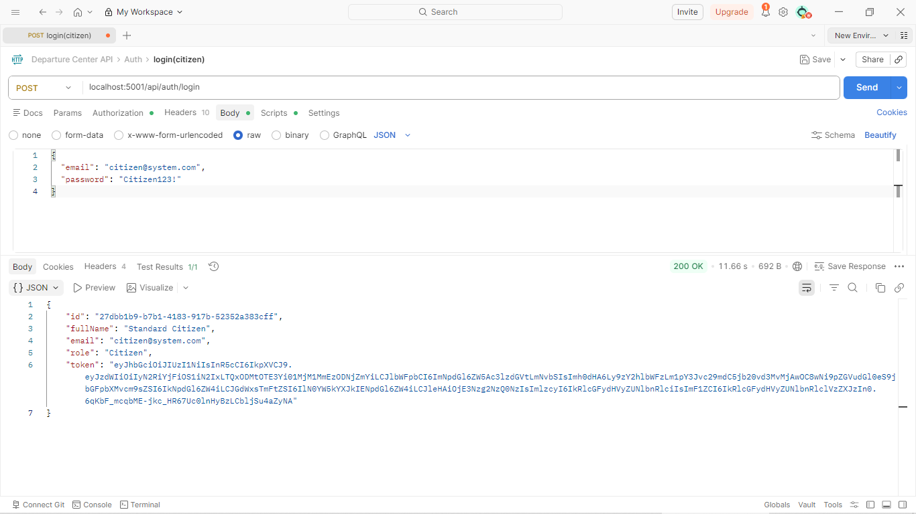

8.2.2 Performance and Load Testing
Performance testing was implemented using k6 to evaluate system responsiveness, scalability, and stability under concurrent traffic conditions.
k6 Testing Structure
k6-tests/
├── utils/
├─────helper.js
├─────config.js
└── scenarios/
├─────laod.js
├─────smoke.js
├─────spike.js
├─────stress.js

Performance Test Scenarios
The project supports multiple load-testing scenarios:
Scenario | Description
Smoke Test | Basic workflow validation
Load Test | Normal expected traffic
Stress Test | Heavy load and saturation testing
Spike Test | Sudden traffic increase and recovery testing

Test Execution
Local Execution
cd k6-tests & k6 run filename.js
Environment Variables
Variable | Description
K6_BASE_URL | API Gateway base URL
K6_USER_EMAIL | Test account email
K6_USER_PASSWORD | Test account password
K6_REGISTER | Register new user before tests
K6_SCENARIO | Selected testing scenario

Example Command
K6_BASE_URL=http://localhost:3000 \
K6_SCENARIO=load \
K6_USER_EMAIL=citizen@system.com \
K6_USER_PASSWORD=Citizen123! \
k6 run main.js

Tested Workflows
The k6 suite validates the following workflows through the API Gateway:
- User login and authentication
- Trip browsing and retrieval
- Booking creation
- Booking history retrieval
- Complaint submission

Performance Metrics
The following metrics were monitored during testing:
Metric | Description
http_req_duration p(95) | 95th percentile response time
http_req_duration avg | Average response time
http_req_failed | Request failure percentage
checks | Business validation success rate
vus | Number of virtual users

Target Thresholds
Metric | Target
p(95) Response Time | < 500ms
Average Response Time | < 350ms
Failed Requests | < 1%
Successful Checks | > 99%

Performance Results Placeholder
Smoke Test Results
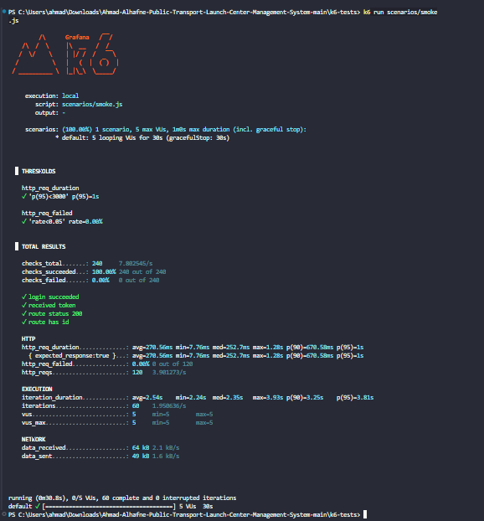

Load Test Results
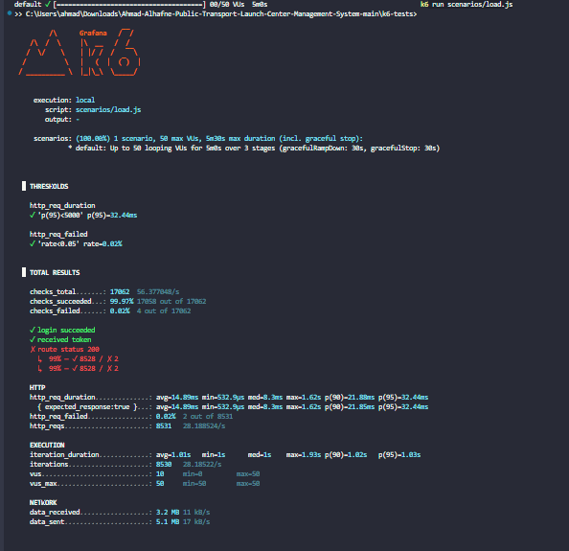

Stress Test Results
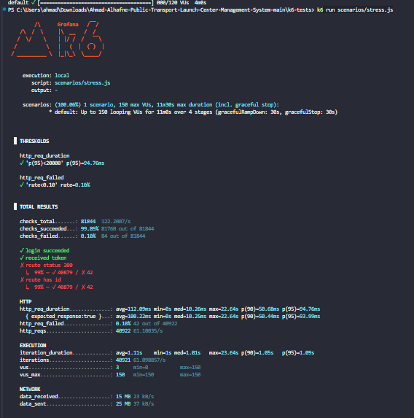

Spike Test Results
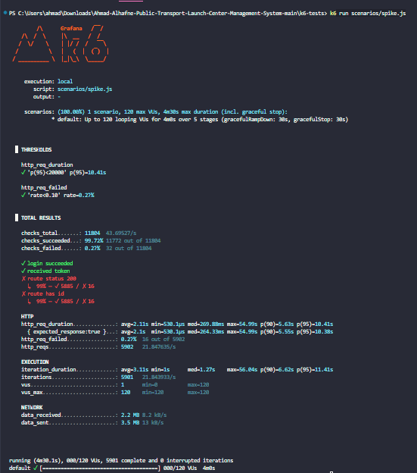

8.3 Testing Environment
The testing environment was containerized using Docker Compose to ensure consistency and reproducibility across different executions.
Test Environment Components
Component | Technology
Backend Services | ASP.NET Core Microservices
Frontend | React + Vite
Database | SQL Server
API Gateway | Ocelot
Performance Testing | k6
Containerization | Docker & Docker Compose

8.4 Testing Architecture
The testing process interacted with the system through the API Gateway to simulate real-world client behavior.
Testing Tools
(Postman / k6 )
↓
API Gateway (Ocelot)
↓
Backend Microservices
↓
SQL Server Databases
This approach ensured that all requests passed through the same routing, authentication, and communication layers used in production environments.

8.5 Test Results and Analysis
The testing process demonstrated that the system was capable of handling normal and high-load scenarios while maintaining acceptable response times and low failure rates.
The API Gateway successfully routed requests between services, and JWT authentication mechanisms operated correctly during concurrent access scenarios.
Performance testing also helped identify potential bottlenecks and resource-intensive operations that could be optimized in future improvements.

8.6 Quality Metrics
The project evaluation focused on several quality indicators.
Metric | Description
Response Time | Average API processing duration
Throughput | Number of handled requests per second
Failure Rate | Percentage of failed requests
Availability | System uptime during tests

8.7 Challenges During Testing
Several challenges were encountered during the testing phase:
- Managing concurrent requests across multiple microservices
- Maintaining stable communication between containers
- Handling authentication tokens during automated tests
- Monitoring performance bottlenecks during stress scenarios
- Configuring realistic load distributions for system simulation
These challenges were addressed through iterative optimization, improved Docker configurations, and reusable testing utilities inside the k6 test suite.

8.8 Summary
The testing and evaluation phase confirmed that the DepartureCenterSystem provides stable API behavior, scalable request handling, and secure communication mechanisms. The use of Postman, k6 enabled comprehensive evaluation of functionality, performance aspects of the system.
The performance testing infrastructure supports multiple traffic scenarios and the overall results indicate that the system architecture is suitable for scalable and maintainable deployment environments.

Part Five:

Result and Recomendation

Chapter 9

Result and Analysis

9.1 System Application Results
The DepartureCenterSystem successfully achieved the implementation of an integrated electronic transportation management platform based on a microservices architecture. The system provides centralized management capabilities for transportation operations while supporting passengers, administrators, and transportation staff through a unified web platform.
The implemented system enables users to browse available trips, create bookings, submit complaints, and manage transportation-related operations through secure RESTful APIs and a modern frontend interface.

Main Achieved Functionalities
The final implemented system includes the following functionalities:
Module | Achieved Functionality
Authentication System | User registration, login, JWT authentication
User Management | User profile management and authorization
Trip Management | Trip creation, scheduling, and retrieval
Booking System | Booking creation and booking history
Complaint System | Complaint submission and tracking
Vehicle Management | Vehicle registration and management
API Gateway | Centralized routing and service communication

User Interface Results
The frontend application successfully provided an interactive and user-friendly interface for managing transportation operations.
Implemented Interfaces
- Login and registration pages
- Trip browsing interface
- Booking management pages
- Complaint submission pages
- Administrative management dashboard
UI Results
4.Admin add user

7.Admin Manage Drivers
15. Logout

API and System Results
The backend services successfully communicated through the API Gateway using REST APIs and JWT authentication mechanisms.
Achieved Backend Features
- Independent microservice deployment
- Service isolation using separate databases
- Secure JWT-based authentication
- Role-based authorization
- Docker containerization support
- Scalable service communication
Performance Results Summary
The testing process demonstrated acceptable performance under multiple traffic conditions.
Metric | Result
Average Response Time | 94.76 ms
P95 Response Time | 10.41 s
Failed Request Rate | 0.27%
Concurrent Users Supported | 150 Virtual Users
Successful Requests Rate | 99.73%

9.2 Comparative Analysis with Existing Systems
We currently don’t have any Analysis report to our steady application.

9.3 Achievement of Project Objectives
The project objectives defined in Chapter 1 were reviewed and evaluated against the final implementation results.
Main Objective Evaluation
Objective 1- Create an integrated information system for transportation center management
Achieved successfully through the implementation of multiple integrated backend services and centralized management capabilities.
Objective 2 -Develop an platform that facilitates travel between cities
Achieved through trip management, booking workflows, and route management functionalities.
Objective 3- Improve public transportation services
Partially achieved through automation of booking operations, complaint management, and centralized transportation management.
Future improvements such as live tracking and real-time notifications can further enhance this objective.

Technical Objectives Achievement
Technical Objective | Status
Microservices Architecture | Achieved
API Gateway Integration | Achieved
JWT Authentication | Achieved
Docker Containerization | Achieved
SQL Server Integration | Achieved
Performance Testing | Achieved
Frontend Integration | Achieved

9.4 Strengths and Weaknesses Analysis
System Strengths
The developed system includes several important strengths:
1. Scalable Architecture
The microservices architecture enables independent deployment and scaling of services without affecting the entire system.
2. Maintainability
The use of Clean Architecture improves code organization and separation of concerns, making maintenance easier.
3. Security
JWT authentication and role-based authorization provide secure access control.
4. Flexibility
The modular service design allows future extensions and additional services to be integrated easily.
5. Containerization Support
Docker support simplifies deployment and testing across different environments.
6. Performance Testing Infrastructure
The integration of k6 performance testing enables continuous monitoring of system scalability and stability.

System Weaknesses
Despite the achieved results, several limitations and weaknesses were identified.
1. Limited Real-Time Features
The current implementation does not fully support live vehicle tracking or real-time trip updates.
2. Absence of Mobile Application
The system currently focuses on a web-based platform without dedicated mobile applications.
3. Limited AI Integration
Although the architecture supports future intelligent features, the current implementation does not yet include advanced AI-based prediction or recommendation models.
4. Infrastructure Complexity
Microservices architectures increase deployment and monitoring complexity compared to monolithic systems.
5. Limited Production-scale Testing
Testing was primarily performed in development and simulated environments rather than large-scale real-world deployments.

9.5 Key Performance Indicators (KPIs)
Several KPIs were used to evaluate the system performance
Performance KPIs
KPI | Source
94.76 ms average response | Stress test sustained high load
10.41 s p95 | Worst-case spike latency
150 VUs | Maximum tested concurrency
0.27% failed requests | Highest observed failure rate
100% auth success | Smoke test login checks passed

System Quality KPIs
KPI | Description
Service Availability | Stability of backend services
API Reliability | Successful request processing
Scalability | Ability to handle increasing load
User Experience | Ease of navigation and interaction

KPI Analysis
The collected metrics indicate that the system maintained stable API responses and low failure rates under normal and moderate load scenarios. The testing infrastructure also demonstrated the ability of the platform to recover from traffic spikes and concurrent request loads.
The modular architecture contributed to better service isolation and operational stability during testing scenarios.

9.6 General Analysis
The final implementation demonstrates that the DepartureCenterSystem successfully provides an integrated transportation management platform based on modern software engineering practices.
The project combines microservices architecture, Clean Architecture principles, RESTful APIs, JWT authentication, Docker containerization, and performance testing methodologies into a unified system capable of supporting scalable transportation management operations.
The conducted tests and comparisons indicate that the system provides a strong technical foundation for future expansion toward more advanced smart transportation solutions.

Chapter 10 Conclusion & Recommendations

10-1 Conclusion
At the conclusion of this research, and thanks to God, an integrated system for managing public transport departure centers has been developed. The primary goal was to automate administrative and field operations within departure centers. The project addressed the system's lifecycle, starting from studying the current situation and analyzing functional and non-functional requirements, to software design and the implementation of user interfaces serving the three stakeholders (the manager, the driver, and the citizen).
The system helps solve issues of chaotic trip organization and provides managers with effective supervisory tools to monitor the fleet and financial reports, in addition to improving passenger experience through real-time tracking and trip search features. This work represents a step towards digital transformation in the public transport sector, enhancing the efficiency of services provided to citizens.

10-2 Difficulties and challenges
Dynamics of requirements and data structuring: Difficulty emerged in converting traditional and complex paper-based mechanisms for departure garages into flexible software algorithms, especially in organizing the overlap between trip schedules, driver availability, vehicle conditions, and ensuring no data conflicts occur (data consistency).
Resource management and time constraints: Reconciling the massive scale of the required system (user management, complaints, and trips) with the limited project timeline was a real test of the team's ability to manage priorities and allocate technical tasks effectively under deadline pressure.
Accuracy of simulation to reality: The greatest challenge was in designing a user interface (UI/UX) that combines simplicity to suit garage employees with technical robustness to handle complex operations, while ensuring the security and accuracy of data entered by multiple parties.
10-3 Future Work
This system does not represent the end, but rather a cornerstone that can be developed in the future through the following prospects:
Electronic Payment Integration: Enabling ticket booking and payment via electronic payment gateways to facilitate the process and reduce cash handling.
Use of Artificial Intelligence: Integrating prediction algorithms to forecast bus arrival times more accurately based on historical traffic patterns, and smartly distribute trips to reduce congestion.
Dedicated Mobile Application for Drivers: Expanding the driver app’s functions to include integrated navigation (GPS) and smart safety alerts.
Periodic Maintenance Management System: Adding a software module that notifies the manager of vehicle maintenance schedules based on kilometers recorded in the system.

10-4Recommendations for institutions:
adopt smart systems to reduce waste and prevent price manipulation, and rely on the analytical reports provided by the system to make data-driven decisions. For students: focus on studying similar systems globally before starting the design, and adhere to agile development methodologies (Iterative Incremental) to ensure continuous delivery of functional components.

Section Six: Appendices and References

Appendix A: Requirement Collection Questionnaires and Interview Outcomes
The requirements gathering process relied on a mixed methodology to ensure system comprehensiveness, and its results can be summarized as follows:
Field Interviews: A series of meetings were held with stakeholders, primarily the director of the Daraa Garage, to understand the traditional mechanism used in managing shifts, distributing trips, and documented driver and vehicle information.
Key Questions Raised: These focused on how congestion is addressed, the mechanism for citizens to submit complaints, and the methods for verifying vehicles' legal papers.
Questionnaire Outcomes: The study concluded the necessity of having a central system that connects the director, driver, and citizen in a single digital loop to ensure transparency and reduce time wastage.
Deriving Requirements: The questions posed during the analysis phase focused on:
How is the "role" organized and how are trips currently distributed?
What are the gaps in the paper-based complaint system?
What are the essential data that must be available in the record of each driver and bus?

Appendix B: Detailed Design
B-1: Main Use Case Diagrams:
The system includes comprehensive diagrams covering:
Driver Management: (Add a new driver, edit data, verify driving license).
Bus Management: (Add a bus, delete a bus, and update its status between 'Available' or 'On Trip').
Complaint System: (Submit a complaint by the citizen, and handle it by the manager).
B-2: Activity Diagrams:
Workflows were drawn for each function within the system to ensure smooth transitions between interfaces, starting from login to executing complex tasks such as trip management.
Appendix C: Test Case Descriptions
Test cases were documented to ensure system quality, and here are examples of actual records included in the project:
Driver Management:
* TC-01: Successfully add a new driver (Expected: Saved successfully).
TC-02: Attempt to add a duplicate license number (Expected: Unique Constraint Error).
Bus Management:
TC-06: Add a new bus (Expected: Bus added with status Available).
TC-07: Delete an available bus (Expected: Bus removed from list).
Complaint System:
TC-08: Submit a complaint (Expected: Saved as Pending with tracking number).
TC-09: Respond to the complaint (Expected: Status becomes Replied).
Appendix D: User Manual
A guide for using the digital system:
Personal Account Management: Instructions on how to change the password (TC-10) and update profile data.
Operations Management (for the manager): How to access control interfaces for drivers and buses and review reports.
Public Interaction: Steps for a citizen to submit a complaint and track the response status using the reference number.

First: Reference Studies and Similar Applications (Reference Study)
A set of leading global systems and platforms in the field of transportation management and logistics services were studied and analyzed to derive functional requirements and compare them:
Careem & Lyft Platforms: Studying driver management interfaces and intelligent ride organization mechanisms.
Moovit & Citymapper Applications: Analyzing public transportation routing systems and the user experience in tracking schedules.
Transit App: A reference on how to display routes and schedule departure trips for public vehicles.
Second: Tools and Technologies Used (Tools & Technologies)
These references rely on the software tools and management platforms employed to build and document the project:
GitHub Projects: The main reference for managing source code and tracking the team's programming tasks.

